NORTH EAST LINCOLNSHIRE SACRE ANNUAL REPORT 2025

Welcome and Executive Summary

Welcome to our Standing Advisory Council on Religious Education (SACRE) annual report for the period September 2024 to August 2025.

During this period, schools and academies across the region have continued to embed the Lincolnshire locally agreed syllabus for Religious Education, which was adopted by North East Lincolnshire SACRE in 2021.

North East Lincolnshire SACRE has worked hard to continue to support schools and academies in this region during this period by providing information, resources and support to ensure that RE continues to be a key part of the broad and balanced curriculum.

SACRE meetings have been held in person throughout this period. We have also co-hosted the joint SACRE Conference with North Lincolnshire SACRE. RE teachers and leaders from North East Lincolnshire contributed to this conference by delivering workshops.

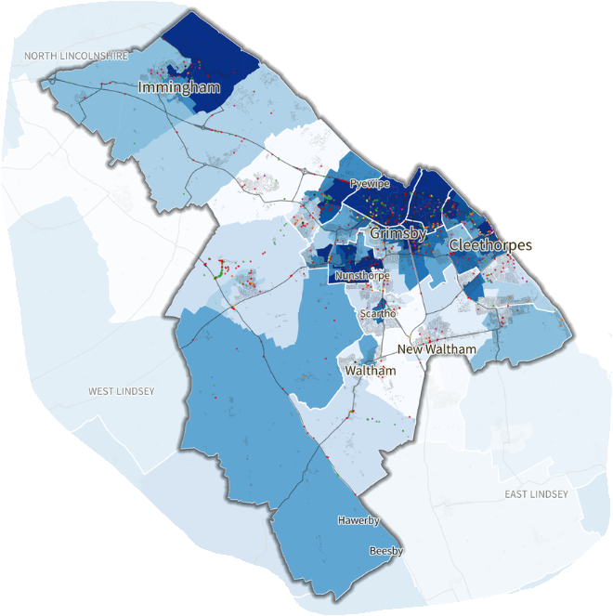

Context

Local authorities have a duty to set up a Standing Advisory Council on Religious Education (SACRE). The duties of the SACRE include gaining an overview of the quality of religious education provision in local authority maintained schools and developing effective strategies to promote the highest standards.

The Agreed Syllabus Conference (ASC) holds the legal responsibility for revising the Agreed Syllabus. The ASC members are all members of SACRE.

Part of a SACRE’s role is to support the effective provision of collective worship in community schools and to advise the local authority on issues related to provision and quality. It must also consider applications from head teachers in community schools that the requirement for collective worship to be wholly or mainly of broadly Christian character be disapplied for some or all of the pupils in that school.
SACRE ‘determines’ the appropriateness of that application and grants a ‘determination’ to those schools where the application is judged to be in the best interest of the pupils. All pupils in schools with determination continue to have an entitlement to daily collective worship.

A SACRE is set up to represent a balance of all the interests of the local community. This includes elected councillors, representatives of local faith and belief communities and members of the education community. The constitution of the SACRE is determined by law.

SACRE membership is comprised of the following groups:
- Representatives of Christian denominations other than the Church of England and representative of other faiths and beliefs
- Representatives of the local Church of England diocese
- Representatives of Teachers’ Associations
- Local Authority Representatives
For a list of serving SACRE members, please see Appendix 1 on p.10 below.



 | SACRE Meetings 2025 | During 2024/25, North East Lincolnshire SACRE met on the following occasions:  Wednesday 9th October 2024  Monday 10th March 2025  Monday 30th June 2025
These meetings covered a range of topics, including:

- The funding allocated by the local authority for the statutory work of SACRE
- Membership of SACRE, including identifying, appointing and training potential new members
- Analysis of Ofsted and Section 48 reports for references to Religious Education and collective worship
- Audit of the quality of Religious Education in Maintained Schools.
- Discussion of national developments in Religious Education.
- Analysis of data, including school survey data, workforce data and GCSE data.
- Planning for the SACRE conference held jointly with North Lincolnshire.
- Convening an Agreed Syllabus Conference jointly with North Lincolnshire SACRE.

Census 2021 – Religion (North East Lincolnshire)

Statutory Responsibilities: Religious Education

Standards and Monitoring: Ofsted Inspections

During this period, SACRE analysed the reports from eleven Ofsted inspections, covering primary and secondary schools and academies across North East Lincolnshire. These were a mixture of Section 5 (graded) and Section 8 (ungraded) inspections. Two of the inspections involved a ‘deep dive’ in RE.

Although RE was not specifically mentioned in several of the Ofsted reports, there were a range of comments about pupils’ preparedness for life in modern Britain. The majority of schools and academies were able to evidence that they are preparing pupils well for life in modern Britain and that they are supporting pupils’ personal development effectively. Some extracts from the reports can be found below:

Extract 1: The academy has a well-designed programme of PHSE in which pupils learn about tolerance and that everyone is an individual.

Extract 2: Pupils have a good understanding of Fundamental British Values.

Extract 3: The PHSE programme and assemblies help children understand about different faiths and beliefs.

Extract 4: Pupils learn about many religions, cultures and differences through a well-designed programme. They learn about tolerance and show this routinely.

Standards and Monitoring: Section 48 inspections

An inspection carried out under Section 48 is an inspection of a faith school or a school of religious character to ensure that the religious character of the school is being appropriately upheld. This includes Church of England and Catholic schools and academies across North East Lincolnshire. RE and collective worship must be considered as part of this inspection. Although all Catholic academies have the quality of education in RE inspected by denominational authorities because the RE curriculum is shaped by a diocesan syllabus, the same is not the case for all Church of England schools and academies. Voluntary controlled Church of England schools and academies receive a general comment on RE and collective worship as part of a Section 48 inspection, also known as a SIAMS. In these schools, Ofsted can carry out a ‘deep dive’ in RE as part of a Section 5 (graded) or Section 8 (ungraded) inspection in order to judge the quality of education in the school. This is because in voluntary controlled Church of England schools and academies, there is a legal requirement to follow the locally agreed syllabus for RE. Voluntary aided Church of England schools and academies receive the equivalent of an Ofsted ‘deep dive’ in RE as part of SIAMS; these schools are provided with a comment on the quality of education in RE. This is because in voluntary aided Church of England schools and academies, the RE curriculum is designated by the governing body. They are not required to use the locally agreed syllabus as the basis of their RE curriculum.

Standards and Monitoring: GCSE Religious Studies

In summer 2025, 162 students in North East Lincolnshire sat the GCSE Religious Studies examinations. Of these, 159 (98%) achieved grades 9-1 – 1% above national. 110 students (68%) achieved grades 9-4 – 3% below national. 75 students (46%) achieved grades 9-5 – 14% below national.

SACRE discussed concerns about the numbers of students being offered the opportunity to sit a GCSE qualification in Religious Studies at KS4. All secondary provision in the region is academised, so SACRE has no legal right to intervene in decisions around curriculum, but concerns were raised with particular secondary academies during this period where it appeared that very few or no students had the opportunity to sit a GCSE in Religious Studies, and, furthermore where it seemed that academies were in breach of the funding agreements in relation to RE at KS4 (see Compliance section below).

Standards and Monitoring: Compliance

During this period, SACRE scrutinized data, including inspection reports and workforce data, as well as anecdotal evidence from RE teachers and leaders.

According to the School Workforce Census data, only one secondary academy in North East Lincolnshire met the required curriculum allowance for RE at KS3. The same academy was the only academy that complied with statutory duties in relation to RE at KS4. All other academies were non-compliant at KS4.

Apparent non-compliance in secondary provision continues to be a grave concern to SACRE members. As noted above, all secondary provision in the region is academised. SACRE note that all academies are required to include RE as part of the broad and balanced curriculum, as designated on their funding agreements. Whilst there is flexibility in how this might look in a given secondary academy, it is of great concern that many students in the region are not receiving their entitlement to a high-quality education in religion and worldviews. SACRE continues to proactively contact secondary academies to offer advice, guidance and assistance. To date, very few secondary academies have requested support.

RE Support and Advice

Unlike other SACREs, North East Lincolnshire does not retain the services of an RE Adviser to deliver support, advice and training to schools and academies in the region. Although the Diocesan RE Adviser attends SACRE meetings and provides advice and guidance to SACRE members, she was not asked to provide training sessions during this period. SACRE members drawn from Committee D (teacher representatives) have provided networking meetings for RE leaders and teachers during this period.

Other Information

During this period, SACRE did not receive any complaints about the delivery of Religious Education in North East Lincolnshire schools or academies. SACRE did not track the number of pupils withdrawn from the RE curriculum, although information on how to handle requests for withdrawals was shared with school and academy leaders across the region. SACRE did not provide any specific advice to the local authority regarding Religious Education, other than the advice shared with school leaders at local authority leadership briefings.

Statutory Responsibilities: Collective Worship

During this period of reporting, North East Lincolnshire did not actively monitor collective worship, although members of SACRE offered advice and guidance to schools and academies that sought it, especially regarding the right of parents/guardians to withdraw their children from collective worship. No training on collective worship was provided by North East Lincolnshire SACRE.

North East Lincolnshire SACRE did not receive any requests for determinations during the period of reporting.

North East Lincolnshire SACRE did not receive any complaints in relation to collective worship.

Links with Other Bodies (Local and National)

North East Lincolnshire SACRE continues to work closely with the Church of England Diocese of Lincoln, and the Diocesan RE Adviser has worked alongside the SACRE members to deliver advice, support and training to schools and academies in North East Lincolnshire.

A member of Committee D facilitated the sharing of resources and key data to schools and academies in the region through a free-to-attend NATRE-affiliated RE teachers’ network.
Other members of SACRE provide a useful link with faith communities in the region and schools have benefited from this through the arrangement of virtual and in-person visits and visitors.

North East Lincolnshire SACRE is a member of NASACRE and accesses training and support through this.

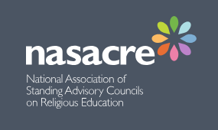

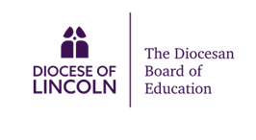

Management of SACRE and Contribution to Wider Local Authority Agenda

The work of SACRE is funded by the Central School Services Block (CSSB). In the academic year 2024-25, North East Lincolnshire received £1,370,513 for the CSSB. NASACRE recommends that 2% of the CSSB should be designated for the work of SACRE. In the period of reporting, North East Lincolnshire SACRE received the funds to retain the use of a clerk, along with £5000 (0.36 % of the CSSB) to contribute to the joint SACRE conference.

Unlike other local authorities in the region, North East Lincolnshire SACRE does not retain the services of a local authority RE adviser; support work and advice is primarily provided by members of Committee D (Teacher Representatives) and the Diocesan RE Adviser, who sits on SACRE as a co-opted adviser. The members of SACRE seek to fulfil their statutory duties as best they can. However, the local authority has only four maintained primary schools and two nursery schools, which were all audited in this period for the quality of religious education. Reports were provided to the SACRE for review and comment.

During this period, membership of Committee C (Local Authority Representatives) has been strengthened with the result that the work of SACRE has a greater profile within the local authority. This has not yet translated into sustained funding for the work of SACRE. Recruitment of new members remains a priority in order to increase the positive impact of SACRE in the region.

APPENDIX 1

SACRE MEMBERSHIP

Chair of SACRE | Cllr. Sophia Farren
Vice Chair of SACRE | Julie Childs
Strategic Officer for SACRE | Wendy Jackson
Clerk to SACRE | Diane Grimshaw

Committee A  Representatives of Christian denominations other than the Church of England and representatives of other faiths | Nigel Bishop (Methodist Church)  Amanda Mellows (Catholic Church)  Shereen al-Ankar (Muslim community)  Peter Altoft (Jewish community)  Kevin Nightingdale (Jewish community)
Committee B  Church of England representatives | Pat Barlow
Committee C  Local authority representatives | Cllr Sophia Farren  Cllr. Marian Boyd
Committee D  Teacher representatives | Julie Childs  Inga Greet

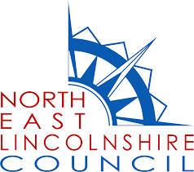

SIAMS – the Statutory Inspection of Anglican and Methodist Schools

