North East Lincolnshire Best Start Local Plan
A Guide for Families - Giving Every Child the Best Start
In North East Lincolnshire families should feel supported from pregnancy until their child starts school, with services that are easy to find and welcoming.
We know some areas face extra challenges, so we’re working hard to make sure every family gets the right help at the right time, no matter where they live.
We’re using the Department for Education’s Best Start in Life guidance to help children reach a Good Level of Development.
What Families said
“My son loved his weekly portage visits. They showed me how important learning through play is, and our worker reassured me about his development.” | “A friendly welcome, varied activities, and a safe space for children to play. Staff know the children well and can signpost to other services if needed.”
“This group is amazing. They’ve helped my son grow in confidence and supported us as parents whenever we need it.”

Our goals 2027/28
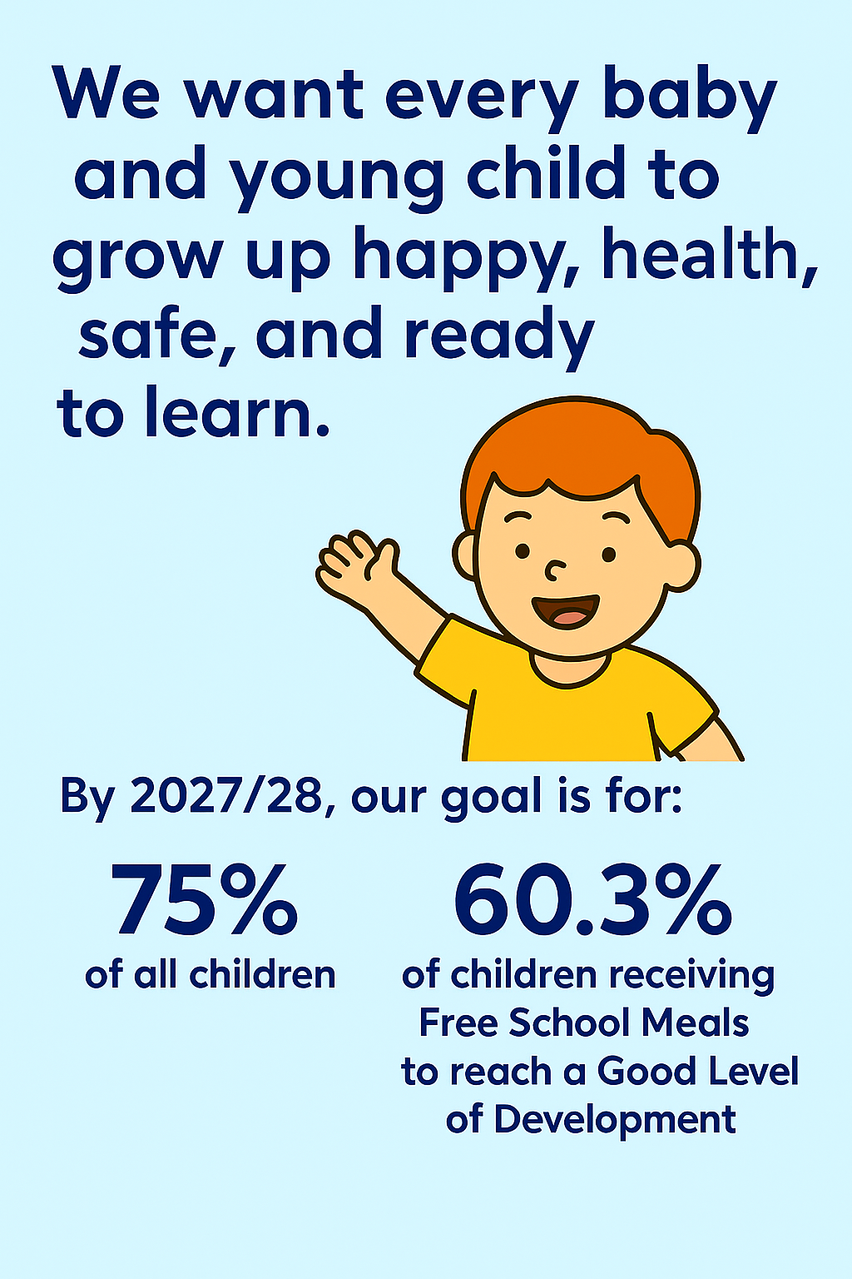

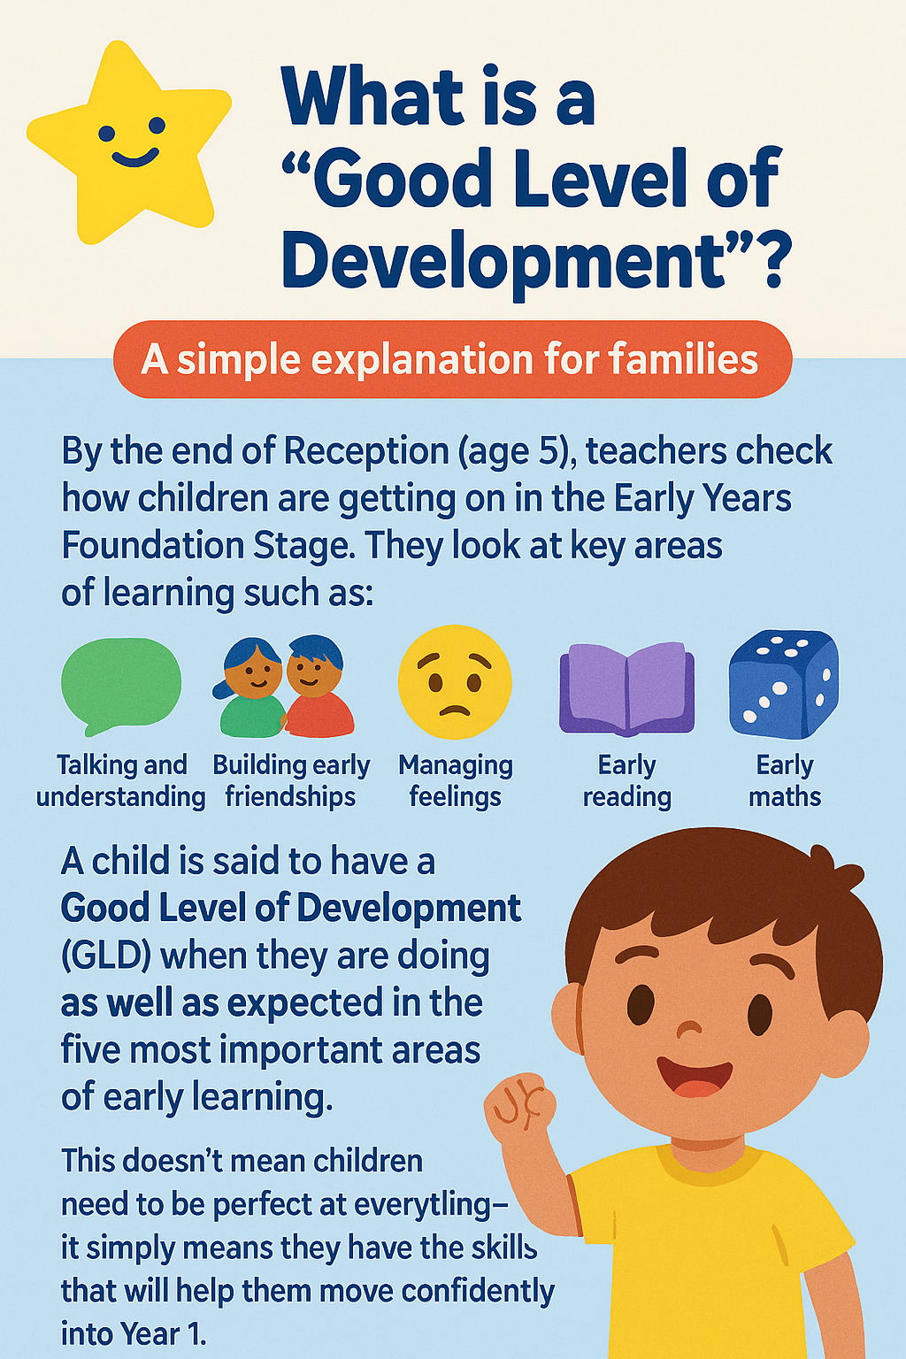
What is a “Good level of development”?
Local data shows us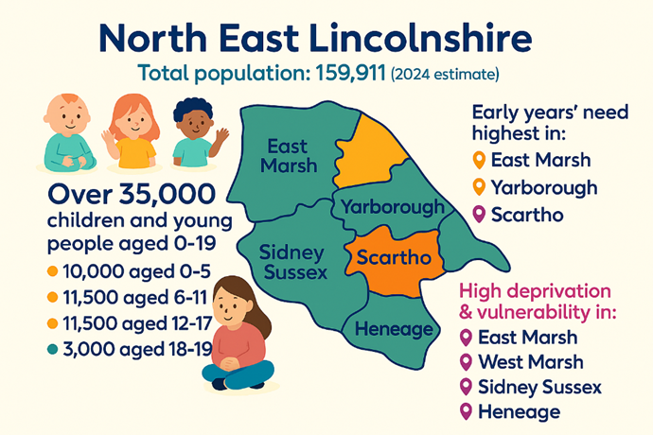
4129  Members of Best Start Hubs | 99.2%  3 Year Olds attend their Ages and stages review | 95.3%  2- 2.5 Year Olds attend their development review
66.7%  of Children are currently reaching a Good Level of Development. | 4461  Children Identified with SEN | 54.6%  of Children on Free School Meals are currently reaching a Good Level of Development.

What Support Is Available for you and your family?
Universal Services - These are open to everyone:
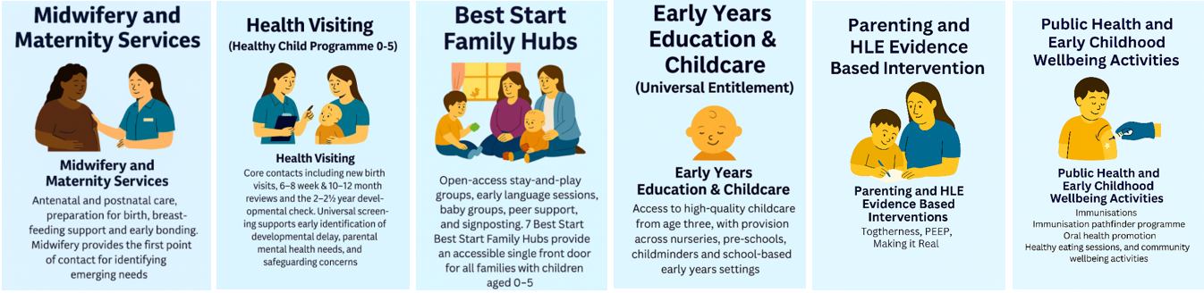
Targeted Services - for families with additional needs
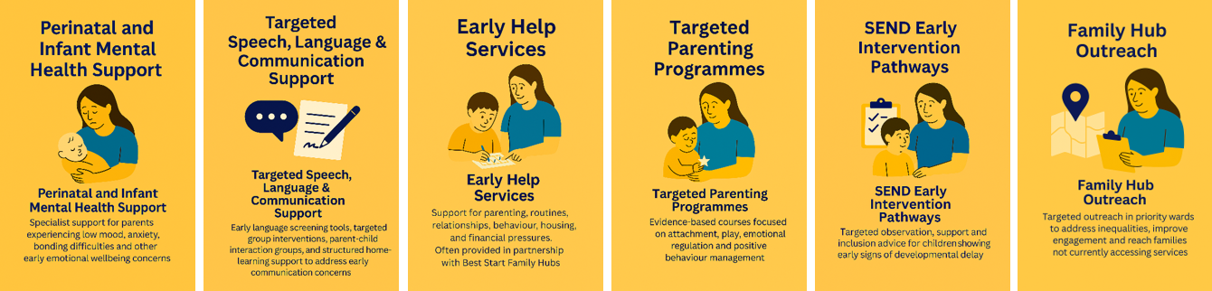

Specialist Services - for more complex needs
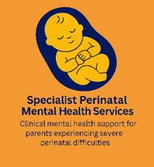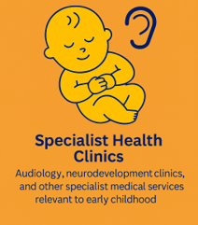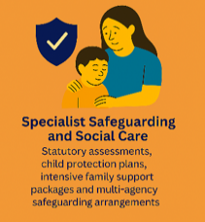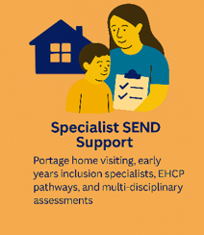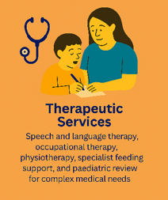

How We Will Make Services Better
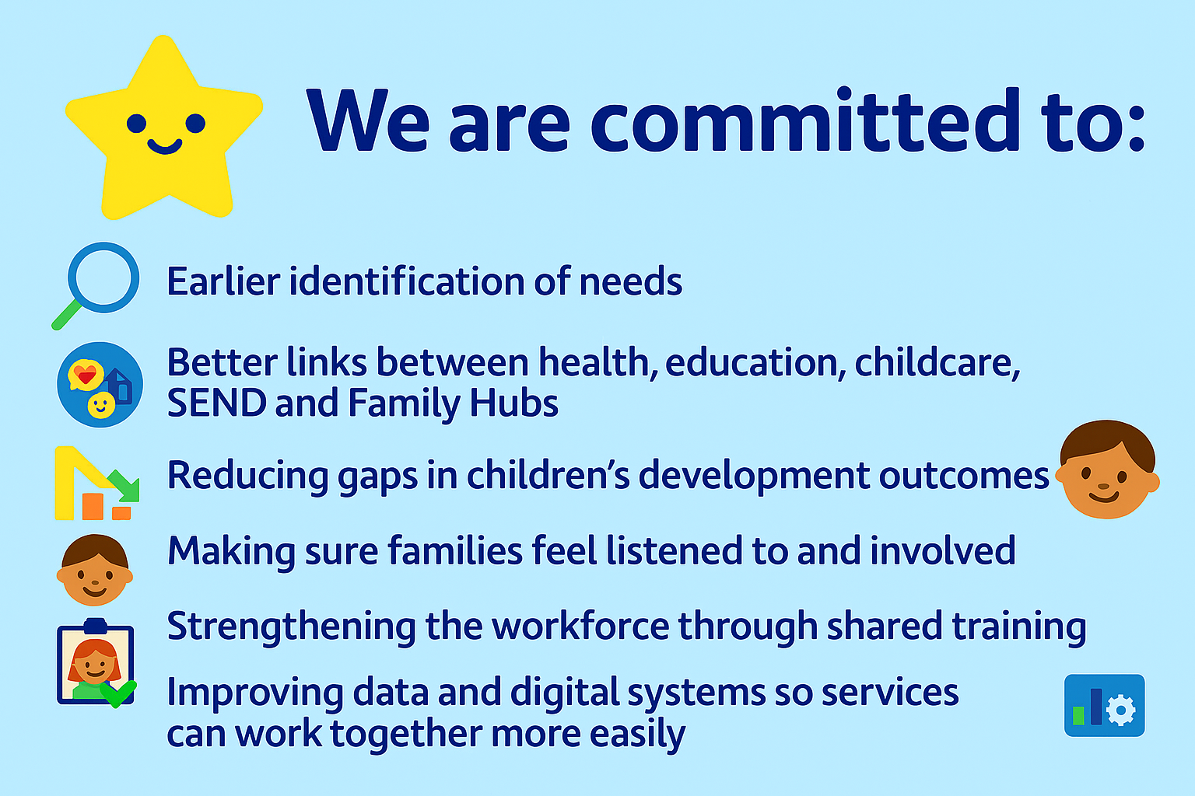

What This Means for Families
