North East Lincolnshire Best Start Local Plan
This Best Start Local Plan sets out North East Lincolnshire’s shared ambition to ensure that every baby and young child has the strongest foundations to thrive. It brings together our local vision, early years priorities, evidence of need, and a coordinated whole‑system approach to improving outcomes from pregnancy to age five. The plan outlines how partners across health, education, Best Start Family Hubs, SEND, social care and the voluntary sector will work together to reduce inequalities, strengthen early development, and create a seamless, family‑centred early years offer.
Contents
Vision & Strategic Intent 2
National context 3
Understanding Local Needs 3
Parent Feedback 4
Baseline data to support this plan includes in 2024/25 5
Analysis of the outcomes of current system 7
Shaping the Plan 8
Current Core Service Offers 9
What Support Is Available for you and your family? 10
Universal Services 10
Targeted Services 11
Specialist Services 12
System Enablers 13
Workforce capability and multi-agency training 13
Data sharing systems 14
Co-production with families 14
Culture, leadership, and cross sector- collaboration 15
Delivery Model 15
Monitoring, Evaluation & Understanding Progress 16
Key performance indicators (KPIs) 16
Access, reach & equity 16
Quality & workforce 17
System efficiency & experience 17
Governance & Accountability 18
Test & Learn Approach 19
Pilot approaches to trial 19
Financial Strategy 20
Where available, short-term grants will be used for Test & Learn activity, small scale pilots, data and digital innovation, and targeted workforce development to strengthen delivery models and improve children’s outcomes. 21
This combined funding approach supports Best Start Family Hubs and early years partners to deliver a high quality and integrated offer, in line with BSIL expectations and our local plan vision for improving child development across North East- Lincolnshire. 21
Appendices 21

Vision & Strategic Intent
In North East Lincolnshire, our vision is that every baby and young child grows up happy, healthy, safe and ready to learn, supported by families and communities that nurture strong relationships and lifelong resilience. We are committed to ensuring that all children begin school with the foundations they need to thrive physically, socially, emotionally, and cognitively supported by a high‑quality early years system.
Our Marmot Place ambition. North East Lincolnshire is working towards becoming a Marmot Place, committing the whole system to reduce health and developmental inequalities by addressing the wider determinants that shape children’s life chances from conception to age five. We will embed the Marmot principles give every child the best start in life, tackle inequality systematically, and act in partnership so that improvements in Good Level of Development (GLD), language development, and family wellbeing are achieved equitably across all communities. This Best Start in Life (BSiL) plan is the delivery vehicle for that ambition, translating Marmot principles into practical action in Best Start Family Hubs, early education settings, health visiting, speech, language and communication needs (SLCN) pathways, and targeted parent support.
We recognise that North East Lincolnshire faces long‑standing geographical and social inequalities, with children’s outcomes varying significantly between communities. Insights from the North East Lincolnshire Data Observatory highlight persistent local disparities in child development, health, deprivation, and family wellbeing across the borough.
Our BSiL strategy places reducing inequalities at its centre. Our principals are to:
- Target support where data shows the greatest need.
- Strengthen early identification of vulnerabilities.
- Ensure services are inclusive, culturally competent, and accessible.
- Focus on narrowing the developmental gap before children enter school, an ambition also echoed in national evidence on early childhood inequalities.

National context
This plan aligns with the Department for Education’s expectations for Best Start in Life (BSIL) local plans, ensuring we:

Our mission is to improve early childhood development, including increasing the proportion of children in North East Lincolnshire Council achieving a Good Level of Development at the end of the 2027/28 academic year is at least 75.0%; and the proportion of children eligible for Free School Meals (FSM) and achieving a Good Level of Development (GLD) at the end of the 2027/28 academic year is at least 60.3%.

Our vision reflects extensive collaboration across North East Lincolnshire, bringing together health partners, early years providers, schools, Best Start Family Hubs, social care, community organisations, and families. The local threshold document reinforces this strong value base-centred on relationships, compassion, community and partnership working-emphasising that “relationships unite us and we put children at the heart of our work”NEL-Threshold-Document.pdf

Understanding Local Needs
Input into this BSiL Plan from:
- Practitioners across early years, health, and education
- Local data and intelligence via the NEL Data Observatory - North East Lincolnshire Data Observatory – North East Lincolnshire Data Observatory
- Feedback and lived experience from parents and carers.
Feedback gathered through Best Start Family Hubs, early years providers, health services, and local engagement activities shows clear themes that relate specifically to the 0-5 experience:
Parents and carers report that they need:
- Clear and simple access routes into early years support
- Support available early and at the first sign of concern
- Services that understand the everyday pressures affecting young families

Parent Feedback
“My son loved his weekly portage visits. They showed me how important learning through play is, and our worker reassured me about his development.” | “This group is amazing. They’ve helped my son grow in confidence and supported us as parents whenever we need it.” | “A friendly welcome, varied activities, and a safe space for children to play. Staff know the children well and can signpost to other services if needed.”

Practitioners emphasise:
- The essential role of relationships in the early years, echoing the local principle that “relationships unite us” in supporting children and families.
- A need for consistent information‑sharing between early years, health visiting, midwifery, childcare settings, and Best Start Family Hubs
- Increased capacity for early identification and intervention for children aged 0-5
These insights highlight the importance of co‑produced solutions and family‑centred practice within the early years’ system.

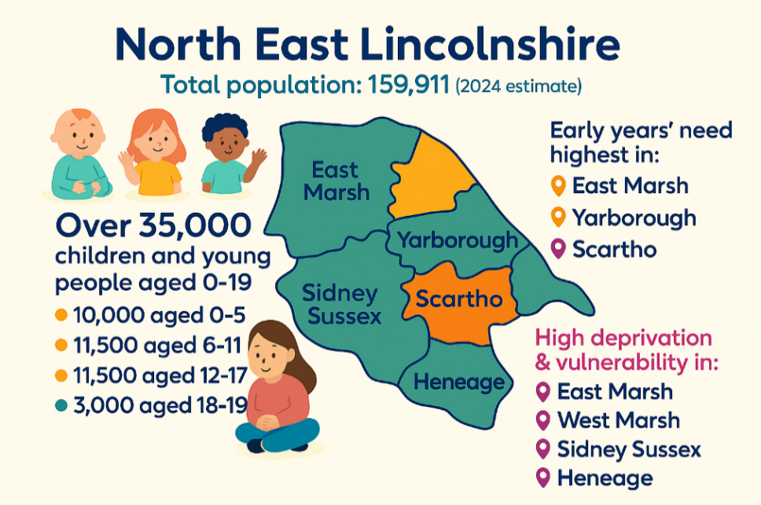
Baseline data to support this plan includes in 2024/25

46%
Members attending Best Start Hub
592
Non-Members attending Best Start Hub
4129
Members of Best Start Hubs

66.7%  Overall GLD  -1.6% vs National | 54.6%  FSM GLD  +3.4% vs National (FSM) | 22%  Children Eligible for FSM  -3.7% – National | 4461  Identified with SEN | 5295  3 -4yo part time (PTE) places available | 43%  Working‑offer take‑up for 2‑year‑olds  -41% vs National | 23%  Overall GLD  -1.6% vs National
95%  Universal funded place take‑up (3–4yo)  +4% vs National | 2748  2yopart time (PTE) places available | 3.9%  NEL residents with a non‑English home language | 95.3%  2-2.5 review  +14.5% vs England | 67%  Healthy weight (ages 4-5)  -8% vs England | 38%  Breastfeeding at 6-8 weeks  -17.6% | 94.1%  MMR vaccination at age 2  +5.2% vs England
99.2%  ASQ-3 Completion  +5.3% vs England | 82.2%  Communication  -5.4% vs England | 92.9%  Gross Motor  -0.7% vs England | 94.4%  Fine Motor  +0.7% vs England | 93.2%  Problem Solving  +0.2% vs England | 91.6%  Personal-Social  -0.2% vs England | 4129  Members of Best Start Hubs
592  Non-Members attending Best Start Hub | 46%  Members attending Best Start Hub | 1482  Take up of Health Start Scheme March 25 | 597 per 10,000  Referrals to Childrens Social Care  614 – National Average | 45 per 10,000  CP  41 – National Average | 524 per 10,000  CIN  416 – National Average

Key implications for the 0-5 cohort include:
- Variability in availability and uptake of early years provision across wards
- Early development outcomes are not consistent across the borough, with some children experiencing greater vulnerabilities before age five.
- Speech, language and communication development
- High Prematurity rates
- Social and emotional readiness for school
- Maternal and infant health, influenced by deprivation and wider family circumstances.
- Family stressors, including poverty, housing instability, and mental health pressures.
- Unequal access to early years childcare and education across different wards
- Variation in uptake of funded early education entitlements, consistent with national reporting on under‑5 participation patterns
- Need for earlier identification of developmental delay-especially in communication and early language
- Limited reach of some specialist services supporting the 0-5 age group.
- Fragmentation in pathways, meaning families sometimes struggle to find consistent, coordinated support.
- Access to Family Hubs is limited in certain areas, where a Hub is not in their locality.
The Children’s JSNA and wider public health reports available through the Data Observatory show notable variations in early childhood health and wellbeing-indicators that directly affect the 0-5 population’s development trajectories.

Analysis of the outcomes of current system
Key Strengths
- Strong universal offer through health visiting, midwifery and Best Start Family Hubs
- Committed multi‑agency workforce with strong local relationships.
- Available early years childcare market with mixed provision
- Established pathways for SEND early identification.
- Best Start Family Hubs providing an accessible single front door for 0-5 support
- Clear commitment to reducing inequalities in priority wards.
- Quality of childcare provision.
Key Gaps Identified
- Uneven access to early education and childcare across wards
- Variable availability of provision, particularly for disadvantaged 2‑year‑olds.
- Inconsistent uptake of funded entitlements among families in high‑need areas.
- Further development of multi-agency pathways to prevent duplication for families.
- Identification of communication and language need.
- Outreach to families who are not currently engaged by universal services.
- Capacity constraints within specialist therapies and SEND assessments.
- Variation in parent awareness of local offers and entitlements
- Limited engagement of dads and non-birthing partners, reducing opportunities to strengthen home learning and shared caregiving.
- Seldom-heard families not consistently reached by current offers (e.g. migration/English as an additional language)

Shaping the Plan
Based on local intelligence, population needs, JSNA findings, and performance variation across the borough, the key priorities for transforming the early years system in North East Lincolnshire are:
- Strengthening early identification and intervention, for example emerging SEND and speech, language and communication needs (SLCN) but not limited to.
- Reducing inequalities in early childhood outcomes, particularly in the most deprived wards.
- Improving access, quality and uptake of early years education and childcare, including funded entitlements for 2, 3 and 4-year-olds, given national evidence of uneven participation patterns among under 5’s.
- Enhancing family support and parental wellbeing, recognising the strong link between parental stress, deprivation, and outcomes for children in the early years, as evidenced in the Children’s JSNA and Public Health datasets.
- Building an integrated early years system, ensuring health visiting, Best Start Family Hubs, early education and childcare, SEND services, and voluntary sector support work together seamlessly.
- Embedding co-production and lived experience, reflecting the local commitment that families be “listened to, involved… and respected” in shaping services.

Current Core Service Offers
Universal Services (Available to All Families)
These services form the foundation of the early years system, providing consistent access and support for all families during pregnancy and early childhood.

What Support Is Available for you and your family?
Universal Services - These are open to everyone:
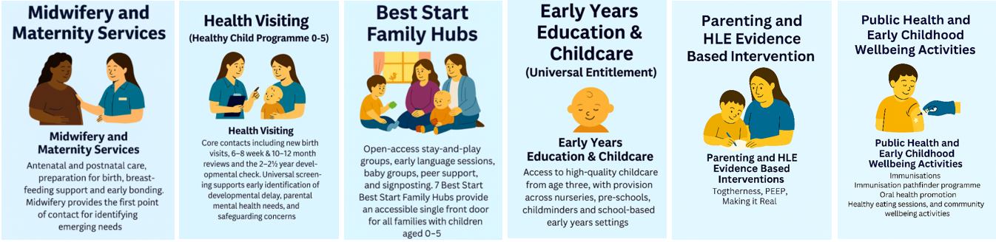
Targeted Services - for families with additional needs
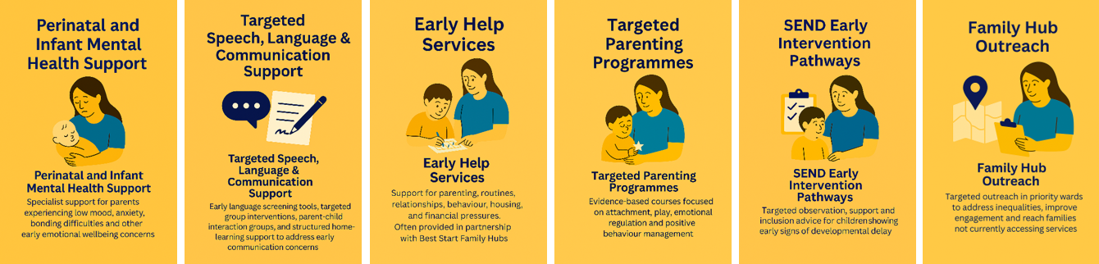
Specialist Services - for more complex needs
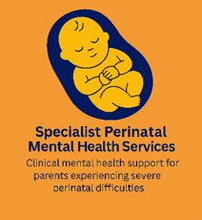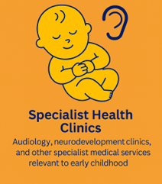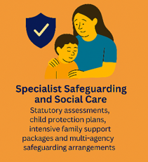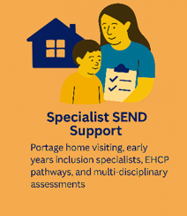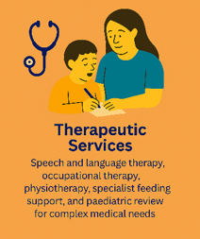

System Enablers

Workforce capability and multi-agency training
A skilled and confident workforce is central to improving outcomes for children aged 0-5. North East Lincolnshire’s early years system is supported by professionals across health, early education, social care, SEND, Best Start Family Hubs, and the voluntary and community sector. To strengthen capability, we will:
- Develop a shared early years workforce development framework across all partners.
- Deliver joint multi‑agency training on topics such as:
  - Speech, language and communication development
  - Trauma‑informed practice and attachment
  - Early identification of and support for SEND.
  - Information, advice and guidance for Early years foundation stage
  - Safeguarding and contextual safeguarding (Education)
  - Infant mental health and perinatal wellbeing
  - Substance misuse – hidden harm
  - Oral Health
  - Obesity
  - Parental relationships and Domestic abuse
  - Poverty
  - Parent Mental Health
- Promote consistent practice standards across midwifery, health visiting, early years settings, and family support.
- Strengthen supervision and reflective practice opportunities for integrated teams.
This will ensure that all professionals working with families share a common language, approach, and understanding of early childhood development.

Data sharing systems
Effective early years planning and intervention depend on strong data, insight, and digital infrastructure. To strengthen this enabler, we will:
- Improve data sharing agreements across health, education, social care, and Best Start Family Hubs
- Strengthen data quality, data‑sharing and the use of dashboards to drive decision‑making.
- Ensure timely and secure sharing of information to support early identification and reduce duplication.
- Strengthen digital systems to support integrated pathways, including,
  - Shared case management tools where appropriate
  - Early years dashboards and real‑time service data
  - Improved use of Public Health and Data Observatory analytics
- Develop a multi-agency early years outcomes dataset to track progress on GLD‑related outcomes from birth to school entry.
- Use insights to shape commissioning decisions and monitor impact.
This will create a more coherent picture of early years needs and allow for proactive and targeted support.

Co-production with families
Co‑production is a core principle of North East Lincolnshire’s approach, ensuring that services are shaped by the people who use them. To build and embed co-production, the plan commits to:
- Establishing ongoing Parent and Carer Advisory Groups linked to Best Start Family Hubs
- Ensuring lived‑experience voices from priority wards are represented in all service redesign work.
- Conducting regular lived‑experience reviews that inform quality improvement.
- Involving children, parents and carers in shaping communication materials, pathways, and service expectations
- Strengthening mechanisms for practitioners to capture and escalate child and parental feedback.
Embedding co‑production and lived experience - designing services with parents and practitioners ensures they respond to real needs, improving engagement, trust, and effectiveness. This supports families to create nurturing home learning environments-one of the strongest predictors of GLD.

Culture, leadership, and cross sector- collaboration
A strong and unified culture is one of the most important enablers of an effective early year’s system. To strengthen culture and leadership, North East Lincolnshire will:
- Embed a shared ambition that all children have the best start in life.
- Promote a culture of trust, collaboration, and shared accountability across sectors.
- Encourage leaders to champion integrated approaches, early intervention, and evidence‑based practice.
- Strengthen joint decision‑making and align priorities across health, education, social care, and the voluntary sector.
- Support staff to feel valued, motivated, and empowered in their roles.
- Celebrate successes and continuously learn from what works.
Through strong leadership and a culture of collaboration, the system will work more effectively for families.

Delivery Model
The delivery model for Best Start in Life in North East Lincolnshire will transform the early years system from a set of individual services into a coordinated, family‑centred network offering seamless support from pregnancy to age five. The changes will focus on:
- Earlier identification of need through improved screening, shared pathways, integrated assessments, and clearer referral routes.
- A strengthened Best Start Family Hubs model, acting as the central access point for all 0–5 support across the borough.
- A more consistent and aligned early years offer, ensuring that every family receives the same core support regardless of where they live.
- Better coordination between health, education, social care, and the voluntary sector, reducing duplication and improving the experience for families.
- Embedding evidence‑based approaches, such as targeted SLCN interventions, infant mental health support, and proven parenting and Home Learning Environment programmes.
- Targeted support in high‑need wards, ensuring resources are matched to areas of greatest early childhood vulnerability.
These changes will ensure families receive the right support, at the right time, from the right service, with smoother transitions and a clearer journey through the system. The best start in life delivery model will form part of the wider delivery of the national social care and SEND reforms.

Monitoring, Evaluation & Understanding Progress

Key performance indicators (KPIs)
Child outcomes
- GLD at EYFSP - % children achieving GLD (overall and by domain).
- GLD gap - Gap between disadvantaged and non‑disadvantaged; SEND vs non‑SEND; EAL vs non‑EAL; by ward/IMD decile.
- Year 1 Phonics - % meeting expected standard (for pipeline assurance from EY to KS1).
- Speech, Language & Communication - % at/above expected on ASQ‑3/ASQ:SE (where available); SLCN referral/acceptance rates.
- Attendance (Reception & KS1) - Persistent absence rates (to understand engagement/early risk).

Access, reach & equity
- 2‑year‑old, funded entitlement - Take‑up and attendance overall and for disadvantaged eligibility groups.
- 3–4 funded hours - Take‑up, hours delivered vs eligibility, split by ward/IMD.
- Every child who has 2 - 2.5 reviews and an identified development need or parental need has a plan and relationship with a key professional.
- Start Family Hubs/Early Help reach - Unique families engaged; repeat engagement; proportion from priority cohorts.

Quality & workforce
- Ofsted outcomes - % early years providers Good/Outstanding; trend and distribution by area.
- Setting quality support - settings in ‘intensive’ support; time‑to‑improvement; relapse rate.

System efficiency & experience
- SEND timeliness - EHCP 20‑week compliance; wait times for SLCN therapy.
- Parent/carer experience - Net satisfaction; qualitative themes from surveys/complaints/PALS.
- Provider experience - Admin burden, sufficiency/places, funding/payment timeliness.

Governance & Accountability
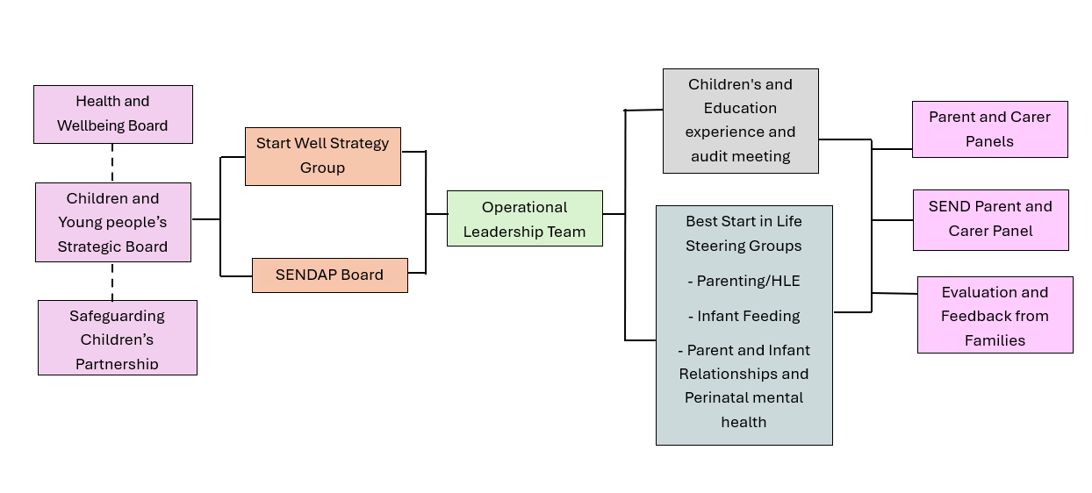
A strong governance framework ensures that Early Years transformation is strategically led, operationally robust, and transparently monitored. Governance in North East Lincolnshire aligns Early Years functions with wider Children’s Services structures to create a coherent, whole-system approach to improving outcomes.
This alignment ensures that Early Years provision does not operate in isolation but contributes directly to broader children’s outcomes, safeguarding responsibilities, and community strategies.

Test & Learn Approach
A Test & Learn methodology enables North East Lincolnshire to adopt innovation safely, understand what works for different cohorts, and scale effective practice across the Early Years system. This approach is built around rapid cycles, strong learning loops, and proportionate risk management.
Innovation will play a key role in improving early childhood outcomes. The delivery model will:
- Test new approaches in priority wards first.
- Evaluate impact through structured test‑and‑learn cycles.
- Scale successfully tested models across the borough, ensuring consistency and equity.
- Embed ongoing learning, using feedback from practitioners, families, and data monitoring.
- Develop innovation partnerships, including universities, voluntary sector organisations and national best-practice networks.

Pilot approaches to trial
The Early Years Team is piloting a targeted GLD improvement initiative focused on the ten schools with the lowest recent GLD outcomes. Working alongside each school and their feeder nurseries, the initiative tracks the progress of disadvantaged two‑year‑olds as they move through the early years system. Where slower or limited progress is identified, tailored support- including training, modelling and workforce upskilling-will be provided to address specific areas of need. This proactive, data‑informed approach is designed to close attainment gaps earlier, strengthen school readiness, and improve outcomes for our most vulnerable children.

The Immunisation Pathfinder is a national NHS England pilot being delivered in North East Lincolnshire to test whether childhood vaccination uptake can be improved in underserved populations by enabling Health Visiting teams to offer routine immunisations as part of health visits. The pathfinder is supplementary to the core GP immunisation offer and focuses on children aged 0–5 living in areas of high deprivation and low uptake, where families may face barriers such as access difficulties, disengagement from primary care, or social complexity. Its purpose is to improve access, reduce inequalities, and generate evidence on alternative delivery models that better meet family need. The programme is subject to local and national evaluation, including monitoring vaccination uptake, reach into non‑GP‑registered or under‑immunised populations, delivery models, and feedback from families, staff and partners, with learning intended to inform future national policy and commissioning decisions.

Financial Strategy
Government has provided funding through the BSIL programme to support North East Lincolnshire’s ambition to improve early childhood development and reduce inequalities across the borough. This investment forms part of a wider whole system approach, ensuring families receive joined- up, high- quality support from pregnancy to age five. Our local plan brings together multiple funding streams-core, council, commissioned and -short-term- innovation pots-to create a sustainable and coherent delivery model for early years services, Family Hubs, health visiting, and parent support, as outlined within our wider BSIL strategy and Best Start Local Plan documents.

North East Lincolnshire Council and its partners will be using the following core funding streams to deliver and sustain the Best Start in Life offer:
- Dedicated Schools Grant (DSG) - Early Years Block
- Council funded- Early Help / Best Start Family Hubs Budget
- Public Health / Health Visiting Resources
- Commissioned Services Funding

Where available, short-term grants will be used for Test & Learn activity, small scale pilots, data and digital innovation, and targeted workforce development to strengthen delivery models and improve children’s outcomes.

This combined funding approach supports Best Start Family Hubs and early years partners to deliver a high quality and integrated offer, in line with BSIL expectations and our local plan vision for improving child development across North East- Lincolnshire.

Appendices
- NEL-Threshold-Document - https://www.nelincs.gov.uk/assets/uploads/2025/08/NEL-Threshold-Document.pdf
- Joint Strategic Needs Assessment (JSNA) - https://www.nelincsdata.net/jsna-state-of-the-borough/
- NEL Early Intervention Strategy - NEL Early intervention strategy
- Starting Well Plan - Starting Well Plan
- NEL Children, Young People and Families ‘Stronger Together Strategy - 1.08.03 Children, Young People and Families 'Stronger Together' Strategy 1
- Joint Health and Wellbeing Strategy - Joint Health and wellbeing strategy 2025
- SEND Local Offer - NELC SEND Local Offer | North East Lincolnshire Special Educational Needs & Disability
- SENDAP Strategy - NEL SENDAP Strategy 2024-2029
- SENDAP Joint Commissioning Strategy - SENDAP Joint Commissioing Strategy May 2024
- SENDAP Sufficiency Strategy - SENDAP Sufficiency Strategy 2024-2029
- North East Lincolnshire Council Childcare Sufficiency Assessment 2025 -NEL Childcare sufficiency assessment

