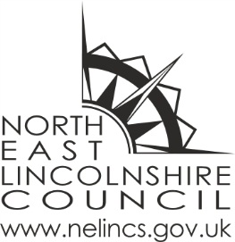

North East Lincolnshire Council – Evidence of Education

This document has been designed as a resource for parents who may wish to submit annual written reports to North East Lincolnshire Council regarding their child’s elective home education. Completion of this form is not mandatory, and you are welcome to use an alternative format if preferred. We also encourage other methods of communication; should you wish to arrange a visit, phone call, or online discussion about your child’s education, please contact the Elective Home Education (EHE) team at: electivehomeeducation@nelincs.gov.uk

Name of child:
Date of birth:
Address:
Parent/Carer’s name:
Contact number:
Email address:
Does your child have any Special Educational Needs? | Yes | No
Does your child have an EHCP? | Yes | No
If yes, how will the education you are providing at home meet their SEND needs?

Planning - You might like to include a copy of your timetable or maybe tell us about your chosen educational plans or educational philosophy i.e. project based learning, distance/e-learning, student led learning, learning about a particular culture, learning through play, national curriculum studies etc.
Wellbeing
- What opportunities has your child had for social development?

- What opportunities has your child had for physical or outdoor activities?

Educational program
Numeracy/ Maths
- What topics have you been covering in numeracy?
- What progress has your child made?
- What challenges and celebrations have they had in numeracy?

Literacy/ English
- What topics have you been covering in literacy?
- What is your child reading about?
- What progress has your child made?
- What challenges and celebrations have they had in literacy?
Other Subjects/Interests
- What other areas of learning have you covered?
- What progress have they made in these areas?
- What hobbies or interests does your child have?
- Have you been on any excursions and what was the educational value?
- What challenges and celebrations have they faced?

Resources and materials being used
- What resources and material are you using to support your child’s education?

Involvement of parents/carers
- How are you supporting your child to make progress?
- How are you monitoring your child’s progress?

Life skills

- Has your child had any experience of cooking, planning meals, or following recipes?
- Has your child looked after animals, completed work on financial management or planned journeys?
- This is not an exhaustive list of life skills.

My child’s views about their learning:
Good news or success I would like to share:
Note- please let us know if you are happy for us to share your child’s success in our newsletter

Future plans:
Signed: Date:
You may like to attach any photographs of your child and/or their work to accompany your report.

