North East Lincolnshire Market Position Statement 2026
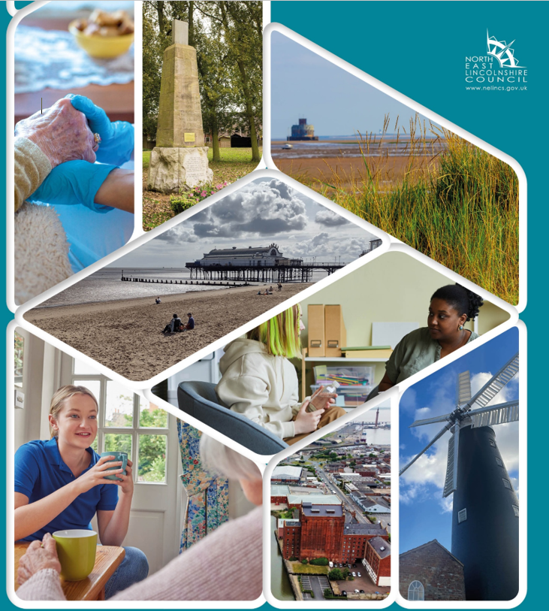

Contents
Foreword 3
Working with people 4
Our Local Population 4
Making it Real 6
What is a market position statement 6
What are our plans to transform health and care in NEL? 7
What are we planning to achieve 8
Sector Overview 9
Residential care 9
Support at home (domiciliary care) 11
Carers Support 13
Extra care housing 16
Community Living Services Framework 16
Assisted living centre 18
Single Handed Care - Community Handling Assessment Team (CHAT) 20
Disabled Facilities Grant programme 21
Telecare 22
Single Point of Access (SPA) 22
Connect NEL 23
Complex care 23
Fees paid for care services 26
Strategic Priorities 27
Commissioning Intentions 27
Housing and health 28
Useful Links 29

Foreword
Welcome to the third adult services market position statement for North East Lincolnshire (NEL). The purpose of a market position statement is to set out for the benefit of care providers and care recipients:
- What support and care services people need and how they need them to be provided.
- What the future of care and support will be like locally, how it will be funded and purchased.
- The support and services available now, and what is not available but needs to be.
- What support and care services the council thinks people will need in the future.
- How commissioners want to shape the opportunities that will be available. The market position statement also demonstrates compliance with the Care Act 2014 statutory duties in relation to the operation of a local market for care in NEL.

The integration between health and social care in North East Lincolnshire continues to be the foundation of the delivery of services. This Market Position statement highlights the continued impact of integrated services as well as the expected impact of Neighbourhood Health.

North East Lincolnshire formally committed to becoming a Marmot Place-, in July 2025 showing its commitment to reducing health inequalities and improving wellbeing for everyone who lives, works, and studies here.

Working with people
The Council and ICB at Place have made a shared commitment to working with the local community to make the best use of our resources. Drafted with community and VCSE representatives, this commitment is set out in our engagement strategy ‘Talking, Listening, and Working Together’.
This commitment is reflected in our approach to service development, evaluation and monitoring, which seeks to ensure that people with lived experience are involved in all stages.
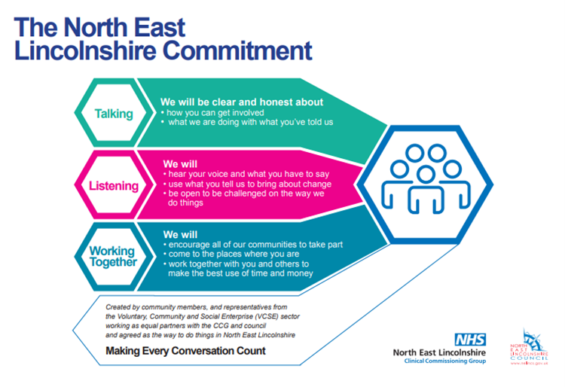
We have a system commitment that co-production, following the principles of talking, listening and working together, will be used for all system activity where people with lived experience will be impacted.

Our Local Population
North East Lincolnshire is a unitary authority in the Humber region of England, covering the port towns of Grimsby and Immingham and the seaside resort of Cleethorpes. The area is home to approximately 158,300 residents (2021 Census), in just under 70,000 households. Our population has slightly decreased (by 1.7% between 2011 and 2021) and overall growth is forecast to remain low in coming years. However, the demographic makeup is shifting significantly: over 21% of our residents are now aged 65 or above, up from 17.7% a decade ago. This is higher than the national average (around 18.6% over-65) and means our community is ageing faster than many others. Supporting a growing number of older people – many with complex health conditions – is a key consideration for local services.

The diagram shown overleaf gives a visual summary of some local population challenges. More information about our population and how it compares with other areas can be found at within our useful links section.

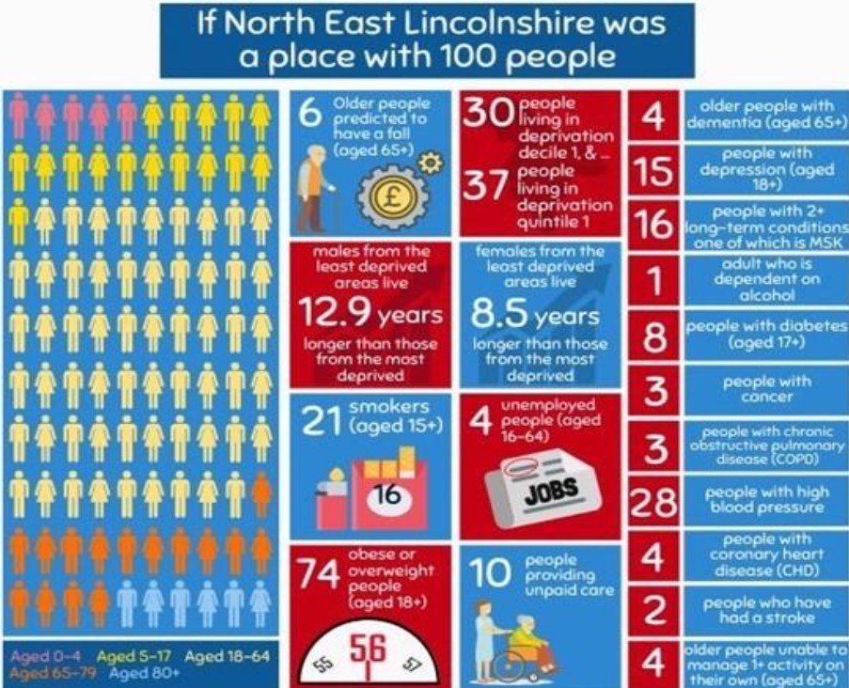

Local challenges include relatively high levels of claimants related to long term sickness and disability, high levels of low paid work, and relatively low levels of skills / qualifications in the adult population. This has a knock-on impact in terms of work readiness, unemployment, and the ability to attract new business to the area. Consequently, skills is one of the 4 key strands of the North East Lincolnshire Economic Strategy

In January 2025, 2011 people were supported by adult care services across NEL – 1493 with community support; 618 people in permanent residential and nursing care.

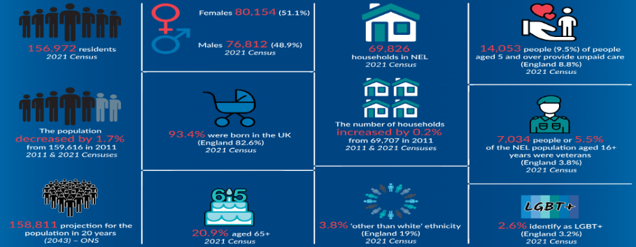

We serve a relatively small population, but with an increasingly elderly age profile and some deprived neighbourhoods. These factors drive demand for Adult Social Care. They also strengthen our resolve to focus on prevention and early intervention, to narrow the inequalities gap, and to target our support where it’s needed most.

Making it Real
Making It Real Professional Networking in NEL is a series of events designed to build stronger connections to support the sector to develop professional alliances, that focus on the wellbeing of residents, improving outcomes without an over-reliance on more traditional forms of care and support. These events are designed to improve knowledge of local services. Professional networking and relationships, improved working relationships and collaborative projects. In North East Lincolnshire, children, young people, families and adults are at the centre of everything we do. Relationships unite us and there is a real commitment to ensuring the right support, at the right time by the right person. These regular events are a collaboration between sector support NEL, NELC, Health and Care Partnership and Children’s Safeguarding Partnership.

What is a market position statement
Market Position Statements are tools we use to show current and future supply and demand in the borough, to explain how the Council will support and take action in the local care market to meet demand, and to let providers know about the potential business opportunities that exist. This cannot be delivered without the active cooperation of providers and without clarity over their strategic approach. These functions are likely to be helped by the development of a market position statement (MPS).
They also fulfil some legal duties in the Care Act 2014 – such as ‘provider failure’ and ‘market shaping’.
The MPS aims to:
- Present a picture of demand and supply now, what that might look like in the future and how strategic commissioners will support and intervene in a local or regional market to deliver support for adults.
- Be a brief, analytical document that is clear about the distinction between description and analysis. It will allow providers to come to their own judgements about where, and in what amount to invest in a market. Providers not only need to understand the direction the local area is taking, but also why it is going in that direction and based on what evidence.
- Support its analysis by bringing together material from a range of sources such as JSNAs, surveys, contract monitoring, market reviews and statistics into a single document which presents the data that the market needs to know and use, if providers are to develop effective business plans.
- Cover all potential and actual users of services in the local area, not just those that receive funding from commissioners.
- Offer a start to, not the end point of a process of market facilitation.

Consequently, the MPS is the basis for strategic commissioning and is a document which we will review and update regularly. We increasingly recognise that the local health and care workforce needs to be grown from within the local community as there are shortages of skilled workers in every area of health and care support. We aim to work closely with our care providers and partners in the borough to identify ways of increasing the supply of workers in the care sector, as well as looking to initiatives to sustain and enhance careers in care. Moving forward, as we transform local care and support services there are requirements for a different mix of skills, and we have described how we see the workforce of the future. We are keen to have a dialogue with our providers to ensure that we work collaboratively in developing the workforce that is needed for the new environment.

What are our plans to transform health and care in NEL?
Adult social care will continue to work with health partners to support the overall vision for integrating care and support around the needs of service users. We have aligned adult social care to the wider vision for health and wellbeing locally, focusing on prevention, putting the community at the centre of service redesign, and supporting people to take responsibility for their own health and wellbeing. Our whole system model aims to deliver the right care in the right place by the right people, as close to home as possible. It seeks to release the capacity and innovation in our community which will promote healthy living, self-care, and prevention, and reduce the risk of problems escalating and/or lead to unplanned hospital admissions. It is clear there is a need to move away from traditional models of service delivery and organisational boundaries towards reorganising services around communities and their needs. The universal offer of ‘one size fits all’ has many limitations, especially for citizens who have grown used to seeing personalisation and customisation as a ‘given’ through the growth of digital technologies. Through partnership working and building community assets and capabilities, there is an opportunity to re-shape public services to ensure they meet the financial challenge head on and deliver on outcomes for citizens. We are clear that improving health and wellbeing relies on considering and addressing a wide range of issues beyond just health and social care – economic growth and prosperity, learning and skills, housing and many more are all key contributors. We are also committed to working more closely with our colleagues in children’s services so that we better plan for meeting the needs of younger adults as they prepare for adulthood, ensuring we have the right services and arrangements in place as close to home as possible.
The Council Plan and all adult services’ priorities can be found within our useful links section.
North East Lincolnshire has formally committed to the Marmot principles of reducing inequalities in health. In 2024, the Council resolved to become a Marmot Place, embedding the goal of fairness and addressing social determinants of health in all our strategies. For Adult Social Care, this reinforces our Corporate Plan commitment to “enable all adults to maximize their capabilities and have control over their lives” and to ensure that our services reach those in greatest need. We are working closely with Public Health and other partners on targeted initiatives in our most deprived neighbourhoods to help improve life opportunities and reduce the stark health gaps in our community.

What are we planning to achieve
The North East Lincolnshire Market Position Statement aims to:
- Share local context and outline services and support currently being delivered with existing and prospective providers

- Highlight future needs and development opportunities for the area to the care sector.

- Provide information on how we want to shape and develop opportunities in the form of solutions to meet local need and demand.

We will work together closely with providers to ensure innovative and flexible support solutions for people living in North Lincolnshire. We will continue to work with wider partners, people with lived experience, voluntary and private sector organisations using evidence and lived experience to develop and shape local solutions to provide a range of opportunities which help keep people in their own homes, families, jobs & communities.
Our vision for Adult Social Care in North East Lincolnshire is to ensure “All Adults in NEL will have healthy and independent lives, with easy access to joined-up advice and support – helping them to help themselves.” This vision, which is echoed in both the Council Plan and the Humber and North Yorkshire Health and Care Partnership plan, puts people at the centre of everything we do. We want to ensure that wherever possible, individuals can live in the place they call home, connected to the people and activities they love, with the right support to stay as independent as possible.

Underpinning this vision are our core values: working together, inclusion, and empowerment. We believe in Talking, Listening and Working Together with residents, treating everyone with dignity and respect. We celebrate diversity and strive to make our services accessible and fair for all. And we are committed to empowering people – whether through giving individuals more choice and control over their care, or through supporting our staff to be creative and compassionate in their practice.

Finally, our long-standing value of partnership is embodied in our integrated arrangements. We value our close working relationships with the NHS, voluntary sector, care providers, and communities. These partnerships are founded on trust, shared goals, and a willingness to innovate. By pooling our efforts and resources, we can deliver better outcomes

Sector Overview

Residential care
North East Lincolnshire currently has 33 residential homes and 4 residential homes with nursing, operating under the local framework. Residential and nursing care plays an important role in supporting people with the highest and most complex needs; however, the area continues to experience an oversupply of traditional care home beds, with average occupancy at around 86%. Current and projected demand data does not indicate a need for significant expansion of residential care capacity.
The profile of people entering residential and nursing care is continuing to change. people are generally older, with higher acuity, greater frailty, and more complex long-term conditions, including dementia. As a result, care homes increasingly need to deliver specialist, adaptable care that supports people with complex health and social care needs. This includes ensuring accommodation is suitable, fully accessible, and capable of meeting rising levels of dependency.
Future needs and demand analysis
Although North East Lincolnshire has an ageing population, current modelling does not indicate a significant rise in demand for long-term residential or nursing care placements. Instead, population pressures are being felt in the need for complex care, particularly for people living with dementia, multiple long-term conditions, frailty, or severe functional decline.
A continued oversupply of traditional care home beds sits alongside an under-provision of other forms of supported accommodation, including supported living, extra care housing, and community-based alternatives. Future demand is therefore expected to shift away from residential care and towards models of support that enable people to remain in their own homes or housing-based support services.
Workforce remains a key risk factor for future capacity. Recruitment, retention and the availability of staff with the right skills mix are persistent challenges and may limit the sector’s ability to meet the rising complexity of the people requiring care.
To manage future pressures, forecasting and system oversight will continue to focus on:
- ensuring that residential and nursing capacity aligns with actual local need
- reducing avoidable long-term admissions, and
- maintaining high-quality short-term, reablement-focused care to support people to return home wherever possible.
Strategic direction
North East Lincolnshire’s strategic intention is to reduce reliance on long-term residential placements, supporting people to remain at home safely for as long as possible. Residential care will remain essential, but increasingly for people whose needs cannot be met safely in the community and who require specialist nursing support, complex dementia care, or 24-hour oversight.
Key priorities include:
- Continuing to reduce the number of people supported in long-term residential care.
- Expanding extra care housing, supported living, shared lives, and other independence focused models.
- Embedding assistive technology, aids and adaptations across all pathways.
- Residential and nursing care will continue to be required for those with complex support needs, including people with advanced dementia and high dependency levels.
- Building capability and environments suitable for complex and specialist care.
- Reducing avoidable deterioration and deconditioning.
Some increased capacity within the commissioning and transformation team allows for additional contracting oversight across the adult’s social care market and enables:
- Proactive contract monitoring visits.
- Early identification of provider risks.
- Targeted intervention and improved support to the market.
What we are looking for from the market
As we reshape the market, we will work with providers to ensure we have the right supply for the future. We are looking for:
- A move away from oversupply of traditional residential beds.
- Growth in accommodation-based alternatives (supported living, extra care, shared lives).
- Care homes to be able to meet complex dementia, frailty, and multiple long-term conditions.
- Workforce capability to manage rising acuity.
- Providers willing to participate in a forthcoming market shaping programme for residential care, focusing on sustainability, quality, and future demand.
- A market that embraces innovation, including assistive technology and digital solutions.
- Providers who work alongside NHS, social care, housing, and VCSE partners.

Support at home (domiciliary care)
The overarching vision for adult social care as articulated in the Council Plan is where 'All Adults in North East Lincolnshire will have healthy and independent lives with easy access to joined up advice and support, helping them to help themselves', Provision of Domiciliary care is a statutory requirement for all local authorities and is fundamental to achieving this.
Domiciliary care supports people to remain at home while having their eligible care needs met, such as help with washing, dressing, eating and with personal care. The integrated health and social care model in NEL means the domiciliary care is commissioned to meet both health (continuing healthcare) and social care needs.
The rise in the number of older people is likely to impact on the demand for care services locally.
Following a procurement exercise, the new arrangement for domiciliary care, locally referred to as ‘Support at Home’ (or S@H), commenced in October 2025 under a new commissioning model with the following 'locality providers' delivering care within three geographical areas:
- HICA – providing services in the East of NEL

- Comfort Call – providing services across in the South of NEL and in Burchester Court Extra Care housing scheme

- Hales – providing services in the West of NEL and in Strand Court Extra Care housing scheme

Between the hours of 6am-8am and 8pm-11pm the locality providers also support people who do not have a commissioned package of care by responding to their telecare activations where S@H is the most appropriate response.
The S@H system resilience team, delivered by HICA, includes an out of hours team that provides care and support needs during the night for people supported by the locality providers, this includes responses to telecare activations.
The system resilience team also:
- responds to telecare activations for people who do not have a S@H commissioned package of care.

- system pressures capacity support people for up to 14 days when the locality providers are unable to pick up a new package of care from an acute, reablement or short stay placement within 24 hours.

The remaining elements of the S@H model include:
- Nurtrio providing an informal carers breaks service.

- Health Now providing an enhanced S@H service to people who need a high level of support and to their informal carers

In exceptional circumstances, where people’s needs cannot be safely met within the S@H arrangement, the Council may make time-limited, off-contract arrangements as a last resort. This may include micro-commissioning with alternative registered providers to secure continuity of care, or manage short-term capacity pressures while longer-term solutions are identified. Such arrangements are used sparingly, are tightly governed, and are intended to complement, not replace, the core service. The expectation is that the S@H arrangement meets the vast majority of need.
Under the new model:
- care provision is provision is based on a ‘Teams not Times’ approach which is a move away from a rigid structure of times and lengths of calls towards a more person-centred proactive service which aims to improve outcomes for Individuals.

- Locality providers assign their care workers to neighbourhood zones/ teams within their locality with; improved staff retention, more consistency staffing, more responsive service, more control of staff resources, better partnership working with social workers and other key stakeholders.

S@H Step-up, Step-down, S@H is a core, place-based service within the integrated health and care system, acting as both a step-down and step-up provision across multiple pathways. S@H supports people to step-down to return home following hospital discharge, short-stay or community bed-based care, and reablement services, ensuring timely continuity of care and preventing unnecessary admissions to longer-term settings. It also provides a step-up response for people living in the community whose needs are escalating, including crisis situations, telecare responses and unplanned support.
The S@H model operates across distinct but connected pathways, including locality-based long-term support, short-term discharge and system resilience capacity, out-of-hours provision, and enhanced support for people with more complex needs. These pathways enable S@H to function as a key enabler of Home First principles, supporting flow through hospital and community services, maximising independence following reablement, and providing a flexible safety net for people whose needs fluctuate over time.
Future needs and demand analysis
On 30 June 2024, there were 662,320 people receiving long-term adult social care arranged or provided by Local Authorities nationally. This represents 1,450 people per 100,000 adults in England: (data is from DHSC Adult Social Care in England monthly statistics). 481,150 people were receiving support in the community, 1,053 per 100,000 adults. The numbers of Individuals supported by health and care is on the increase as is the acuity and complexity of their needs.
North East Lincolnshire has a population of 159,000. The following figures show the number of active S@H clients (December 2024):
- 793 Individuals assessing S@H services to meet their social care needs
- 41 for their continuing health care needs,
- 4 with combined continuing health care and social care needs
- 175 informal carers assessing carers support through a carers sit/ break.

We know the demand for S@H services is growing and will continue to do so, it is predicted that the NEL population increase in those aged over 65 is likely to continue.
Strategic direction
The strategic direction is for more of the people who need long term care to receive this in the community.
Neighbourhood working will continue to develop over the next period as the main way of organising integrated health and social care support. The focus is on bringing services together more consistently at a local level, using population data to identify people who are more likely to need support, particularly those living with frailty and long-term conditions. This approach is intended to support earlier intervention, reduce duplication between services and shift activity away from reactive responses towards more planned, preventative support delivered closer to where people live.
The S@H contributes to this approach, delivering flexible, strengths-based domiciliary care through locality-based teams aligned to neighbourhood geographies and working in close partnership with social workers, community services and neighbourhood MDTs.
What we are looking for from the market
With the new Support @ Home arrangement recently going live, there are no opportunities for additional providers to deliver services. The current contracts commenced 1 October 2025 and operate for a three-year term until 30th September 2028, with an option to extend until 30th September 2030.
Carers Support
It is estimated that there are around 14,000 carers in NEL, 3856 of whom (Dec 2025)
are registered with our carers support services. Within this 3856, 1.1 per cent are 0 -
16yrs, 6.6 percent are 17- 30yrs, 28.9 per cent are 31 – 50yrs, 40.9 per cent are 51 – 69yrs, 20.1 per cent are 70+yrs and 2.4 per cent are an unknown age. We have an all-age carers’ strategy, developed through consultation and engagement with those we intend to support. We involve carers in decisions as well as in evaluating the delivery of carers services.

We are now beginning to develop a new strategy for 2027 – 2030 and we remain committed to working in partnership with carers throughout the process. The number of those registered at the carers support service is primarily static, and those accessing formal support through an assessment has been decreasing for the last 5 years; however, the work done in 2025/26 has slowed this and resulted in those accessing direct payments doubling.

The following providers deliver support to carers in NEL:
- Carers’ Support Centre
- NAViGO
- Care Plus Group
- Carelink
- Alzheimer’s Society

The lengths of contract are as follows:
- Carers’ Support Centre – 5 years with a potential extension +1 +1 (contract end date of March 2031, without extension)
- NAViGO – (contract reviewed annually, as part of budgeting. The contract sits within the wider Navigo contract)
- Care Plus Group – (contract reviewed annually, as part of budgeting. The contract sits within the wider CPG contract)
- Carelink – 2 years (contract end date of March 2027)
- Alzheimer’s Society – 3 years with a potential extension +2 (contract end date of December 2026, without extension)

The expected outcomes of all carers’ support services are:
- Delivery of a high quality, culturally sensitive and inclusive carer led service that is delivered by appropriately trained staff and volunteers to meet individual and collective carers’ needs.
- Carers of all ages, and the people who work with them, are well informed about the information, support and services available for carers.
- Effective partnership working with all local carers’ forums and wider carer participation from all carer groups to gain a strong collective carer voice that informs the development and improvement of local services.
- Effective strategic partnership and working relationships with relevant organisations and agencies across the statutory, voluntary, community and independent sectors to improve the overall health and wellbeing of carers residing in NEL.
- Development of a carer-aware and friendly community through robust publicity, promotion, outreach and engagement activities.
- Carers of all ages, including those from hard-to-reach carer groups, are identified and encouraged to register with the carers’ support service/ GP.
- All carers, professionals and community members can access a wide range of advice and information.
- Registered carers can access a range of information, specialist advice and carers support services which are responsive and sensitive to their individual needs.

13.1 Future needs and demand analysis
Many informal carers are unregistered/ unrecognised, remaining hidden from formal support. Current capacity in the above service provision meets the current demand. As further work is undertaken to raise the profile of carers, create a carer friendly NEL and improve pathways to registration and support, it is hoped that many more carers will come forward for support. In addition, as people live longer with life-limiting conditions and long-term complications (i.e. long COVID, etc), the number of people who are carers will grow and the burden on those carers will increase – as a result it is anticipated that there will be year on year growth in demand. This is particularly the case for NEL as we have an aging population compared to other areas so an increase in the numbers of carers is expected.
13.2 Strategic Direction
Please find the carers’ strategy 2023-2026 within the useful links section. The new carers strategy will be launching in April 2027.
The current strategy has six priorities:
- Identification, recognition, and provision of information
- Workforce - culture and practice
- Access to assessments and support
- Carer education, training, and employment
- Tackling carer inequalities
- Carer Led

Supporting carers is part of our strategic agenda to promote preventative interventions i.e., by offering carers’ ‘easy-access’ lower-level support via the NEL carers’ support service. We hope to support carers to sustain the caring relationship wherever possible and have a life outside of caring; we also look to reduce the need to access more complicated/ expensive commissioned services, where this need is necessitated by avoidable crises. We understand the role carers play in our local community and the vital contribution they make to the local health, social care and wider economy.
13.3 What we are looking for from the market
The NEL carers’ strategy action plan aims to address any wider carers’ agenda
developments/ gaps to ensure continued support to carers in NEL. We would favour models of practice which promote client and carers’ independence, self-care, and overall family wellbeing. Currently there is a focus on promoting support for parent carers, working carers and young carers and ensuring that carers are embedded in all pathways. We have now embedded additional support for carers in the hospital discharge pathway, to ensure they are informed, assessed and that their needs/ views are considered before and during discharge. We will be extending this support out to other health/clinically appropriate settings in 2026/27 like reablement at home.

We have also identified the need for digital solutions to support carers both in formal aspects of carer support and for those who struggle (or who actively dislike) to access direct person to person support. With the first, we are considering assessment and information AI tool options and for the latter targeted information, peer support options, online training, apps, and opportunities access, etc. We continue to seek to make the market itself more carer friendly and transparent, both in the general community (via targeted social media projects) and in employment settings (i.e. with a focus on recognition and flexibility around employers’ own worker carers and the needs of business clients).

Extra care housing
There is a growing need for housing that can adapt as people’s needs change, so that more people can stay living independently for longer. This means having a more planned approach to housing and care, working closely with housing associations, developing new extra care schemes, and making better use of tools like the Disabled Facilities Grant to help people remain safely in their own homes.
North East Lincolnshire currently has two extra care housing schemes, Strand Court and Burchester Court. Both are 60-unit developments for people aged 55 and over and offer a more independent option than a care home, with access to housing and care support when needed. Demand for both schemes is high, with strong occupancy levels and waiting lists. While Burchester Court currently supports more people with lower-level needs, this is expected to change over time as homes become available and are offered to people with more complex needs.
Local analysis has identified a need for at least 300 units of extra care housing in North East Lincolnshire as agreed by the Health and Care Partnership.
It is also clear that there are gaps in housing for some groups, including people who may previously have lived in warden-assisted housing and people who need supported accommodation linked to mental health or homelessness. Future planning will therefore look at a wider range of supported housing options, working more closely with housing providers and voluntary and community sector organisations. Overall, expanding and improving extra care housing will play an important role in supporting independence, tackling social isolation and reducing reliance on residential care.
North East Lincolnshire Council welcomes early engagement from developers, housing providers and partners who are considering new extra care or supported housing schemes in the area. Early discussions are encouraged so that proposals can be shaped in line with local needs, neighbourhood priorities and wider health and care plans, and to help identify suitable locations.
Community Living Services Framework
In North East Lincolnshire, along with our residential and support at home provision we also commission a Community Living Services framework which includes supported living, housing related support and personal support. Our supported living services are currently used predominantly by adults over 18 years of age with learning disabilities but are also used by people with mental health support requirements, physically disabled and older adults. Our Housing Related Support services are predominantly to support maintenance of a tenancy and personal support focuses on enabling people to meet their broader social needs and is often commissioned via a personal budget.

Supported living is well established in our area and has enabled us to reduce the number of working age adults residing in residential care settings. The services enable individuals to have a home within their chosen community and to develop and maintain relationships with a bespoke level of support. Individuals are supported to manage their own tenancy, seek meaningful activity (employment, training, volunteering, community-based activity), and increase independent living skills.

People are at the core of the service, which is delivered in a person-centred and flexible way to support individual outcomes and promote choice and control. Those using supported living services have the right to the same opportunities as anyone else to live satisfying and valued lives and to be treated with the same dignity and respect. Supported living promotes independence and positive risk taking and is strengths-based and outcome-focused.

As part of the Community Living Services framework (supported living) we currently commission over 15,000 support hours each week for 250 individuals in 72 supported living schemes/properties. We have 13 approved providers of supported living on our Community Living Services framework in North East Lincolnshire and these are a mixture of local and regional/national providers.
What we are looking for from the market

The focus of future supported living provision includes supporting people to stay in and return to North East Lincolnshire. This strategic intention will require a range of accommodation based solutions including more apartment based models, reducing Houses of Multiple Occupancy where the environment is no longer fit for purpose (although there is still some requirement for this model within new provision) and increasing the number of more resilient and robust environments to better meet the needs of people with more complex and sensory needs, who communicate physically, or who have accessibility difficulties. This re-modelling of our supported living market is underway in collaboration with our providers and key partners in line with our All Age Housing with Care Strategy 2025-2029 (please see our useful links section).

We intend to continue working closely with our Community Living Services framework providers to facilitate the required growth and re-modelling described. This will be via some mini tender/call offs for the support provision but primarily we are asking our framework support providers to collaborate with Registered Social Landlords and developers and to present commissioners with care and accommodation solutions via our newly established framework processes.

These processes are in their infancy but are proving successful and allowing us to establish a collaborative and transparent approach to the growth required in the market. We are looking for continued collaboration from our framework support providers and their wider partners and stakeholders.

Current position

The April 2026 position is that we are working with a number of developers, support providers, Registered Social Landlords to develop new supported living provision. A new 4 person supported living house opened in April 2026 to support people with complex mental health to return or remain in their chosen area with support to have their own tenancy.

A bespoke single person supported living service has been established to support an individual with learning disability and mental health needs to return from residential provision to the least restrictive community setting.

A further 4 person supported living house is due to open in Summer 2026 to enable a further 4 individuals with complex mental health to return to a community setting with support including with the maintenance of their own tenancy.

In line with All Age Housing with Care Strategy 2025-2029 we are also looking to establish other supported living provision in the form of apartment models across all required needs. These developments are currently at planning permission stage but current projections suggest the opening of around 20-30 new apartments in late 2027.

The Council is experiencing some challenges and delays to the establishment of new supported living provision due to a multitude of factors including the economic situation and the internal processes and procedures of partner organisations. We are very keen to welcome new developers and Registered Social Landlords to the North East Lincolnshire area to work alongside and develop the required provision with our framework of support providers.

Assisted living centre
Aids for daily living
The assisted living centre (ALC) aims to provide residents with accurate, up to date and timely advice, information and signposting with regards to aids for daily living (equipment and wheelchairs). This includes clear advice on what items may be supplied and provided by the service and/ or signposting to alternative and purchasable items. It includes a demonstration facility displaying the range of aids for daily living available, which includes self-purchase defined items of equipment. Based on site at Diana Princess of Wales Hospital in Grimsby the facility provides choice and improved access to equipment and wheelchairs, helping to promote independence and wellbeing, and support self-care wherever possible. The service also provides some office space accessible for allied health professionals, occasional disabled facilities grant (DFG) sessions, and other activities of community benefit, to support the promotion of health and wellbeing for NEL residents.
Where aids for daily living have been prescribed by authorised professionals/ prescribers, the service aims to stock, supply, deliver, fit, install, adjust, repair/refurbish, collect, decontaminate and recycle/ dispose of aids for daily living (as appropriate). The service is flexible, responsive and operates within timescales that support the service user and the wider health and social care system to avoids delay in key areas such as discharge from hospital.

Current Contract
Northern Lincolnshire and Goole Foundation Trust (NLaG) provide ALC services under the NLaG block contract arrangement. The contract is required to meet presenting need and is reviewed in line with the wider NLaG block contract arrangement.
Quality and performance are reviewed on a quarterly basis. The service works with a wide range or partner organisation and service providers including telecare provision, carers’ support, allied health professionals, social care, intermediate care, disabled facilities grant team and with domiciliary care providers.
Future needs and demand analysis
Demand for the service continues to grow year on year, as individuals are living longer with long term and more complex conditions, as reflected in our local demography.
10,763 people are currently using aids for daily living, and we continue to see demand increasing. This includes a steady increase in requests for nonstandard care equipment outside of the core offer and stock held.
The self-purchase model is operational, and the reach of the service is growing to those with prevention and wellbeing needs, as well as those with eligible needs for prescribed equipment/ wheelchairs.
Strategic Direction
Our aspiration in NEL is to support people to remain as independent as possible at home for as long as possible, and our Assisted Living Centre provides a wide range of aid for daily living to support this. The service also works with carers to provide the right equipment for them to continue to support individuals. Therefore, the service improves service user outcomes and delivers costs savings for health and social care.
The assisted living specification reviews ensure the service continues to be fit for purpose, now and in the future. Our aim is that further improvement work will ensure the assisted living centre continues to be a fully inclusive ‘assisted living service’ that offers advice, information, guidance and assessment of an individual’s needs, support, and assistance where necessary to meet those needs.
Moving forward we would like to see greater footfall and use of its demonstration facilities, improved access to low level aids for daily living assessments, greater sales of aids for daily living to meet prevention and wellbeing needs and an increased take up of personal wheelchair budgets. As the remit and scope of the service broadens, the demand for the service will inevitably grow as has already been seen.
What we are looking for from the market
While the existing provision meets local aids for daily living needs, the service needs to further strengthen its linkages with assistive technology provision to support individuals holistically to use equipment and technology. For example, working in partnership with Carelink to provide the local telecare offer, and with North East Lincolnshire Council, regarding minor and major adaptations. As demand increases for the service; there will inevitably be strain on the availability of aids for daily living, staff capacity and timings of assessments/ provision of aids for daily living. Constant review of supply and demand will ensure that appropriate conversations can occur to ensure the correct level of investment is directed to the service. We would like to see increased use of the centre by the public going forward with site promotion and demonstration of equipment, leading to a rise in self-care and self-purchase
Single Handed Care - Community Handling Assessment Team (CHAT)
The Community Handling Assessment Team (CHAT) deliver this service across our providers and partner organisations, as part of the wider Care Plus Group block contract.
Training
The team deliver a range of face-to-face training available to local care providers which is free at the point of access. Additional bespoke training is available to support more complex need or specific equipment as needed.
Assessments
The team work closely with partner organisations and services, including community therapy, Reablement at Home, Community Inpatient Unit, Support at Home Providers (Domiciliary Care), the Disabled Facilities Grant service, the Assisted Living Centre and Wheelchair Services.
Support to carers
Initial training can be followed up by more bespoke training sessions if needed, this includes home and service visits.
Aim is to empower service users to be as independent as possible and to participate in their care following a strengths based approach. Working to ensure that wherever possible care is delivered by a single carer.
This approach also ensures that the best possible use is made of resources and funding and releases capacity for care back into the system.
Disabled Facilities Grant programme
Disabled Facilities Grant programme (DFG) is a national statutory entitlement which enables people with a physical disability or support need to access financial support up to a value of £30,000 to enable them to meet their needs and remain in their own home.

An Occupational Therapist or similar professional must assess the applicant’s needs and specific the adaptations which are clinically appropriate to support the individual. The works must be completed by an appropriately qualified and accredited contractor and comply with building and planning requirements. The support can be means tested and applicants may be required to make a contribution to the cost of the works.

Current Contract
North East Lincolnshire Council (NELC) went out to the market in December 2023 and current framework for delivery partners is in place until December 2027.

Future needs and demand analysis
The demographic profile of the area, coupled with the desire for people to remain independent and in their own homes as long as possible is likely to result in increase in demand for DFG Services over the lifespan of this MPS.

Strategic Direction
Our aspiration in NEL is to support people to remain as independent as possible at home for as long as possible, and our DFG programme offers a range of support to enable this. The service works with Occupational Therapists employed by NLaG who develop a specification of works for the appropriate adaptations to meet the needs of the applicant. A review of the Housing Assistance Policy which governs use of DFG funds as well as other related discretionary support is planned to start in late 2026 and will continue 2027. The review will include consultation and engagement with people who use and are affected by DFG services including the wider community and related professionals.

We aim to work with stakeholders to coproduce a policy which will ensure that statutory and discretionary support continues to meet the needs of the community and that funds are used judiciously to provide support to those who need it in a timely and appropriate manner.

The review of the Housing Assistance Policy will ensure the service continues to be fit for purpose, now and in the future.

Moving forward we would like to ensure that DFG is delivered in a manner which targets those most in need of support as demand inevitably grows.

What we are looking for from the market
NELC went out to the market in December 2023 and current framework for delivery partners is in place until December 2027.

Work is due to begin in April 2027 to develop the new framework that will run from 2028 onwards and development will include engagement current and prospective delivery organisations.

Consideration will be given to the type of dynamic market or framework that is most suitable for this activity as well as the structure and rates of the activity within it.
Interested parties should ensure they are registered with Find a Tender to receive notification of Pre-Market Engagement activities in due course.

Telecare
Telecare supports independent living in North-East Lincolnshire. By providing 24/7 monitoring and rapid-response escalation, we support vulnerable residents to remain in their homes with dignity, choice, and control. Since 1995, North East Lincolnshire has commissioned a robust telecare offer funded through a pooled health and social care budget. The service provides a 24/7, 365 days-a year, lifeline alarm and pendant system along with peripherals to eligible clients to facilitate and support independent living at home for as long as possible. The peripherals are a system of sensors in an individual’s home which detect household dangers, e.g. fire/ flood, or risks to vulnerable people, e.g. falls/ failing to take medication. On detecting a danger/risk, sensors alert a 24/7 monitoring centre. The call monitoring service provides a robust triage service, advice, guidance and emergency response escalation - calling on the most appropriate response to their telecare activations such as family/ friends, in a visit from a Support at Home provider, Community Urgent Care Team or an alert to the emergency services. Welfare and wellbeing check along with courtesy calls and happy birthday calls are also provided.
The service maintains a consistent and vital presence in the community:
- Currently supporting circa 1,500 commissioned clients
- 193 supporting people alarm clients per month.

Current Contract
Commenced 1st April 2025 for a 3-year term, with a potential +1 +1 extension.
The Future Telecare Model
The North-East Lincolnshire place wants to harness solutions that digital can offer to health and care delivery. We are embarking on a digital programme and want to ensure all our services keep pace with the innovation and changes coming with both digital and artificial intelligence.

Single Point of Access (SPA)
North East Lincolnshire has long benefited from a Single Point of Access – a collaboration of key local health and social care providers designed to help our local residents navigate their health and social care requirements easily and effectively. Supported by one telephone number, local people have access to clinical advice out of hours, information about social care and community services as well as mental health provision. Provision and signposting are available round the clock to help people get to the information and/or service they need. The service evolves according to need and new improvements are introduced on a regular basis.

Connect NEL
Connect NEL, based and run at the thriving VCS community hub, Centre4 is a telephone support and information service which links in well with the aforementioned SPA to help local residents with their queries. The local repository of up to date information about community groups, clubs, activities and events, it offers a route to reducing social isolation and promoting health and wellbeing for all ages.
It is fully integrated with the SPA and forms a crucial part of local provision
Complex care
Adult Mental Health, Dementia, Learning Disability and Neurodiversity Services North East Lincolnshire

Strategic Position
Adult Social Care in NEL is committed to a strengths-based, person-centred approach that enables people to live independent, meaningful lives within their communities, reducing reliance on institutional or crisis-led care wherever possible.
Across mental health, dementia, LD and neurodiversity, our strategic priorities are to:
- Prevent, reduce and delay the need for long-term care
- Promote community-based support and early intervention
- Support choice, control and personalised outcomes
- Work in close partnership and integration with health, housing, VCSE and community assets
- Ensure services are safe, sustainable, inclusive and value for money

This approach aligns with national policy direction and the local ambition to rebalance the system away from high-cost, reactive provision toward earlier, preventative and enabling models of support.

Market Overview and Current Position
Adult Mental Health
The adult mental health market in NEL is characterised by a mix of:
- Community-based support
- Supported housing and supported living
- Recovery-focused services
- VCSE-led wellbeing and preventative offers

Adult Social Care’s role is increasingly focused on social care-led recovery, resilience and independence, particularly for people with enduring mental health needs who may not meet secondary care thresholds but still require structured support. The support offer will be based on people’s needs rather than diagnosis or cohort type, leading to service developments across cohorts.

Key pressures include:
- Growing demand linked to deprivation, unemployment and long-term conditions
- Increasing complexity of need
- The need for alternatives to hospital admission and residential placements.

Commissioning intentions:
- Greater emphasis on community-based, non-institutional models
- Integrated working with neighbourhood and place-based services
- Stronger focus on outcomes, recovery and social inclusion
- Improving the breadth of opportunities for people to meet their needs and enabling greater choice and control at individual level.

Shared Lives
Shared Lives carers open their homes to provide either a short or long term living arrangement to people with a care or support need. It's similar to fostering, but for adults rather than children. Most importantly, Shared Lives offers personalised support in a safe, family environment, helping people to grow and thrive. This is a jointly commissioned scheme which will give people more choice and opportunity to take their breaks locally or in the other places. A new provider has been identified, through the partnership with North Lincolnshire and East Riding, who will start this service in 26/7.

Dementia related services
NEL faces increasing demand for dementia support due to an ageing population and rising prevalence of complex comorbidities.
Adult Social Care prioritises:
- Early diagnosis and post-diagnostic support
- Community-based services that support people to remain at home
- Carer support, respite and crisis prevention
- Dementia-friendly approaches across all commissioned services

Commissioning intentions:
- Shifting away from default residential care
- Developing flexible, responsive community and home-based provision
- Expectation that providers demonstrate dementia competence across the workforce, not solely within specialist services

Learning Disability and Autism
NEL has made progress in supporting people with learning disabilities and autistic people to live independently in the community, including increased use of tenancies and supported living models. Demand within the adult learning disability and autism market is increasingly shaped by improved Preparing for Adulthood outcomes, including greater expectations around independent living, employment and community participation. This has resulted in a growing cohort of young adults requiring flexible, strengths‑based support in ordinary housing, rather than traditional residential models.

However, challenges remain:
- Increasing numbers of people with complex and multiple needs
- An ageing cohort of people with learning disabilities
- Pressure on specialist and high-cost placements
- Workforce capacity and skills

Commissioning intentions:
- Continued commitment to community-based supported living
- Reducing reliance on out-of-area and institutional placements
- Supporting providers to deliver trauma-informed, autism-informed and least restrictive care
- Embedding reasonable adjustments as standard practice

What Adult Social Care is Seeking from the Market
NEL Adult Social Care is seeking a diverse, flexible and resilient provider market that can:
- Deliver outcomes-focused, personalised support
- Work collaboratively across health, housing and VCSE partners
- Demonstrate strong quality, safeguarding and governance
- Support prevention, recovery and independence
- Innovate within available resources
- Develop new short break and day opportunity offers

We particularly welcome providers who can:
- Offer community-based alternatives to residential care
- Support people with complex needs in ordinary housing
- Demonstrate co-production with people who draw on services and carers
- Evidence social value, workforce development and local employment

Our Position on Sustainability and Value
NEL Adult Social Care recognises the financial and workforce pressures facing the care market. Our approach is to:
- Commission sustainable, realistic service models
- Prioritise value through outcomes and impact, not volume alone
- Work transparently with providers on market risks and pressures
- Support innovation that delivers better outcomes within finite resources

Future commissioning will increasingly expect:
- Clear outcome measurement
- Flexibility in delivery
- Evidence of continuous improvement and learning

Working Together
This Market Position Statement is not a procurement document but a statement of intent. NEL Adult Social Care is committed to ongoing engagement with providers and partners to:
- Shape future commissioning approaches
- Respond to emerging needs and pressures
- Build a market that supports people to live well, safely and independently in North East Lincolnshire

Fees paid for care services
North East Lincolnshire Health and Care joint framework fee rates relating to 26/7 are tabled below:
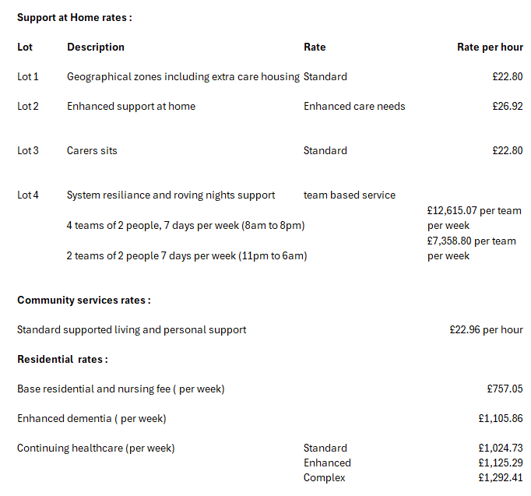
Strategic Priorities
The strategic priorities for Adult Social Care are set out in the Council Plan 2025-28
Within the Stronger Communities section of the Council Plan, “Supporting our Adults” is identified as a core priority area for North East Lincolnshire Council, strategically we are:

Supporting Adults to Live Independent Lives
Where the aim is for residents to live their best lives and people with care needs are supported to remain independent, safe, and connected within their communities.

Strengthening Community-Based Support & Prevention
This approach for North East Lincolnshire is where adult social care is integrated into wider community wellbeing, prevention, and early help with ambitions for:
- Living a healthy life
- Good & sustainable homes
- Safe and clean communities

Ensuring Safe, High-Quality Adult Support Services
As an engaging and effective Council, there are expectations for adult care services in terms of; quality, safety, workforce stability, and responsible use of public funds, the plan sets expectations around:
- Effective management of assets
- Value-for-money services
- Good governance
- Being a great place to work

Working With Partners to Support Vulnerable Adults
The Council Plan emphasises multi-agency working aligning with health, care, voluntary sector and community partners to deliver joined-up support for adults.

Commissioning Intentions
The intentions are to:

- Reduce long-term residential placements - by increasing prevention and supporting people to remain at home wherever possible.

- Expand community support, reablement, and prevention – by prioritising early intervention, reablement, and community-based support to prevent deterioration and delay the need for long-term services.

- Grow supported accommodation and extra care housing – to address the current under-provision of alternatives to traditional residential care, expanding supported living and extra care housing.

- Prioritise complex needs support (frailty, dementia, LTCs) – by ensuring services can meet increasingly complex care needs safely with rising levels of frailty and dementia.

- Strengthen workforce and provider market sustainability - to address workforce shortages and increasing pressure on services.

- Improve user experience through co-production & strengths-based practice to ensure services reflect what matters to residents and improve their overall experience.

- Strengthen neighbourhood based health and wellbeing support by focusing on neighbourhood level, community based health and wellbeing support so that adults can access help closer to home, stay healthy for longer, and remain connected within their local communities.

The councils procurement pipeline (see useful links page) is to set out our indicative procurement activities planned for the next 18 months to enable current and future suppliers to understand and identify potential opportunities.

Housing and health
New Housing options for people who also require care and support are a critical element of ensuring that people can live as independently as possible in accommodation that enables them to stay safe and healthy. The All Age Housing with Care Strategy 2025-2029 considers the housing with care options for children and young people, working age adults and older adults in North East Lincolnshire. The aim of the strategy is to bring together a set of agreed principles and actions that supports the development of accommodation for those whose needs cannot be met by general needs housing and aligns with the North East Lincolnshire Housing Strategy 2023-2028.
Housing and health are inextricably linked. As a borough we have a low value housing market, which on the one hand enables home ownership, but on the other makes it a difficult area for housing developers to generate appropriate levels of return on new build housing. We are also aware that there is a need for a more diversified housing stock able to support the changing needs of an ageing and increasingly frail population. New housing developments need to ensure that services and support are appropriately accessible to ensure that all people can access what they need, when they need it and without having to rely on personal transport. We have a local housing strategy and a more co-ordinated approach to the delivery of housing initiatives that will help people to live in a safe, connected, and supportive community. We are working closely with children’s services to identify early the housing needs of young people with disability, or health problems. Similarly, there is a need for safe and supported housing for young care leavers, or children with emotional and social support needs.

Useful Links
- North East Lincolnshire Joint Strategic Needs Assessment (JSNA): North East Lincolnshire Data Observatory – North East Lincolnshire Data Observatory ..
- Council Plan 2025–2028:. Council Plan 2025 to 2028
- Safeguarding Adults Board Annual Report SAB Annual Report 2024-25 FINAL (2)
- Adults Social Care Charging Policy https://www.nelincs.gov.uk/assets/uploads/2024/03/Adult-Social-Care-Charging-Policy-2024-25.docx
- Deferred Payment Agreement Policy https://www.nelincs.gov.uk/assets/uploads/2023/09/Deferred-Payment-Agreement-Policy-2023-2026-FINAL.docx
- Micro Commissioning Policy https://www.nelincs.gov.uk/assets/uploads/2024/05/Micro-Commissioning-Policy-2024.pdf
- Direct Payments Policy https://www.nelincs.gov.uk/assets/uploads/2024/07/Direct-Payments-Policy-24-27.docx
- All Age Housing & Care Strategy All Age Housing with Care Strategy 2025
- North East Lincolnshire Procurement Pipeline: Procurement pipeline
- North East Lincolnshire Disabled Facilities Grant: North East Lincolnshire Disabled Facilities Grant (DFG) Framework - Find a Tender
- Carers Strategy: Carers Strategy
- Talking Listening Working Together: NELC Talking, Listening and Working Together

