







North East Lincolnshire Council

Childcare Sufficiency Assessment 2025

Table of contents

Introduction

Overall Assessment, Summary and Gap Analysis
Overall sufficiency in our area

1 Demographic Profile: NEL
1.1 Geography
1.2 Population
1.3 Deprivation
1.4 Labour Market
1.5 Children in low-income families

2 Demand for Childcare
2.1 Population of EY
2.2 Population of school age children
2.3 Number of children with SEND

3 Supply of childcare
3.1 Number of EY providers and places
3.2 Vacancies
3.3 EY atypical hours
3.4 Number of school age providers and places
3.5 School age atypical hours

4 Funded Early Education
4.1 Introduction
4.2 Take up of funded places.
4.3 Funded places available
4.4 Two-year funding
4.5 Three-and-four-year funding
4.6 Availability and take up of places.
4.7 Early years Pupil Premium

5 Costs of Childcare
5.1 Cost of early years childcare
5.2 Cost of school age childcare

6 Quality of Childcare in our area
6.1 Ofsted inspection grades

Annex A - Parent Survey 2024 report.

Annex B- Childcare Sufficiency Action Plan

Introduction

The Childcare Act (2006) requires North East Lincolnshire (NEL) Council, like all other local authorities in England, to secure sufficient childcare, so far as is reasonably practicable, for working parents, or parents who are studying or training for employment, for children aged 0-14 (or up to 18 for disabled children).

The duties in the act (section 6) require the council to shape and support the development of childcare provision in NEL in order to make it flexible, sustainable and responsive to the needs of the community. This role is described as a ‘market management’ function, whereby the local authority supports the sector to meet the needs of parents, children and young people, along with other stakeholders.

Local authorities must report annually on how they are meeting their duty and are responsible for determining the appropriate level of detail in their report, geographical division, and date of publication. The report should include:
• a specific reference to how they are ensuring there is sufficient childcare available to meet the needs of: children with special educational needs and disabilities; children from families in receipt of the childcare element of Working Tax Credit or Universal Credit; children with parents who work irregular hours; children aged two, three and four taking up free places; school age children; and children needing holiday care.
• information about the current and projected supply and demand of childcare for age ranges of children, and the affordability, accessibility, and quality of provision; and
• details of how any gaps in childcare provision will be addressed.
This Childcare Sufficiency Assessment (CSA) provides evidence as to how North East Lincolnshire Council is securing sufficient childcare, so far as is reasonably practicable, for working parents, or parents who are studying or training for employment, for children aged 0-14 (or up to 18 for disabled children).
In 2004, the Government published a ‘10-year Strategy for Childcare’, to ensure that every child has the best possible start in life; whilst also providing the option for parents, particularly mothers, to work and progress their careers. The strategy covers four primary categories, which will be referred to within this CSA:

- Choice and flexibility: parents to have greater choice about balancing work and family life;
- Availability: for all families with children aged up to 14 (18 for disabled children) who need affordable, flexible, high quality childcare place that meets their circumstances;
- Quality: high quality provision with a highly skilled childcare and Early Years workforce, among the best in the world;
- Affordability: families to be able to afford flexible, high quality childcare that is appropriate for their needs.

Overall Assessment, Summary and Gap Analysis

Like many local authorities, North East Lincolnshire Council uses data from Families Information Service (FIS) as one measure of sufficiency and to gauge unmet demand. This includes enquiries and complaints received from parents who are unable to find a suitable childcare place to meet their needs. There is currently no evidence of unmet demand using this measure in NEL. However, where there is anecdotal evidence from professionals, the Local Authority undertakes more in-depth investigation to assess needs.

When deciding whether there is a need for additional places, several indicators and measures are used in the assessment. Take up levels are a primary indicator and do not in themselves indicate the need for more places. Another primary indicator is the number of places available. It does not necessarily mean that a lack of places in a particular area is affecting a family’s ability to access a place. Families are free to access a place across the authority and many travel to access a provider of their choice as not all families choose to access their funding in the area, in which they reside. In summer 2025 there was an average of 62% for 3- and 4-year-olds assessing a place in the ward, in which they live. This represents a drop of 4% since the previous year. An average of 55% of 2-year-olds and 42% of the under 2’s stay in their resident ward to access their funded hours. It is only when take up rates are also applied that we can understand whether the supply of places might be a barrier to less mobile families accessing a place. Other factors such as the location of provision in neighbouring wards, travel patterns, future housing developments etc. must be considered. These factors are all considered when carrying out secondary analysis.

Upcoming changes and expansion of funded childcare and potential gaps
The financial support that is available to parents to help with the cost of childcare has significantly increased since April 2024. Funded hours are now available to children from the term after they turn 9 months to school age with working parents, providing up to 570 hours of funded early education per year. This will expand again in September 2025, enabling working families to access up to 1,140 hours of funded early education.

The supply, demand and take up data suggest that there are sufficient places across North East Lincolnshire across the full age range. However, not all of these are in the right place or age range to meet the needs of local families. There is a potential need for approximately a further 144 PTE for the under twos across the borough.

Potential gaps for 3&4-year EYE places
The national target for this cohort is 100% for the universal offer (15hrs) and 85% of those who are eligible for the extended offer (30hrs) and if this is to be achieved a place is required for every eligible child. Data shows that in total in the summer term 2025, there were 5,612 EYE places available and an eligible population of 3,712 children which equates to 1.51 places per child within NEL.

It is projected that 48% of 3& 4-year-olds across NEL will be eligible for 30 hours in the academic year 2025-26. At ward level projections range from just 18% in East Marsh up to 83% in Wolds ward. Based on the projections, there are sufficient places available across the borough however there may be a need for additional places within some wards in the next academic year. The availability and take up of places are monitored carefully each term to manage the childcare market and to ensure the demand is met.

Potential gaps for 2-year funded places
The national target for take up of the disadvantaged 2-year funding offer is 80%. To meet this target, there is a need for at least 80 places for every 100 potentially eligible children. Currently (summer 2025) there are 164 places per 100 across NEL but these are not always in the areas of highest demand. Overall, there was an average take up rate of 65% in NEL during the academic year 2024-25 across both disadvantaged (low or no income) and the working families offer.

The number of families who are potentially eligible for the disadvantaged 2-year funding offer has been falling steadily. The projected number of eligible children was highest in summer 2016, at 55% of all local 2-year-olds. The projections for autumn 2025 suggest that an average of 34% of children will be eligible. This is a drop of 4% on the previous year.

The new cohort of 2-year-olds with working parents have been eligible for a funded place Since April 2024. Projections suggest that there could be as many as 40% of all local 2-year-olds that could be eligible for the working families offer across the borough. It is projected that an average of 74% of all 2-year-olds could be eligible for a funded place. At ward level projections range across both 2 year offers range from 63% in West Marsh and 86% in Haverstoe wards. The working offer doubles the number of hours in September so those eligible children will require two part time places to access their full hours. Current data points to there being enough places for this age range across the borough but when this is drilled down to ward level, additional places are required to meet projected demand in Haverstoe and Scartho wards

Potential gaps for under 2’s funded places
The new funding offer for working families with children under 2 was rolled out in September 2024. It had been projected that up to 42% of children from 9 months to 2 years across NEL could be eligible for a funded place in the academic year 2024-25. Early projections were based on the take up of the 2 year offer but actual take up data can now be used to assess demand for places going forward. Across NEL At ward level projections for 2025-26 range from just 13% in East Marsh up to 69% in Haverstoe ward. Based on the projections, there are sufficient places available across the borough however there will be a need to develop additional places within at least 6 wards in the next academic year. The availability and take up of places are monitored carefully each term to manage the childcare market and to ensure the demand is met.

0-14-year-old Paid for Childcare
The returns from FIS enquiries report, feedback and the parental survey do not show any unmet demand for 0-14-year-old paid for childcare in any ward within the authority. There are occasionally enquiries when no appropriate childcare is found to meet the needs of the family. In these cases, the requirements are usually very specific i.e., need pick-ups from more than one setting etc. but due to the very low number of these cases they do not warrant active intervention in the market. As the new funded offers roll out and demand increases across the age range, it is expected that there will some families who may not be able to secure the place/s they require. The Local Authority will continue to provide support and advice to families in finding suitable childcare by publishing up to date information on a regular basis. This is available to families through the Families Information service Directory and via the social media pages. The Childcare Champion for Parents is available to support families who are unable to find a suitable place. They will liaise with providers and parents to understand their needs and work towards ensuring all children who require a place are able to access one.

Other factors affecting sufficiency of childcare places.
There have been no childcare sufficiency issues within North East Lincolnshire in recent years. However, the market continues to experience some long-term impacts from the pandemic. These include.
- Changes to work patterns- many families, work patterns have changed i.e., working from home, flexible working etc. For some these changes have now become the norm meaning that they may not need as much childcare as they had previously.
- Recruitment and Retention- many settings have seen staff leave to take up roles in other sectors. Recruiting to vacant posts has also been difficult due to lack of qualified and or experienced applicants.
- Costs of living crisis- is impacting on families as well as providers. Although most providers are feeling more confident about their longer-term sustainability, some settings remain concerned about their future viability.

The early years and families information service teams continue to work closely with settings, supporting them in every way possible to meet the challenges of the issues above and ensure they remain viable. The teams are also working to raise the profile and benefits of childcare locally as well as promoting the funding options available to support families with their childcare choices.

1 Demographic Profile: North East Lincolnshire

Geography
North East Lincolnshire (NEL) is a small unitary authority covering an area of 192km. Most of the resident population live in the towns of Grimsby and Cleethorpes with the remainder living in the smaller town of Immingham, or in surrounding rural villages.

The percentage of people living in an urban environment based on the Rural-Urban Classification is 90.1% of the population of North East Lincolnshire; however North East Lincolnshire has a wide variety of parks and open spaces. On the Northern border, the Humber estuary has been designated as a Site of Special Scientific Interest and to the south, the Lincolnshire Wolds are recognised as an Area of Outstanding Natural Beauty.

The boundary of North East Lincolnshire is comprised of 106 Lower Super Output Areas (LSOAs); these LSOAs which contain a minimum population of 1,000 and a mean average of 1,500 are distributed amongst the fifteen electoral wards.

Table 1.1 The fifteen electoral wards within North East Lincolnshire

Croft Baker | Scartho
East Marsh | Sidney Sussex
Freshney | South
Haverstoe | Waltham
Heneage | West Marsh
Humberston and New Waltham | Wolds
Immingham | Yarborough
Park

A map of NEL ward boundaries, is represented below:

Fig 1.1: North East Lincolnshire with Wards
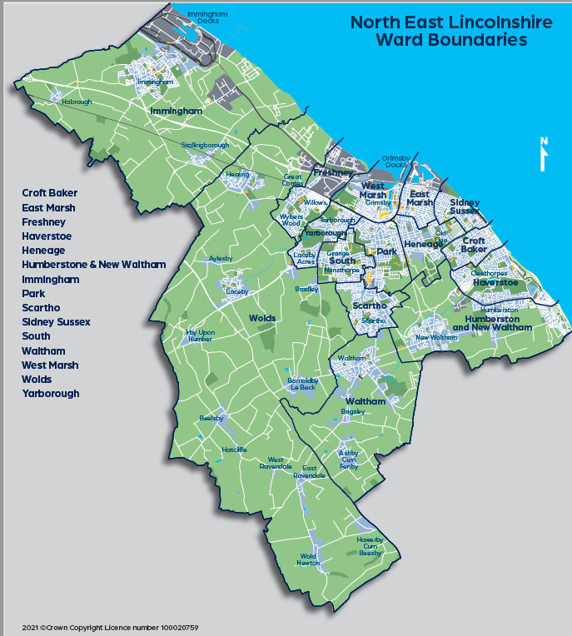

1.2 Population
In 2021, an estimated 156,900 people were living within the boundary of North East Lincolnshire. This is a decrease of 1.7% from around 159,600 in 2011. By comparison, the total population of England grew by 6.6% over the same period.

Comparing age groups to the 2011 Census shows an increase of 16.0% increase in people aged 65 years and over, a decrease of 6.3% aged 15 to 64 years, and a decrease of 2.2% in children aged under 15 years.

1.2a Population of early years children
In 2025, there are 7,578 children under the age of five living in within North East Lincolnshire. These children may require early years childcare

Table 1.2a Early Years numbers by age:
Wards | 0 | 1 | 2 | 3 | 4 | Grand Total
Croft Baker | 83 | 79 | 83 | 84 | 86 | 415
East Marsh | 121 | 150 | 147 | 150 | 165 | 733
Freshney | 72 | 76 | 62 | 69 | 94 | 373
Haverstoe | 37 | 45 | 54 | 49 | 55 | 240
Heneage | 145 | 133 | 123 | 129 | 129 | 659
Humberston and New Waltham | 95 | 114 | 88 | 119 | 83 | 499
Immingham | 87 | 91 | 105 | 107 | 108 | 498
Park | 94 | 104 | 98 | 99 | 116 | 511
Scartho | 98 | 106 | 120 | 138 | 107 | 569
Sidney Sussex | 118 | 128 | 124 | 128 | 156 | 654
South | 133 | 130 | 143 | 147 | 135 | 688
Waltham | 46 | 43 | 54 | 47 | 51 | 241
West Marsh | 113 | 110 | 107 | 119 | 127 | 576
Wolds | 62 | 56 | 69 | 86 | 67 | 340
Yarborough | 112 | 105 | 126 | 124 | 115 | 582
Grand Total | 1416 | 1470 | 1503 | 1595 | 1594 | 7578
* Some four-year-olds will have started reception

1.2b Population of school age children

The Spring School census figures in May 2025 show that there are 11,400 primary aged children attending school who live in North East Lincolnshire. These children may require childcare before and after school, and/or during the school holidays. There are also 3,700 who are in the early years of secondary education, years seven and eight, that may also require some provision.

Previous reporting was based on school age. Figures are now based on school year.

Table 1.2b School age numbers by year:
 |  |  |  |  | Primary |  |  |  | Secondary
Wards | R | 1 | 2 | 3 | 4 | 5 | 6 | 7 | 8 | 9 | 10 | 11
Croft Baker | 98 | 104 | 115 | 119 | 124 | 146 | 122 | 113 | 127 | 118 | 1108 | 112
East Marsh | 172 | 173 | 159 | 165 | 171 | 163 | 162 | 164 | 118 | 145 | 121 | 132
Freshney | 81 | 93 | 93 | 103 | 99 | 132 | 103 | 111 | 107 | 121 | 99 | 91
Haverstoe | 50 | 65 | 85 | 68 | 66 | 75 | 69 | 73 | 84 | 73 | 71 | 54
Heneage | 148 | 124 | 152 | 146 | 158 | 179 | 156 | 159 | 157 | 152 | 150 | 145
Humberston & New Waltham | 118 | 123 | 116 | 107 | 140 | 132 | 145 | 147 | 144 | 145 | 119 | 138
Immingham | 102 | 133 | 122 | 129 | 126 | 145 | 152 | 123 | 141 | 128 | 134 | 131
Park | 84 | 108 | 101 | 132 | 119 | 138 | 136 | 123 | 140 | 150 | 129 | 115
Scartho | 122 | 126 | 113 | 155 | 132 | 140 | 139 | 106 | 126 | 130 | 130 | 110
Sidney Sussex | 136 | 148 | 162 | 160 | 164 | 174 | 164 | 177 | 151 | 175 | 140 | 137
South | 159 | 161 | 162 | 180 | 211 | 197 | 176 | 180 | 182 | 177 | 157 | 166
Waltham | 44 | 39 | 65 | 73 | 60 | 60 | 54 | 45 | 54 | 48 | 38 | 50
West Marsh | 115 | 121 | 92 | 125 | 96 | 116 | 103 | 108 | 93 | 98 | 79 | 82
Wolds | 82 | 72 | 95 | 87 | 73 | 91 | 92 | 49 | 89 | 81 | 84 | 74
Yarborough | 106 | 120 | 131 | 140 | 150 | 154 | 141 | 119 | 117 | 132 | 111 | 116
Not Known | 3 | 2 | 6 | 10 | 7 | 5 | 9 | 2 | 3 | 1 | 4 | 7
Out of Area | 21 | 15 | 23 | 12 | 18 | 25 | 28 | 42 | 58 | 56 | 75 | 74
Total | 1641 | 1727 | 1792 | 1911 | 1914 | 2072 | 1951 | 1841 | 1891 | 1930 | 1749 | 1734

The overall population of ethnic minorities within North East Lincolnshire at the time of the 2021 Census was estimated at 3.8%, which is significantly lower than regional (14.5%) and national (19%) comparators; however, the school census suggests that there is more diversity in the younger age groups.

North East Lincolnshire school pupils as of January 2025 were predominantly White British (84.8%) with a small proportion from other ethnic backgrounds.

Table 1.2c: School age children by ethnicity:

Row Labels | Count | Percentage
White | 21093 | 89.7%
White - British, English, Scottish, Welsh | 19934 | 84.8%
White Eastern European | 562 | 2.4%
White European | 310 | 1.3%
White other | 123 | 0.5%
Any other white background | 51 | 0.2%
Turkish | 26 | 0.1%
White Western European | 17 | 0.1%
Portuguese | 15 | 0.1%
Roma | 13 | 0.1%
Mixed | 716 | 3.0%
Black | 569 | 2.4%
Information not yet obtained | 348 | 1.5%
Asian | 329 | 1.4%
Other | 313 | 1.3%
Refused | 98 | 0.4%
Chinese | 42 | 0.2%
Grand Total | 23508 | 100.0%

1.3 Deprivation
The Index of Multiple Deprivation, commonly known as the IMD, is the official measure of relative deprivation for small areas in England. It is the most widely used of the Indices of Deprivation. The Index of Multiple Deprivation ranks every small area in England from 1 (most deprived area) to 32,844 (least deprived area).

Fig 1.3a North East Lincolnshire with Deprivation

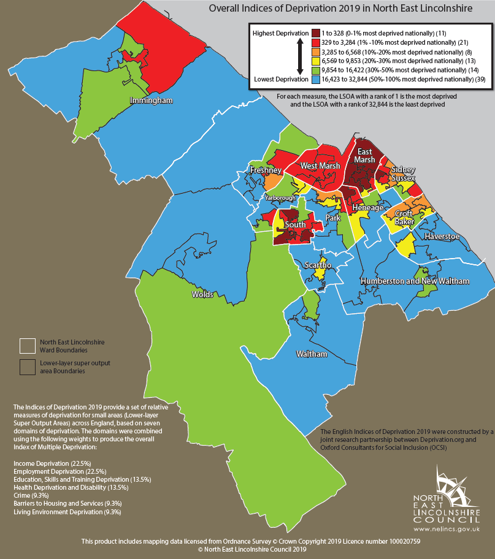

Overall North East Lincolnshire is ranked the 29th most deprived local authority in the country with some wards particularly deprived (such as East Marsh and South Wards). 11 lower super output areas within North East Lincolnshire (6 in East Marsh, 3 in South, 1 in Heneage and 1 in Sidney Sussex) are ranked in the top 1% of 32844 areas nationally for Overall Deprivation (measured across 7 domains).

Table 1.3 Summary of the percentage of LSOAs within the most deprived 10% nationally across all 7 domains
Percentage of LSOA in most deprived 10% nationally
 | Income | Employment | Education, Skills and Training | Health Deprivation and Disability | Crime | Barriers to Housing and Services | Living Environment
North East Lincolnshire | 28.3% | 24.5% | 29.2% | 15.1% | 36.8% | 1.9% | 17.9%

30.2% of LSOAs in North East Lincolnshire are in the 10% most deprived nationally, when measured against all domains.

Labour Market

Figure 1.4a Economic Activity, Economic Inactivity, Employment Rates and Unemployment Rates in North East Lincolnshire
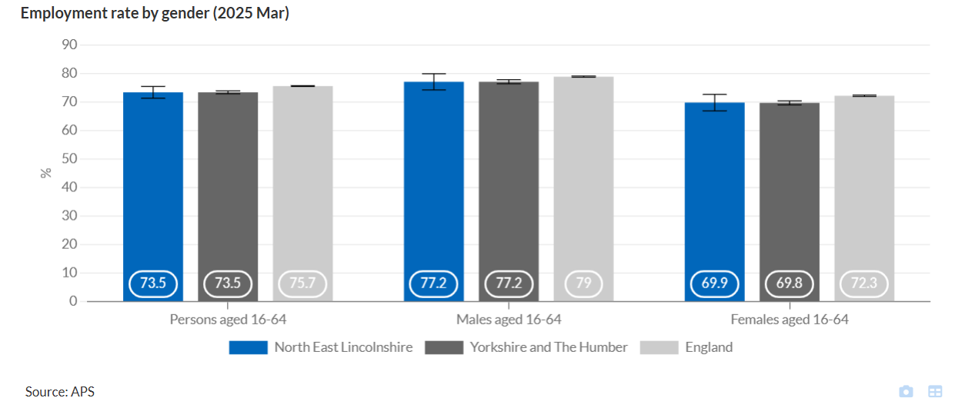

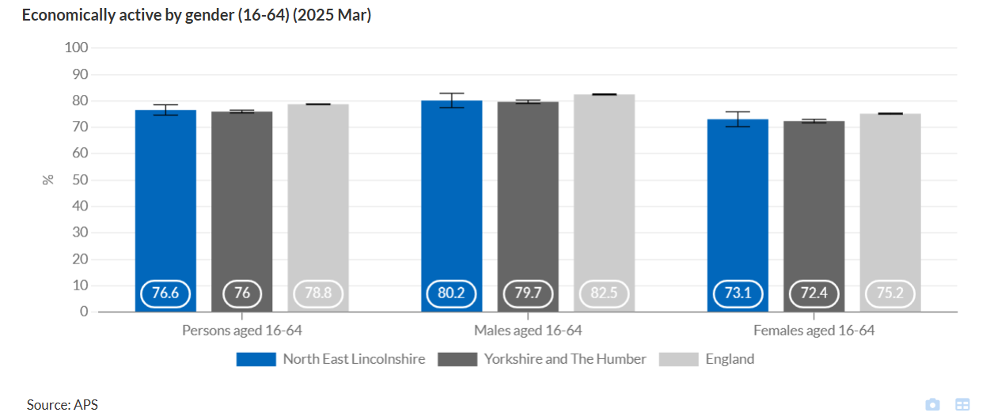

Fig 1.4b: Claimant Counts (September 2025)
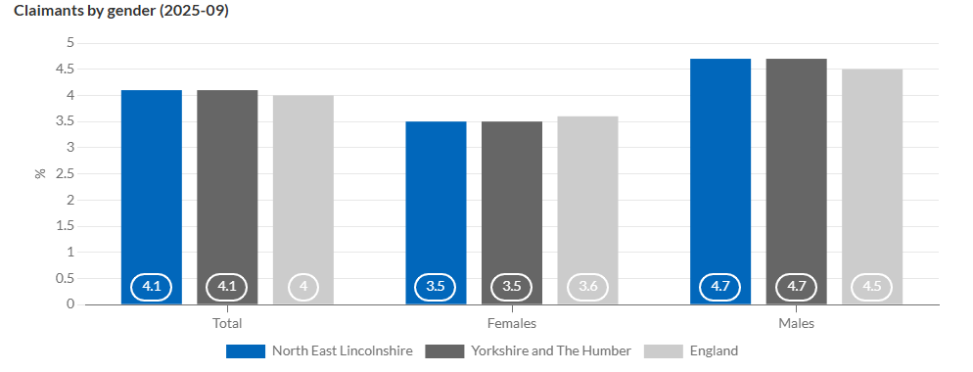

1.5 Children in low-income families
Absolute low-income families
Absolute low-income is defined as a family whose equivalised income is below 60 per cent of the 2010/11 median income adjusted for inflation. Gross income measure is Before Housing Costs (BHC) and includes contributions from earnings, state support and pensions.

Fig 1.5a: Absolute low income for North East Lincolnshire - trend
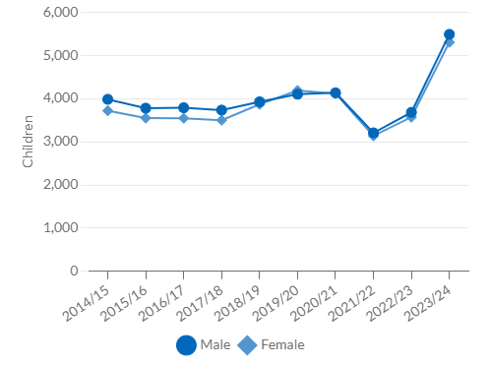

Fig 1.5b: Absolute low income by age group for North East Lincolnshire (2023/24)
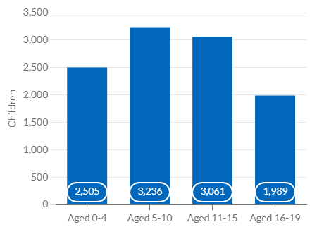
Relative low-income families
Relative low-income is defined as a family in low income before housing costs (BHC) in the reference year. A family must have claimed one or more of Universal Credit, Tax Credits or Housing Benefit at any point in the year to be classed as low income in these statistics.

Fig 1.5c: Relative low income for North East Lincolnshire – trend
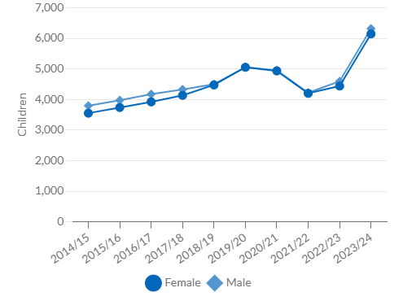

Fig 1.5d: Relative low income by age group for North East Lincolnshire (2023/24)

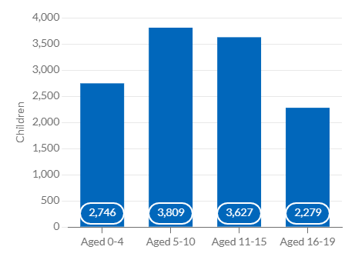

2 Demand for childcare

2.1 Population of early year’s children*

In 2025, there are 7,578 children under the age of five living in within North East Lincolnshire. These children may require early years childcare

Table 1.2a Early Years numbers by age:
Wards | 0 | 1 | 2 | 3 | 4 | Grand Total
Croft Baker | 83 | 79 | 83 | 84 | 86 | 415
East Marsh | 121 | 150 | 147 | 150 | 165 | 733
Freshney | 72 | 76 | 62 | 69 | 94 | 373
Haverstoe | 37 | 45 | 54 | 49 | 55 | 240
Heneage | 145 | 133 | 123 | 129 | 129 | 659
Humberston and New Waltham | 95 | 114 | 88 | 119 | 83 | 499
Immingham | 87 | 91 | 105 | 107 | 108 | 498
Park | 94 | 104 | 98 | 99 | 116 | 511
Scartho | 98 | 106 | 120 | 138 | 107 | 569
Sidney Sussex | 118 | 128 | 124 | 128 | 156 | 654
South | 133 | 130 | 143 | 147 | 135 | 688
Waltham | 46 | 43 | 54 | 47 | 51 | 241
West Marsh | 113 | 110 | 107 | 119 | 127 | 576
Wolds | 62 | 56 | 69 | 86 | 67 | 340
Yarborough | 112 | 105 | 126 | 124 | 115 | 582
Grand Total | 1416 | 1470 | 1503 | 1595 | 1594 | 7578
* Residents report from SystemOne NB Some four-year-olds will have started reception

2.2 Population of school age children

The Spring School census figures in May 2025 show that there are 11,400 primary aged children attending school who live in North East Lincolnshire. These children may require childcare before and after school, and/or during the school holidays. There are also 3,700 who are in the early years of secondary education, years seven and eight, that may also require some provision.

Previous reporting was based on school age. Figures are now based on school year.

Table 1.2b School age numbers by year:
 |  |  |  |  | Primary |  |  |  | Secondary
Wards | R | 1 | 2 | 3 | 4 | 5 | 6 | 7 | 8 | 9 | 10 | 11
Croft Baker | 98 | 104 | 115 | 119 | 124 | 146 | 122 | 113 | 127 | 118 | 1108 | 112
East Marsh | 172 | 173 | 159 | 165 | 171 | 163 | 162 | 164 | 118 | 145 | 121 | 132
Freshney | 81 | 93 | 93 | 103 | 99 | 132 | 103 | 111 | 107 | 121 | 99 | 91
Haverstoe | 50 | 65 | 85 | 68 | 66 | 75 | 69 | 73 | 84 | 73 | 71 | 54
Heneage | 148 | 124 | 152 | 146 | 158 | 179 | 156 | 159 | 157 | 152 | 150 | 145
Humberston & New Waltham | 118 | 123 | 116 | 107 | 140 | 132 | 145 | 147 | 144 | 145 | 119 | 138
Immingham | 102 | 133 | 122 | 129 | 126 | 145 | 152 | 123 | 141 | 128 | 134 | 131
Park | 84 | 108 | 101 | 132 | 119 | 138 | 136 | 123 | 140 | 150 | 129 | 115
Scartho | 122 | 126 | 113 | 155 | 132 | 140 | 139 | 106 | 126 | 130 | 130 | 110
Sidney Sussex | 136 | 148 | 162 | 160 | 164 | 174 | 164 | 177 | 151 | 175 | 140 | 137
South | 159 | 161 | 162 | 180 | 211 | 197 | 176 | 180 | 182 | 177 | 157 | 166
Waltham | 44 | 39 | 65 | 73 | 60 | 60 | 54 | 45 | 54 | 48 | 38 | 50
West Marsh | 115 | 121 | 92 | 125 | 96 | 116 | 103 | 108 | 93 | 98 | 79 | 82
Wolds | 82 | 72 | 95 | 87 | 73 | 91 | 92 | 49 | 89 | 81 | 84 | 74
Yarborough | 106 | 120 | 131 | 140 | 150 | 154 | 141 | 119 | 117 | 132 | 111 | 116
Not Known | 3 | 2 | 6 | 10 | 7 | 5 | 9 | 2 | 3 | 1 | 4 | 7
Out of Area | 21 | 15 | 23 | 12 | 18 | 25 | 28 | 42 | 58 | 56 | 75 | 74
Total | 1641 | 1727 | 1792 | 1911 | 1914 | 2072 | 1951 | 1841 | 1891 | 1930 | 1749 | 1734

2.3 Number of children with special educational needs and disabilities

Children have special educational needs if they have a learning difficulty which calls for special educational provision to be made for them. An Education, Health and Care (EHC) plan details the education, health and social care support that is to be provided to a child or young person who has Special Educational Needs (SEN) or a disability.

Fig 2: - Percentage of pupils getting SEN Support (2025)
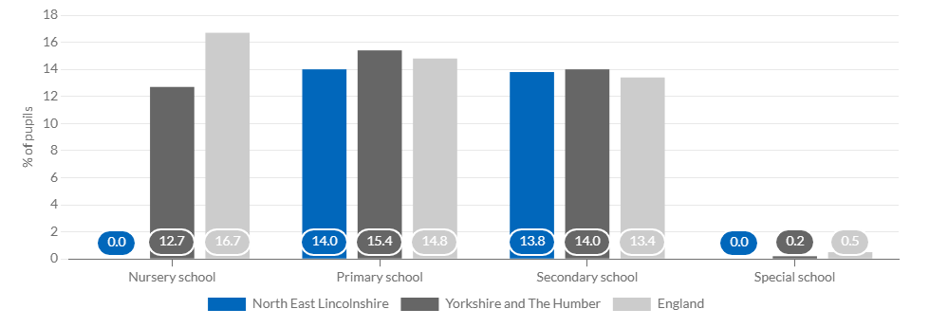

Supply of Childcare

Families use many different forms of childcare, with their choices dependent on factors that include family income, employment patterns, parental preferences, childcare availability, and the age of their children. The 2024 Childcare Survey, covering England, reported that there has been little change in the use of childcare since 2023. Overall, in 2024, almost three quarters (74%) children in England aged 0 to 4 used formal childcare. This includes formal childcare such as nurseries and childminders or informal childcare such as grandparents, friends or relatives. Over a quarter (28%) of families used informal childcare such as grandparents, friends or relatives, and older siblings.

63% of families with children aged 0-4 years used formal childcare each week. This is a slight increase on last tear

The proportion of families with school aged children ages 5-11 using formal childcare was 44% in 2024, an increase of 4% from 2023

Almost two in five parents overall (36%) felt the number of local childcare places was ‘about right’ a fall from 38% in 2023

3.1 Number of early years providers and places
In total, there are 126 providers in our local authority, offering a maximum of 3,654 (full time equivalent) early years education and childcare places: The number of providers has dropped since last year, with an overall loss of four settings. There has been an overall increase of 160 places across the borough. The majority of these are due to a new PVI provider opening and others increasing the number of places available locally.

Table 3.1a Numbers of early years settings, by type: July 2025
Wards | Childminders | Nursery classes in schools inc. academies | Maintained nursery schools | Private, voluntary and independent nurseries | Totals
Croft Baker | 3 | 3 | - | 2 | 8
East Marsh | 1 | 3 | - | 3 | 7
Freshney | 2 | 2 | 1 | 1 | 6
Haverstoe | 7 | 1 | - | 2 | 10
Heneage | 3 | 3 | - | 2 | 8
Humberston & New Waltham | 2 | 3 | - | 3 | 8
Immingham | 8 | 3 | - | 3 | 14
Park | 5 | 1 | - | 4 | 10
Scartho | 4 | 2 | 1 | 1 | 8
Sidney Sussex | 6 | 3 | - | 3 | 12
South | 2 | 3 | - | 5 | 10
Waltham | - |  | - | 2 | 2
West Marsh | - | 3 | - | 2 | 5
Wolds | 4 | 1 | - | 2 | 7
Yarborough | 5 | 2 | - | 3 | 10
NEL | 52 | 33 | 2 | 39 | 126
Table 3.1b Numbers of FTE places offered by early years settings, by type: July 2025
Wards | Childminders | Nursery classes in schools inc. academies | Maintained nursery schools | Private, voluntary and independent nurseries | Totals
Croft Baker | 11 | 85 | - | 107 | 205
East Marsh | 3 | 104 | - | 128 | 256
Freshney | 20 | 52 | 65 | 68 | 203
Haverstoe | 25 | 36 | - | 92 | 156
Heneage | 19 | 120 | - | 16 | 166
Humberston & New Waltham | 6 | 107 | - | 165 | 188
Immingham | 49 | 95 | - | 166 | 320
Park | 26 | 30 | - | 270 | 324
Scartho | 12 | 57 | 65 | 55 | 212
Sidney Sussex | 22 | 156 | - | 132 | 318
South | 6 | 78 | - | 265 | 350
Waltham | 0 | - | - | 217 | 224
West marsh | 0 | 147 | - | 92 | 224
Wolds | 28 | 8 | - | 72 | 96
Yarborough | 13 | 97 | - | 133 | 252
NEL | 244 | 1172 | 130 | 2108 | 3654

- Childminders are the greatest numbers of providers (52), However the private sector, day nurseries and pre-schools deliver the most childcare places (2,108).
- Provider numbers has decreased (3%) in North East Lincolnshire since last year.
- The number of places has increased by approximately 4.6% since last year.

3.2 Early years vacancies
Vacancy rates are a snapshot and can change rapidly. In some cases, providers may have vacancies that are only available for a specific age group, or for a particular part time arrangement. We ask providers to report vacancies to us so we can help promote them though not all choose to take up this offer. In general, vacancy rates are higher in the autumn, when children move to school.

Table 3.2 Early years vacancies
Type of provision | Number of providers | % having some vacancies
Childminders | 52 | 19%
Nursery classes in schools | 33 | 70%
Maintained nursery schools | 2 | 0%
Private, voluntary and independent providers | 39 | 59%

More settings (82%) provided their vacancy data than the previous year, which was 62%). The data provided shows that there are more vacancies available than were reported last year. Schools have seen the biggest jump in vacancies with an increase of 34% since last year, whereas Childminders are reporting a small decrease in their vacancy rate

3.3 Early years atypical hours
Childcare places are usually delivered during the typical working day – between 8am and 6pm on weekdays. Some parents require childcare outside these times to fit with their work or other responsibilities. There has been a drop in providers offering atypical hours for the second year in a row. Many providers have trialled opening earlier or staying open later but take up has been so low it is not sustainable to continue to provide the longer hours. This has also been the case for weekend opening too.

Table 3.3 The number of providers offering childcare for atypical hours in our local authority is:
Type of provision | Number of providers | Available before 8am weekdays | Available after 6pm weekdays | Available weekends
Childminders | 52 | 33 | 3 | 1
Nursery classes in schools | 33 | 1 | 0 | 0
Maintained nursery schools | 2 | 0 | 0 | 0
Private, voluntary and independent nurseries | 39 | 14 | 1 | 0

- One childminder now offers weekend care although many will consider it.
- The 2025 Parent childcare survey reported that many families find it hard to find atypical hours to meet their needs. In these cases, FIS will work with local providers and parents to find a suitable solution

The 2025 parent survey asked when families required additional childcare. Of the respondents with early years aged children, 26% needed care before 8am, 7% required care after 6pm and 1% needed care at the weekend. This is a marked decrease in need from the finding s in 2024 Parent survey.

3.4 Number of school age providers and places
In total, there are 50 providers of childcare for school age children during term time, this is a 12% increase on last year. There are now 14 providers of childcare for school age children during the holidays. This is an increase of 3 providers (21%) on the previous year. The government’s commitment to all schools having a wraparound offer by September 2026 has seen more sites considering developing before and after school clubs either by themselves or by working in partnership with another provider. Many childminders also provide care for school age children as part of their wrap-around offer.

Table 3.4 Number of school age providers
 | Breakfast club – PVI | After-school club – PVI | Holiday Club - PVI | Breakfast club – School | After-school club – School | Holiday Club - School
Croft Baker | - | - | - | 3 | 1 | -
East Marsh | - | 1 | 1 | 3 | 1 | -
Freshney | 1 | 1 | 1 | 3 | 1 | -
Haverstoe | - | 1 | 1 | 3 | 2 | -
Heneage | - | - | - | 3 | 3 | -
Humberston & New Waltham | 1 | - | - | 4 | 4 | -
Immingham | - | - | 2 | 4 | 2 | -
Park | 2 | 2 | 2 | 1 | - | -
Scartho | - | - | - | 2 | 2 | -
Sidney Sussex | 1 | 1 | 1 | 3 | 2 | -
South | 2 | 2 | 2 | 3 | 1 | -
Waltham | 1 | 1 | 1 | - | - | -
West Marsh | 1 | - | - | 3 | 3 | -
Wolds | 1 | 1 | 1 | 2 | 2 | -
Yarborough | 2 | 2 | 2 | 2 | 2 | -
NEL | 12 | 11 | 13 | 33 | 24 | -

Tracking supply of childcare for school age children is difficult because not all provision is registered with Ofsted. A large proportion of the holiday provision is based around activities which is particularly difficult to collate and reliant on private provision informing the service. The Families Information Service do encourage all providers to sign up to the directory, but many choose not to. FIS do ensure that all holiday activities we are aware of are promoted through social media even if they choose not to join the directory. The service will continue to follow a Digital by Default approach to promoting holiday activities as well as formal childcare.

3.5 School age atypical
Childcare is mostly delivered during the typical working day – between 8am and 6pm on weekdays. Some parents require childcare outside these times to fit with their work or other responsibilities. Most of this demand is met by local childminders. There has been no change in the number of providers opening earlier or closing later.

Table 3.5 The number of providers offering childcare for atypical hours in our local authority is:
Type of provision | Number of providers | Available before 8am weekdays | Available after 6pm weekdays | Available weekends
Breakfast club | 50 | 26 | N/A | N/A
After-school club | 38 | N/A | - | N/A
Holiday club | 14 | 5 | - | -

The 2025 parent survey asked when families required additional childcare. Of the respondents with school aged children, 27% needed care before 8am, 12% required care after 6pm and 8% needed care at the weekend. There has been an increase (7%) in demand for care before 8am but the later closing and weekends remains the same as the 2024 survey.

4 Funded Early Education

4.1 Introduction
The availability of good quality childcare has been recognised as being of increasing importance over the past two decades, with government policies introduced to encourage families to access good quality early education for their children. Universal entitlement to a funded nursery place for four-year-olds has been in place now for 25 years and availability and access has increased significantly in that time.
The current early years entitlements (EYE) are for 570 hours per year or 15 hours during term time and include,
- All children aged 3 and 4 are entitled to up to 15 hours per week until they start reception class in school.
- Children aged 3 and 4 where both parents are working, or from lone parent families where that parent is working, are entitled to an additional 15 hours bringing the total to 30 hours per week until they start reception class in school
- Children aged 2 whose families receive certain benefits (including low income families in receipt of in-work benefits), or those who meet additional non-economic criteria , are entitled to 15 hours per week.
- Working families with children aged from the term after they turn 9 months to 3 years are entitled to up to 15 hours per week
- A further increase in hours will be available from September 2025, when working families can access up 30 hours per week (term time offer)

The early years entitlements can be taken over a minimum of two days and no session can be longer than ten hours a day. No sessions to be taken before 6am or after 8pm; funding can be split between a maximum of two sites per day and a child is eligible to start the term after they become eligible for the funding that they wish to claim e.g. 9 months, 2 or 3 years old.

A long-term government study shows good quality early years provision has a positive and long- term impact on children’s attainment, progress, and social-behavioural development. Improvements in children’s academic and social outcomes lasted throughout school, with the effect being especially important for boys, pupils with SEND and those from disadvantaged backgrounds.

Parents do not have to use all the hours of their funded early years entitlement (EYE). They may choose to split them between providers. With the agreement of their provider, parents may also spread them across the year – for example, rather than taking 15 hours for 38 weeks a year they could take just under 12 hours for 48 weeks a year.

4.2 Take up of funded places.

The proportion of eligible children who had taken up a funded place (for at least some of the available hours) during the spring term 2025 census in our local authority is:

Table 4.2 Take up of funded places
Age | Accessing funding | % of all eligible children | 2025 national % of all eligible children
Age 2 | 410 | 73.6% | 65%
Age 3 and 4  (universal & extended offers) | 3024 | 96% | 93%
Source Education provision: children under 5 years of age, January 2025 Department of Education Jul 2025

4.3 Funded places available
Providers are paid directly by the local authority for delivering funded early education. They are not required to offer them to parents, but parents may choose to use a different provider if they do not. Some providers may offer a restricted number of funded places, term time only places whereas others have a stretched and more flexible offer available

Table 4.1b Number of providers and PTE places
Type of provision | Number of providers | 3- and 4-year-old universal (15hrs) and extended (30 hrs) places | 2-year funded places | 9 months to 2-year funded places
Childminders | 51 | 4.6% | 9.8% | 17.8%
Nursery classes in schools | 33 | 40.5% | 5.3% | 0%
Maintained nursery schools | 2 | 4.9% | 0.% | 0%
Private, voluntary, and independent nurseries | 39 | 50% | 84.9% | 82.2%
- The overall market share for 3- & 4-year-old places remains stable.
- There has been an increase in the market share of places for 2-year-olds within the private, voluntary and independent settings
- The market share of funded places for the under 2’s has been included for the first time this year

4.4 Two-year-old funding
Evidence shows that 2-year-olds in good and outstanding places - including nurseries, school nursery classes, and childminders - see benefits in terms of their early language skills, and physical, social, and emotional development.

Families with 2-year-old children can get one of two funded early education and childcare offers. These are the disadvantaged 2-year offer, and the working families offers.

Disadvantaged- families in receipt of some benefits including:
- Universal Credit, including income support, income-based Jobseeker’s Allowance (JSA), income-related Employment and Support Allowance (ESA)
- support through part 6 of the Immigration and Asylum Act

A child can also get free early education and childcare if any of the following apply:
- they are in the care of a local authority, or they’ve left care under a special guardianship order, child arrangements order, or adoption order.
- they have a current statement of special education needs (SEN) or an education, health and care (EHC) plan.
- they get Disability Living Allowance

A full list of all eligibility criteria is available at Help paying for childcare: Free education and childcare for 2-year-olds if you claim certain benefits - GOV.UK (www.gov.uk)

NEL’s Families Information Service (FIS) regularly market potentially eligible families who could be eligible for the disadvantaged offer. FIS use the data provided by the DFE and DWP to make direct contact and encourage families to apply and access a funded place. FIS also promote the offer of free places for eligible two-year-olds on their website, social media pages and with support from local providers and local family hubs.

In our local authority, 35% of 2-year-olds were potentially eligible for the disadvantaged offer in summer 2025. This equated to around 516 children per term in academic year 2024-25. There has been a decrease (3%) to the percentage of potentially eligible children from the previous academic year.

Working families offer- for parents and carers earning between £195 per week up to £100,000 per year each. In two parent households both must be employed and meet the earnings thresholds.

It is acknowledged that as summer 2024 was the very first term of the new entitlement rolling out, it was difficult to project accurately how many families would be eligible for the new working offer. The take up of the 30 hours was used as a baseline in the first instance. The offer has now been available for a full year, and projections are now calculated using actual take up data. There is the potential that some two-year-olds could be eligible for both offers.

Table 4.4 - % of eligible cohort of two-year-olds accessing a place in summer 2025
 | Disadvantaged Offer |  | Working Families Offer |  |  | Both Offers
Wards | % of potentially eligible  children | % of children taking a place | % of potentially eligible  children | % of children taking a place |  | % of children taking a place
Croft Baker | 38% | 33% | 54% | 49% |  | 82%
East Marsh | 66% | 47% | 13% | 10% |  | 58%
Freshney | 43% | 21% | 53% | 48% |  | 69%
Haverstoe | 4% | 2% | 73% | 76% |  | 78%
Heneage | 39% | 30% | 34% | 32% |  | 62%
Humberston & New Waltham | 9% | 4% | 61% | 73% |  | 78%
Immingham | 33% | 23% | 45% | 41% |  | 63%
Park | 27% | 14% | 56% | 53% |  | 67%
Scartho | 12% | 6% | 68% | 55% |  | 60%
Sidney Sussex | 44% | 30% | 39% | 29% |  | 59%
South | 51% | 37% | 28% | 18% |  | 55%
Waltham | 17% | 11% | 71% | 65% |  | 76%
West Marsh | 48% | 36% | 28% | 17% |  | 53%
Wolds | 12% | 11% | 69% | 61% |  | 71%
Yarborough | 39% | 29% | 68% | 39% |  | 68%
North East Lincolnshire | 35% | 25% | 47% | 40% |  | 65%
NEL Summer 2024 | 39% | 36% | 46% | 31% | 66%
NEL Summer 2023 | 41% | 36% | N/A
NEL Summer 2022 | 42% | 36%
NEL Summer 2021 | 43% | 35%
NEL Summer 2020 | 43% | 29%

- In summer 2025, it was projected that 35% of all resident children may meet the criteria for the disadvantaged/low/no income funded offer. The actual number of eligible children was 33% of all local 2-year-olds, equating to 93% of the projected cohort.
- Overall, 65% of all 2-year-olds in North East Lincolnshire’s accessed a funded EYE 2-year place in summer 2025.
- The take up rate of those children eligible for the disadvantaged offer was 70% and 85% of those projected to be eligible for a working family’s place accessed a funded place.
- There has been a marked decrease (15%) in take up of the disadvantaged offer and a marked increase (18%) in take up of the working offer.
- The shift in take up could be due to some families being eligible for both offers but can only access one or the other. Many may also be claiming tax free childcare (TFC). It would be easier to apply for their funded hours through the childcare account with the TFC rather than apply via the LA for the disadvantaged offer.

4.5 Three-and-Four-year-old funding
Funding for 3-and 4-year-olds has two parts:
- Universal offer - All children, the term after they reach the age of 3 are entitled to 15 hours per week until they start reception class in school.
- Extended offer - Children aged 3 and 4, where both parents are working, or for lone parent families where that parent is working, are entitled to 30 hours per week until they start reception class in school

Table 4.5 Take-up of three- and four-year-old early education places: Summer term 2025
Wards | Universal offer - % take up | Extended offer - % take up
Croft Baker | 94% | 57%
East Marsh | 84% | 16%
Freshney | 101% | 60%
Haverstoe | 103% | 83%
Heneage | 97% | 35%
Humberston and New Waltham | 94% | 72%
Immingham | 87% | 53%
Park | 97% | 60%
Scartho | 99% | 71%
Sidney Sussex | 96% | 35%
South | 93% | 37%
Waltham | 96% | 77%
West Marsh | 87% | 36%
Wolds | 95% | 81%
Yarborough | 96% | 63%
NEL | 94% | 50%
NEL Summer 2024 | 97% | 47%
NEL Summer 2023 | 95% | 48%
NEL Summer 2022 | 95% | 41%
NEL Summer 2021 | 94% | 36%
NEL Summer 2020 | 93% | 34%
*Due to cohorts obtained separately percentages over 100 can occur

- In total 97% of 3- and 4-year-olds had accessed a universal early education place during of summer term 2025. This is a decrease on the previous year.
- Take up the extended offer (30 hours) increased by 3% since summer 2024

4.6 Availability vs Take-up of Early Education Places
Each place is equal to 15 hours a week term-time (38 weeks per year), and includes all sectors i.e., childminders, pre-schools, day nurseries, schools, and academies. It does not include any reception places.
Ofsted registered settings now have more flexibility as to how they allocate their maximum number of places across the age ranges. This means that the overall number of places remains the same but the places available within each age range can change term on term to take account of the occupancy, ages and needs of the children attending.

The penetration rate is the number of places required for each of the early years entitlements. A number less than 1 reflects a deficit of places within the ward for the projected number of resident children who may be eligible for funding. Numbers over 1 reflect more places than children. Those 3- and 4-year-olds who are eligible for the extended offer will require 2 places to access the full 30 hours.

Table 4.6 Availability and take up of two-, three- and four-year-old early education places: Summer term 2025
Ward | Total number of children aged 9mths to 4 | Projected Number of PTE places required | Total number of places (15hrs) | Penetration rate | Actual take up | % Take up of places
Croft Baker | 295 | 326 | 501 | 1.70 | 262 | 52%
East Marsh | 545 | 421 | 545 | 1.00 | 341 | 63%
Freshney | 259 | 296 | 528 | 2.04 | 261 | 49%
Haverstoe | 183 | 214 | 431 | 2.36 | 190 | 44%
Heneage | 459 | 415 | 545 | 1.19 | 342 | 63%
Humberston and New Waltham | 332 | 344 | 524 | 1.58 | 276 | 53%
Immingham | 381 | 374 | 754 | 1.98 | 290 | 38%
Park | 382 | 416 | 974 | 2.55 | 342 | 35%
Scartho | 382 | 436 | 501 | 1.31 | 342 | 68%
Sidney Sussex | 509 | 503 | 857 | 1.68 | 402 | 47%
South | 525 | 464 | 1094 | 2.08 | 404 | 37%
Waltham | 167 | 199 | 805 | 4.82 | 161 | 20%
West Marsh | 430 | 370 | 530 | 1.23 | 294 | 55%
Wolds | 256 | 295 | 283 | 1.11 | 240 | 85%
Yarborough | 437 | 522 | 732 | 1.68 | 368 | 50%
Grand Total* | 5542 | 5597 | 9604 | 1.73 | 4515 | 47%
NEL Summer 2024 | 4148 | 4432 | 7737 | 1.87 | 4719 | 61%
NEL Summer 2023 | 4309 | 4522 | 7459 | 1.73 | 4404 | 59%
NEL Summer 2022 | 4506 | 7447 | 4548 | 1.64 | 4383 | 59%
NEL Summer 2021 | 4602 | 7773 | 4733 | 1.69 | 4381 | 56%
NEL Summer 2020 | 4713 | 7954 | 4989 | 1.59 | 4248 | 53%
*This now includes supply, demand, and take up data for the under 2’s for the first time.
- There is a total of 9,059 funded places available within NEL for eligible children aged 9 months to school age.
- In summer 2025, there were 7,813 early education places available to two-three-and-four-year-olds. This is an increase of 76 places on the previous year. Some providers have made changes to their funded offer in response to changes in childcare needs.
- Most funded places were available through PVI providers (74.3%).
- The penetration rate of early education places available for every potentially eligible child between 9 months and school age in NEL has decreased slightly since 2024.
- Penetration rates at ward level show that Waltham continues to have the most places with almost 5 places per eligible child available. Park ward has the second highest with 2.55 places per eligible child.
- Ideally there would be 1.2 places per child to factor in the need for additional hours for fee paying hours required.
- The penetration rates shows that there are more than enough places across the borough. However, some wards, East Marsh, Heneage and Wolds now have less than the ideal number of places per potentially eligible children. Despite this, there have been no reports of families not being able to access a place locally.

4.7 Early Year Pupil Premium
The early years pupil premium (EYPP) is additional funding for early years settings to improve the education they provide for disadvantaged children. Prior to summer 2024 EYPP was only available to 3- and 4-year-olds. From April 2024 the age range for EYPP expanded to include all funded offers. From summer 2024 all eligible 2, 3-and 4-year-olds in a funded early education place will attract EYPP funding and from September 2024 this will also include all eligible children from 9months to school age. The eligibility criteria include:
- Income Support
- income-based Jobseeker’s Allowance
- income-related Employment and Support Allowance
- support under part VI of the Immigration and Asylum Act 1999
- the guaranteed element of State Pension Credit
- Universal Credit
- they are currently in the care of a local authority in England or Wales
- they have left care in England or Wales through:
- an adoption
- a special guardianship order.
- a child arrangement order

Table 4.7 Number of children recorded as eligible for early years pupil premium by age - January 2025
 | 3- and 4-year-olds | 2-year-old | Under 2’s
England | 117,160 | 48,630 | 4,280
Yorkshire and Humber | 14,420 | 6,400 | 670
North East Lincolnshire | 457 | 220 | 26
Source; Education provision: children under 5 years of age, January 2025 Department of Education Jul 2025

Early Years Pupil Premium (EYPP) is only paid for the first 15 hours that a child attends. This will be the universal offer hours for 3- & 4-year-olds, and the working families offer. They do not have to take up the full 570 hours of early education they are entitled to get EYPP.

Children become eligible for free early education at different points in the year depending on when they turn the relevant age.

5 Costs of childcare

The Childcare and Early Years Parents Survey 2024, reported there has been very little change in the use of childcare since 2023. Overall, in 2024, 40% of children in England aged 0 to 14 had used some form of formal childcare. This is a drop of 10%, on the previous years reporting. A quarter (25%) have used informal childcare such as grandparents, friends or relatives, and older siblings.

There has been a decrease of 2%, in the number of families finding difficult/very difficult to pay for childcare. In 2024 42% of families report that they find it easy or very easy to pay for childcare.

5.1 Costs of early years childcare
For early years childcare outside the funded entitlements, we report on average prices per hour, reported to us by settings*. There may be variations to prices based on the number of hours a family uses, with reductions for longer hours, or discounts for sibling groups. There may be additional payments for additional services, e.g. lunch and other meals which are not included in these prices.

Table 5.1 Mean hourly rate of early years childcare
Price per hour* | Under 2-year-olds | 2-year-olds | 3- and 4-year-olds
Private, voluntary and independent nurseries | £7.63 | £7.14 | £6.88
School and maintained nursery schools which make charges to parents | £N/A | £7.15 | £5.20
Childminders | £5.74 | £5.72 | £5.70
Lowest | £4.50 | £4.50 | £4.00
Highest | £10.92 | £10.92 | £12.32
* Prices are averaged by number of providers, and appear above where available

Comments from the NELC Parent survey 2025
Can’t afford it even on high income we struggle
The general cost of it is really expensive. As a single mum if I didn't qualify for universal credit I'd struggle even more than I do now

5.2 Costs of school age childcare
For school age children during term time, we report on average prices per hour. There may be variations to prices based on the number of hours a family uses, with reductions for longer hours, or discounts for sibling groups. There may be additional payments for additional services, e.g. lunch and other meals which are not included in these prices.

Table 5.2 Mean hourly rate of school age childcare
Cost | Breakfast club per hour | After-school club per hour | School age childminder per hour | Holiday club per hour
Average | £3.41 | £4.50 | £5.71 | £4.20
Lowest | £0.50 | £1.00 | £4.50 | £3.00
Highest | £7.50 | £8.00 | £9.50 | £7.50

- The average costs of school age childcare have fallen over the last year except for breakfast clubs. This may be due to the ongoing support to develop more places as part of the wraparound programme.

Comments from the NELC Parent survey 2025

It’s expensive, they don’t cater for working parents outside of a '9-5’
Whist I don't use the wrap around care at the moment due to not needing it, I will do in the future when necessary. I need childcare of the holidays which is very expensive.

Not enough school holiday clubs with better hours a lot are school hours but doesn’t help for working families when you also already having to use breakfast and after school, also for the holidays for both my children is going to cost me £1483 I only work 3 days a week

The general cost of it is really expensive

6 Quality

6.1 Ofsted Inspection Grades
The quality of registered childcare in England is inspected by Ofsted, the Office for Standards in Education, Children’s Services and Skills, using standards set out in the Early Years inspection handbook. Inspected Providers receive a rating based on the effectiveness of the setting to provide good quality childcare to children. The ratings range from ‘Outstanding’ to ‘Inadequate.’ It is essential that, where possible, children should be attending provision of a ‘Good or ‘Outstanding’ rated quality.
- Nationally, two thirds (66%) of parents rated the quality of local childcare as very or fairly good

Table 6.1a Ofsted Rating January 2025 for 3- and 4-year-old children with universal EYE places:
Of those in setting with judgement - Ofsted inspection rating

 | Outstanding | Good | Percentage attending Good or Outstanding Providers | Requires Improvement | Inadequate
England | 17.7% | 80.0% | 97.7% | 1.9% | 0.4%
Yorkshire and Humber | 23.5% | 76.0% | 99.5% | 0.3% | 0.2%
North East Lincolnshire | 23.3% | 76.6% | 99.9% | 0% | 0.1%

Table 6.1b. Ofsted Rating as of January 2025 for 2-year-old children with EYE places
Of those in setting with judgement - Ofsted inspection rating
 | Outstanding | Good | Percentage attending Good or Outstanding Providers | Requires Improvement | Inadequate
England | 14.9% | 83.4% | 98.3% | 1.3% | 0.4%
Yorkshire and Humber | 20.1% | 79.3% | 99.4% | 0.4% | 0.2%
North East Lincolnshire | 15.4% | 84.6% | 100% | 0% | 0%

Table 6.1b. Ofsted Rating as of January 2025 for 9 months to 2-year-old children with EYE places
Of those in setting with judgement - Ofsted inspection rating
 | Outstanding | Good | Percentage attending Good or Outstanding Providers | Requires Improvement | Inadequate
England | 16.8% | 81.6% | 98.4% | 1.3% | 0.3%
Yorkshire and Humber | 21.9% | 77.5% | 99.4% | 0.3% | 0.3%
North East Lincolnshire | 13.4% | 85.9% | 99.3% | 0.% | 0.6%


Annex A- Parent survey 2025

Introduction
The 2025 parent survey for NEL was open during July and August. The survey went out via all social media platforms and shared with and by our childcare providers. Most responses were completed early in the survey despite it being advertised regularly throughout the time it was open. This is likely to be due to the school and family holidays.
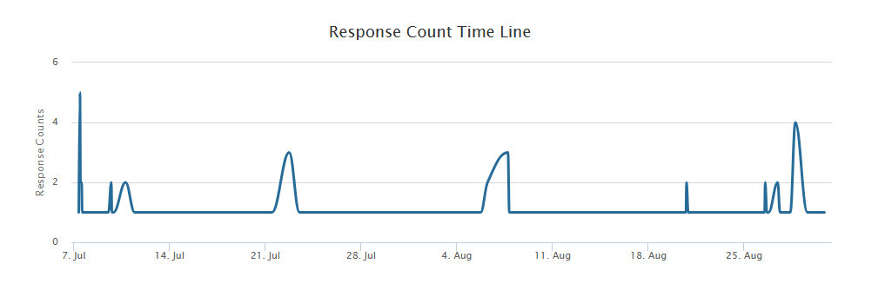

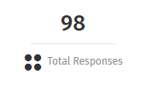

Summary
Most respondents had just one child (54%) with 39% of all having 2 children. The most represented age group was the parents /carers of Primary aged children at 32%, closely followed by families with the under 2’s (31%) 2-year-olds (12%) and secondary school age (10%)
Over half (64%) of families already use formal childcare. This is an increase from last year of 10%. For those who do not use formal childcare, not needing any was the main reason at 43%, followed by not being able to afford it at 24%.
Most families currently use childcare to enable them to work (58%) with the majority (73%) using childcare all year round. The number of families using all year-round childcare has increased by 12% since the last survey. This could be due to more families knowing about (83%) and using the stretched offer for the working families funded offers.
Over half of those responding (65%), could get the right amount of childcare required to enable them to work, train or access education. However more than half (52%) of those using wraparound childcare could not access the right number of hours to meet their needs. This overall percentage for being able to access the hours that families need has decreased slightly (2%) since the previous survey.
A high proportion of families can access the right number of hours required for them to work, train or study (73%), and to access their funded childcare offer (68%) Families who require wraparound childcare had more difficulty accessing the hours that they need with half being able to get the right number of hours, but half could not.
The main reason for not being able to access the childcare families required was that they cannot afford the hours that they need (42%). This number has reduced by 23% in the last four years. Needing atypical hours remains a barrier to getting the childcare hours that families need. Requiring childcare before 8am has increased by 20% since 2021 and is now 68%. However, needing a later finish, after 6pm has fallen since last year and is now 15%.
Over the last year, the number of hours childcare that families used has remained stable with 55% confirming they use about the same as they did last year. Just under a quarter of families reported using more childcare (22%) and 10% used less than the previous year.
- Childcare Preferences
Most families prefer their childcare to be close to home (53%) and 57% need childcare in order work, study, or train. Two thirds of families (66%) of respondents more than 15 hours childcare per week. Of those 44% required up to 30 hours and a further 22% needed more than 30 hours per week

- General Comments
The main themes from the comments included.
  - Affordability- Some respondents report still finding childcare to be expensive. Although the funded childcare offers have expanded significantly in the last few years some families are still struggling with the cost. In September 2025, the final stage of the funded childcare expansion rolls out and will enable eligible families to access up to 30 hours of funded childcare (term time offer) from the term after a child turns 9 months up to stating school.

  - Availability- The number of families requiring childcare before 8am continues to increase whereas requiring a later finish, after 6pm has decreased by 13% in the last year. Some families have reported that they have had difficulty finding a suitable place even though they have contacted providers in early pregnancy. Many have had to put names down on waiting lists at multiple providers in the hope of getting a place nearer the time. Families with school age children have reported they need more wraparound childcare., including an earlier start, later finish, and more availability during the school holidays.

  - Accessibility- Families with children with additional needs have found it difficult to access childcare places as they feel that providers do not have the knowledge and experience to meet their Childs needs.

- What next
NELC will share the results of the survey with local childcare providers and will collaborate with them to review and explore ways to increase their childcare offers to meet the needs of local families.
The Families Information service will continue to market and raise awareness of the childcare funding offers including what is available, who is eligible and how to access. The FIS web pages on the NELC website will be reviewed regularly, as will the information shared on the social media pages. This will ensure that information is clear, up to date and comprehensive for families with a specific focus on the availability of childcare and funding for local families.

The full Parent Survey 2025 report can be found at Become a childcare provider - NELC | NELC (nelincs.gov.uk)

Annex B- Childcare Sufficiency Action Plan
Sufficiency Risk | Actions to enhance sufficiency | Timeframe | Outcome
Dynamic Childcare Market | - Monitor projections and take-up  - Report on the results of the parent survey and encourage settings to consider the findings.  - Continue to promote the EY’s entitlements and raise the profile of all local childcare settings with partners and other agencies.  - Work in partnership with Family Hubs and childcare settings to maximise take-up of funded childcare | Termly reports  Annual parent survey | Dynamic childcare market that meets the needs of families in North East Lincolnshire
Sustainability of childcare sector | - Provide the highest possible base rate for early years entitlements.  - Promote financial and business support available.  - Promote existing business tools available on-line  - Provide support to enable settings to review their offer and make changes if required to meet the needs of the community.  - Ensure settings are claiming all EY’s entitlements that their children are eligible for i.e. EYPP, DAF | Termly- update projections and support settings who are claiming less than projected | The childcare sector is sustainable and able to meet the needs of families in NEL
Early Years Entitlements and help paying for childcare | - Monitor eligibility and take up across all EY’s entitlements  - Target areas where take up is low and provide marketing activities in those areas  - Attend events to promote the childcare funding options | Termly and academic year reports inform which areas to target | Enables families to access all childcare funding options and make using childcare more affordable
Information for parents | - Provide the most up to date information to parents via a range of media i.e. website, leaflets, social media platforms  - Schedule reminders of when, where and how families should apply for their childcare funding and places etc. | Ongoing scheduled posts in line with termly deadlines | Ensures families and the community are aware of all childcare funding options available to them
SEND | - Promote the SEND Local Offer  - Support parents to find suitable childcare that meets their Childs needs  - Provide a 1:1 brokerage service to those who are unable to source a suitable place | Ongoing  As and when required | Ensures children with SEND can get support and access suitable childcare



Sources of information
Early Years Entitlement team
New Oxford House,
George Street,
Grimsby
DN31 1HB

North East Lincolnshire Data Observatory NEL Data Observatory
Department of Education (DfE) Department for Education - GOV.UK

North East Lincolnshire
Childcare Sufficiency Assessment 2025
Prepared by:
Early years Entitlements Team

Title: Childcare Sufficiency Assessment 2025
Author: Early Years Entitlements Team
Published: Autumn 2025

DfE, Choice for parents, the best start for children: A ten-year strategy for childcare, December 2004
ONS, census 2021 first results. nelincsdata.net data explorer.
ONS, census 2011. nelincsdata.net data explorer.
nelincs.gov.uk wards.
nelincsdata.net Maps
ONS, census 2021 first results. nelincsdata.net data explorer.
ONS nomis. nelincsdata.net data explorer.
ONS census population change.
ONS, census 2021 first results. nelincsdata.net data explorer.
Ministry of Housing, Communities & Local Government, Index of Multiple Deprivation 2019
nelincsdata.net indices of deprivation map
Childcare and early years survey of parents, Reporting year 2024 – Explore education statistics – GOV.UK (explore-education-statistics.service.gov.uk)
This includes availability at any time during the weekend, not necessarily for the whole weekend
This includes availability at any time during the weekend, not necessarily for the whole weekend
Available to families where each parent (or one parent in a single adult household) are earning the equivalent of working sixteen hours per week on the minimum wage www.chidlcarechoices.gov.uk
Effective pre-school, primary and secondary education (EPPSE) - GOV.UK (www.gov.uk)
Provision for children under 5 in England: January 2024 - GOV.UK (www.gov.uk)
Funded early education and childcare, Reporting year 2025 - Explore education statistics - GOV.UK
The early education pilot for 2-year-old children: age 5 follow up - GOV.UK (www.gov.uk)
Available to families where each parent (or one parent in a single adult household) are earning the equivalent of working sixteen hours per week on the minimum wage
Childcare and early years survey of parents, Reporting year 2024 - Explore education statistics - GOV.UK
Childcare and early years survey of parents, Reporting year 2024 - Explore education statistics - GOV.UK
Childcare and early years survey of parents, Reporting year 2024 - Explore education statistics - GOV.UK
Childcare and early years survey of parents, Reporting year 2024 - Explore education statistics - GOV.UK
Childcare and early years survey of parents, Reporting year 2024 - Explore education statistics - GOV.UK

