Extra Care Housing Information Leaflet

Providing Housing with Care for Older People in North East Lincolnshire

What is Extra Care Housing (ECH)?

The homes are built to a high standard, meaning that people are less likely to need to move (if their care needs change, or they become less mobile and need equipment or adaptations to assist them with daily life). Individual apartments are grouped in a single building and set around communal facilities, i.e. a resident lounge, restaurant and activity rooms. Each project also includes the opportunities for additional communal spaces, such as hairdressing, and maintained private landscaped gardens.
A number of the communal facilities (and some activities) are open to both residents and people living in the local community. The wider community is encouraged to use the communal space to ensure that extra care housing schemes becomes an integral part of their local community.
Social interaction between residents in our EHC schemes is encouraged - for example by socialising in the restaurant and other communal areas, and through planned activities

that are of interest to individuals. Every individual is given the opportunity to access activities and enjoy informal social interaction with others, to ensure where possible they contribute to and help sustain the life of the ECH community.

Developments are close to main roads, and local community facilities where possible, as well as having good transport links. The aim is to enable ongoing independent living.

For people who are assessed as having an eligible need, a care team is available on-site 24 hours a day, all year, to provide care and support. This support is there to meet individual needs and ensures that the right amount of care and support is available to people to help them achieve maximum independence and have a say in how they live their lives.
The care team will also respond to an emergency with any resident, such as when someone has an accident or becomes seriously ill.
The first scheme, called Strand Court, was completed in July 2015 at Hope Street (off Albion Street), Grimsby. Another development, Burchester Court, opened November 2020 at Winchester Avenue, Grimsby. Both schemes offer 60 specially designed ECH apartments for rental and welcome interested parties to visit the scheme before registering their interest.
A minimum of a further two schemes are also planned, as NEL Clinical Commissioning Group is currently pledged to provide a total of 300 ECH flats. A show flat will be made available for viewing at every future ECH site before the scheme is completed, so people can see what is on offer and decide whether they want to apply.

The housing provider

The role of the housing provider is to manage the tenancies, including providing housing support to individuals as necessary. The housing manager organises security, maintenance and repairs in the scheme (i.e. ensuring that the scheme’s facilities are of a high standard). They also organise cleaning services to the communal areas and maintenance of the gardens and parking areas. Additionally, the housing manager has day-to-day responsibility for providing activities and making sure tenants receive appropriate housing / tenancy support.

The care provider

The care provider supplies any eligible personal care requirements, as they would under the support at home service if a person was not in extra care. The care provider is also responsible for ensuring the presence of a 24/7 “static” emergency carer on the premises.

Support is tailored to individual needs such as personal care (washing, getting up or into bed), and taking medicines. There is also a focus on supporting individuals to access the community and encouraging residents to attend activities and social gatherings onsite. The provider can sometimes also offer private calls, for example to do shopping and complete domestic duties.

Who can apply for Extra Care Housing?

Those wishing to move into an extra care housing scheme need to either:
- fill in an expression of interest form to refer themselves for an assessment and submit it to the scheme housing manager

OR
- call Single Point of Access on 01472 256256 and state they wish to apply for extra care housing.
In either case, this will trigger an extra care housing assessment. The assessment will cover the full suite of a person’s care and housing needs (physical needs, emotional and mental health needs and social needs). Those who meet the ECH criteria will be placed on the waiting list for an apartment.
Vacant apartments in a scheme are offered to people who are on the ECH waiting list and who have expressed an interest in living in that particular ECH scheme or no specific interest in any one scheme. The offer is made to an individual on the waiting list whose requirements match the vacant apartment (i.e. the need for ground floor locations, number of bedrooms, etc.).

The housing provider will make the formal offer of a tenancy to successful applicants and will make all the necessary arrangements to support them to move in at the agreed time.

Applicants who are not assessed as eligible can reapply if their needs change.

To apply for Extra Care Housing, prospective tenants must generally be 55 or over and have an identified need for housing and care. In exceptional circumstances, it may be possible for a younger person to apply.
Extra care housing criteria

The criteria used by the ICB for the allocation of places in ECH developments is based on the following main areas of need:
- Physical needs – currently assessed needs and anticipated changes in social care needs and physical health needs.
- Emotional/mental health needs – assessed needs and any anticipated changes in mental health needs, including dementia and other age-related conditions.
- Social needs – these will relate to people’s particular circumstances in relation to social contact with, and support available from, any partner or carer, family and friends and the wider community or neighbourhood in which they live.

The social worker works closely with the housing provider to support applicants and to assess their suitability. Details of any existing assessment or care services will be particularly relevant in deciding on a person’s priority for a place in an ECH scheme. People with a range of needs will be offered places, to encourage the development of an active and balanced community in each scheme.
Costs
The levels of rental charge for accommodation and the service charges for our extra care housing schemes are worked out and agreed with NEL housing benefits, to ensure they are appropriate for the accommodation in line with the local market.

The charges for accommodation and the associated services and support will include three main elements:
- Rental of accommodation – the rental charge for the actual flat and associated housing management and support.
- Service charges – a contribution to cover the cost of running and maintaining the property, including the cost of communal areas and services.
- Care charges – these will depend on individual circumstances and will be based on assessments of each person’s care needs and their financial circumstances, in exactly the same way as for people living in their own homes in the community. Not all residents of ECH will have a formal care package.
Home care, rental and part of the service charges are eligible for housing benefit support - the support, if applied, may fully cover these costs or partially cover them. However, there is a non-eligible element of the service charge that tenants will need to meet themselves.

Extra Care Housing Schemes
STRAND COURT
Hope Street
GRIMSBY

DN32 7AZ

Housing management: Inclusion Housing
Care provider: Hales Home Care
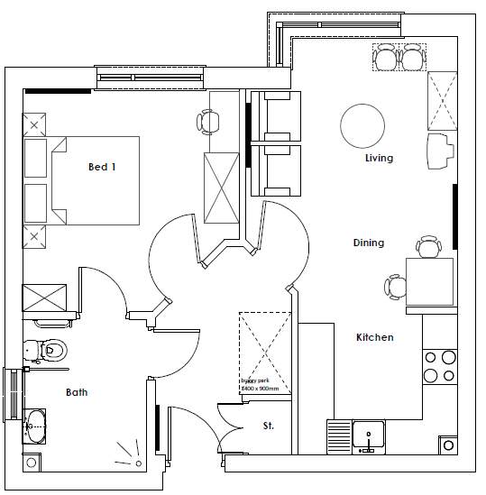
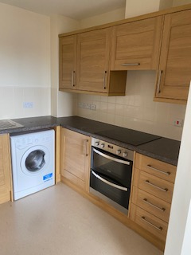

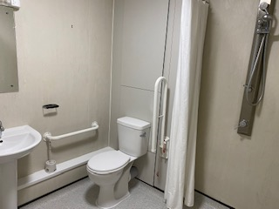

Facilities onsite:
Strand Court has an onsite café, hairdressers, laundry and buggy store.
Catering facilities
The restaurant is available daily (6 days a week, 8:00am – 2pm) serving a wide variety of hot meals and snacks, sandwiches and a range of hot and cold drinks. Menus can be tailored to suit individual requirements and food can be pre-ordered to take up to your own home. The service is managed by Hug a Mug a private business.
Care services
The service is delivered by Hales Home Care (Hales). Support is tailored to eligible individual needs such as personal care (washing, getting up or into bed), and taking medicines. Hales can also offer private calls, for example to do shopping and complete domestic duties. Hales care staff also support individuals to access the community and encourage and support residents to attend activities and social gatherings onsite.

Activities
External organisations offer a range of meaningful activities. The café and housing manager also runs events such as fish and chip evenings, quiz nights, etc. As this offer is continually changing, please speak to the housing manager for details on the current activity offer.

Resident’s Association
Strand Court has a residents’ association which meets to discuss elements of life at Strand Court that are of interest to residents. They also organise various activities, i.e. bingo prizes, name cards etc. The residents raise funds through these activities and use the funds to organise other events and to improve their surroundings (e.g. buying plants and gardening equipment).

Charges

Weekly rental charge (as of April 2025 – reviewed annually)
- One-bedroom flat £476.65 per week
- Two-bedroom flat £498.44 per week
In both cases, the full costs are eligible for housing benefits support.

In addition to the above charges there is a £21.95 for a one-bedroom and £22.17 for a two-bedroom weekly charge (that is ineligible for housing benefit contributions), per apartment, to be met by all tenants for gas, water etc. Residents will pay for their electricity charges separately.

Contacts
For more information or to express an interest in moving to Strand Court, please contact the Scheme Manager
Derrick Rodwell
07703 825369 or 01472 808033
derrick.rodwell@inclusiongroup.co.uk.
You can also call SPA on 01472 256 256 to request an extra care assessment for Strand Court.

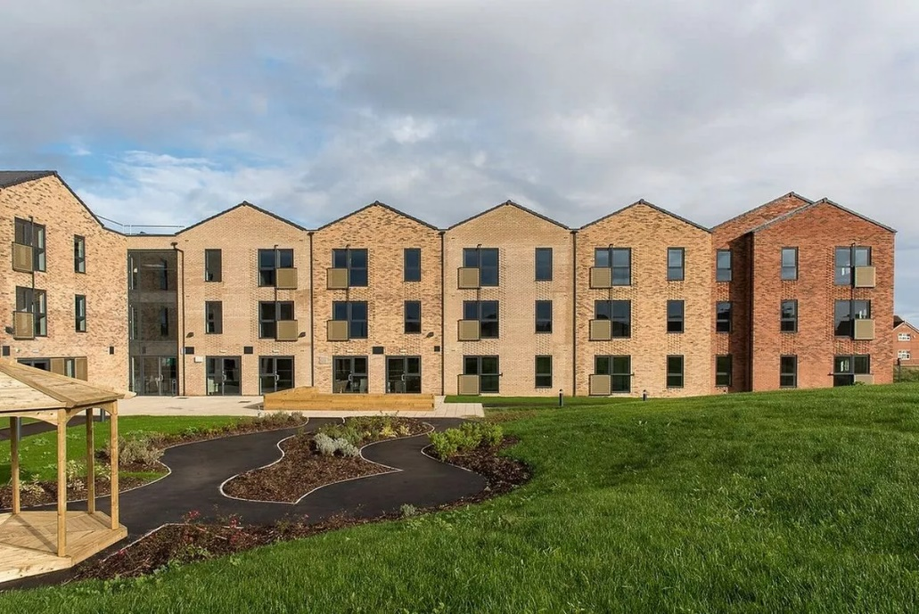
BURCHESTER COURT
Winchester Avenue
GRIMSBY
DN33 1BU


Housing management: Places for People Living +
Care provider: Willows Homecare

Flat layouts
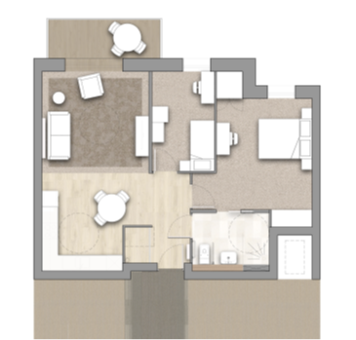
1 bedroom 2 bedroom

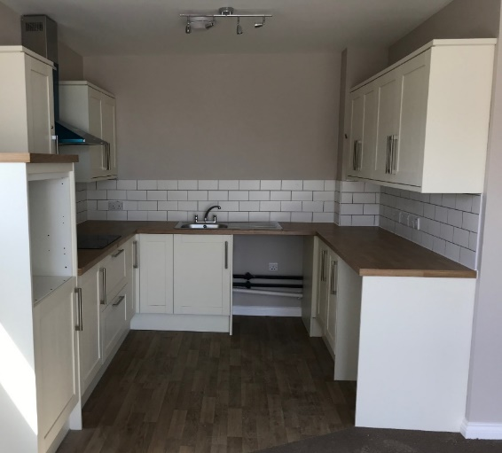
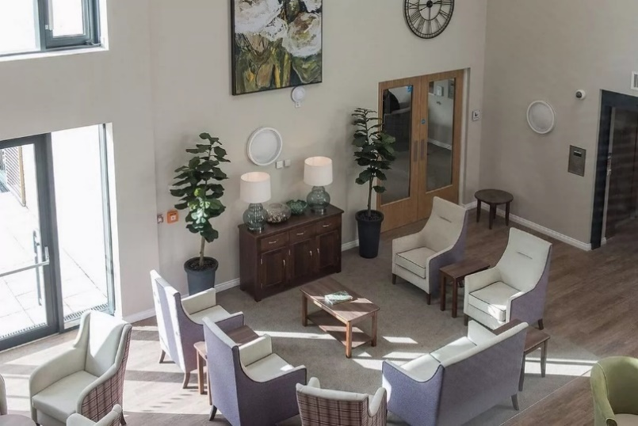
Facilities onsite:
- Entrance lobby
- Main lounge
- Quiet lounge
- Dining room
- Hairdressers/treatment room
- Hobby / reminiscence room
- Buggy store
- Accessible WC
- Secured terraces
- Laundry
- On-site parking and drop off
- Courtyard terrace and garden
- Guest suite (double bedroom with ensuite)
- Care provider’s office and building manager’s office plus staff rooms
- Café
- Assisted bathroom with bath
- Buggy storage

Catering facilities
The restaurant is available daily serving a wide variety of hot meals in the evening and snacks, sandwiches and a range of hot and cold drinks throughout the day. Menus can be tailored to suit individual requirements and food can be pre-ordered to take up to your own home. The service is managed by the Catering Academy, a national provider.
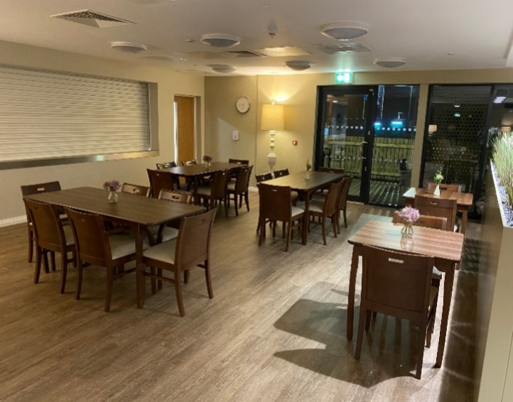
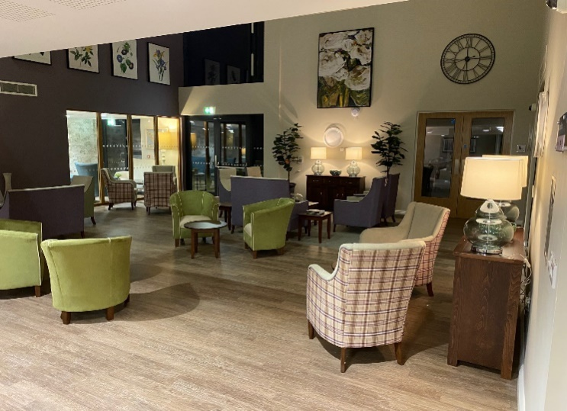

Care services
The service is delivered by Willows Homecare. Support is tailored to eligible individual needs such as personal care (washing, getting up or into bed), and taking medicines. Willows can also offer private calls, for example to do shopping and complete domestic duties. These care provider staff also support individuals to access the community and encourage and support residents to attend activities and social gatherings onsite.

Activities
External organisations offer a range of meaningful activities. The café and housing manager will also provide a range of activities on site to support community inclusion for residents. As this offer is continually changing, please speak to the housing manager for details on the current activity offer.

Resident’s Association
Burchester Court has a residents’ association which meets to discuss elements of life at Burchester Court that are of interest to residents.

Charges
Weekly rental charge (as of April 2026 – reviewed annually)
- One-bedroom flat £360.86 per week
- Two-bedroom flat £405.87 per week
In both cases, the full costs are eligible for housing benefits support.

In addition to the above charges, there is a £10.89 charge weekly for 3 meals provided by the onsite cafeteria. All tenants are also responsible for their own gas, electric and water (guru meter in flats) and council tax.

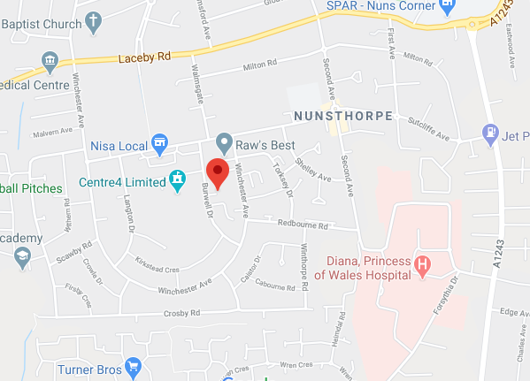
Contacts
For more information or to express an interest in moving to Burchester Court, please contact Places for People’s Burchester scheme.
01472 873 395 Tracey.Greetham@placesforpeople.co.uk

You can also call SPA on 01472 256 256 to request an extra care assessment for Burchester Court.

Frequently asked questions:
Can people on benefits move into the Extra Care homes?
Yes they can. There will be a weekly rent and service
charge, set in-line with what is already charged locally.
We are working with the local housing benefits officers to
make sure prospective residents can afford it.

Who will provide people with the care they need?
The care and support services in the Extra Care scheme
will be provided by the organisation already commissioned
to provide home care services in the zone within the local area. In Strand this is Hales and in Burchester this is Willows.

An emergency care response will be available 24 hours a day; otherwise, care will be provided in line with the care package as it would be in the general community.

Who will run the site?
Inclusion Housing is the landlord for Strand Court. Places for People is the landlord for Burchester Court.

For general information, including ECH development plans and related issues, please contact Amy Tristman (Nel Health and Care Partnership) in the following ways:
Telephone: 07702657465
Letter: Municipal Building, Town Hall Square, Grimsby DN31 1HU
Email: amy.tristman@nhs.net

