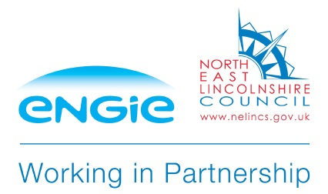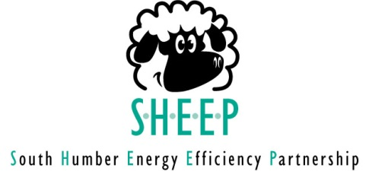

Partner Referral Form – ECO Funded Measures
The SHEEP Scheme can access funding through our partners for energy efficiency upgrades for householders that meet the ECO eligibility criteria. If you think you or a resident of the property may qualify, please complete this form and return it to the council in the freepost envelope provided:
Name: _______________________________________________
Address: _______________________________________________
_______________________________________________
Postcode: _______________________________________________
Tel: _______________________________________________
Energy saving measure required:
□ Loft insulation □ Cavity wall insulation
□ External wall insulation □ Electric storage heaters
□ Boiler upgrade □ First time central heating system
Resident Type:
□ Homeowner
□ Private Renting Tenant

(Landlord Name: ____________________________________ Landlord Tel:____________________ )
Household Information:

Please provide name and date of birth for each occupant:

Name: ________________________________________ Date of Birth: _________________________

Name: ________________________________________ Date of Birth: _________________________

Name: ________________________________________ Date of Birth: _________________________

Name: ________________________________________ Date of Birth: _________________________

Name: ________________________________________ Date of Birth: _________________________

Household Monthly Income: £__________________ Please note confirmation of this will be required.

Does a member of the household suffer from any cold related diagnosed health condition made worse by living in cold conditions?

□ No
□ Yes (please give details) Please note proof of any cold related health condition will be required.

___________________________________________________________________________________

___________________________________________________________________________________

Does a member of the household receive any of the following benefits?
□ Pension Credit - Guarantee Credit
□ Income Based Jobseeker's Allowance
□ Income Support
□ Income Based Employment and Support Allowance (ESA)
□ Child Tax or Working Tax Credit
□ Universal Credit
□ No Benefits Received

Please note that there are various pots of funding available, some of which do not require the householder to be in receipt of a benefit. However, you should complete this form as fully as possible to ensure you can be considered for all the funding currently available.

____________________________________________________________________________

DECLARATION:

The information recorded will be held in accordance with the Data Protection Act 1998. The data will not be passed on to any third party other than the organisations working in partnership with North Lincolnshire and North East Lincolnshire Council to deliver energy efficiency measures.

By submitting this form you have confirmed that the resident is happy for the details recorded on this form to be shared with North Lincolnshire and North East Lincolnshire Council and their partners.

Signature: ______________________________

Date: ______________________________

March 2017 Version 1.1

Energy Company Obligation (ECO): Part 1 - privacy notice, Part 2 - consent statement

Part 1 – Privacy Notice

Your personal information that will be collected and shared includes:
- Your full name, date of birth and address and contact details.
- Proof of identity.¹
- Where required: the Department for Work and Pensions (DWP) will provide a YES/NO response via the Energy Savings Trust to verify whether or not you or a member of your household are in receipt of the relevant benefits to be eligible for support under the ECO scheme.
- Where required: Copies of documents showing proof of benefits and income supplied to you by the DWP and HMRC, this will be limited to information relating to your entitlement to assistance.
- Where relevant: the amount of any financial contribution towards the cost of the installation.

To check eligibility and gain funding for the Energy Company Obligation (ECO) scheme and to check that a supplier is meeting its obligations under the scheme we need to collect and share your information with other organisations including:

- Where required: The DWP Scheme Organisations including:
- The Office of Gas and Electricity Markets (Ofgem) who will share your information in order to fulfil its statutory duties as well as with the installer of the measure (on request) in order to verify whether it has been notified to Ofgem. Ofgem may share your information with third parties contracted to carry out audits on behalf of Ofgem and the promoting energy company.
- The installation company and companies supporting the installation such as building specialists, software providers, guarantee companies, technical monitoring agents, the installer’s accreditation body, local authorities or their intermediaries/contractors; and charities, social housing providers, building control inspectors, the property owner or managing agent (where applicable), and the energy company promoting the measure.

Company Details
Type of company (delete as applicable):
[ installation company/ lead generation company/ energy company/ / other (please specify) ]

Full Name of company²:

Full Company address:

Tel no: | Email:
Name of person completing this form with customer: | Signature:

- This may be collected to evidence a supporting component for benefit evidence.
- Notes:(1) s.4, paragraph 2(3)(a), of Part II to Schedule 1 of the Data Protection Act 1998 requires that any fair processing notice explicitly sets out the identity of the data controller. As such, once this is known, the data controller’s details should be inserted here; (2) as from 25 May 2018, consumers should be provided with the data processing information required by article 13 of the General Data Protection Regulation (GDPR). A such,this version 1.0 of the privacy should not be relied upon after 25 May 2018, as it requires updating to capture the new requirements of the GDPR.

ECO Reporting Working Group document. May not be accepted if amended.
March 2017 Version 1.1

Part 2 - Consent Statement
Customer Details – please note that separate consent forms must be provided for each individual whose information will be shared. For example the Help to Heat Group member providing eligibility and the named individual on the Declaration of Completed Conformity handover must provide separate consent forms unless they are the same person.
Title: |  |  | First Name: | Surname: | Date of Birth:
Type of customer: Main applicant Benefit recipient
 |  | Other (please specify) ______________________
Full Customer Address:

Tel no: Email:
Access to your information and correction
You have the right to request a copy of the information that we hold about you. If you would like a copy of some or all of your personal information, email or write to us using the details listed in the company details section above. We may make a small charge for this service. We want to make sure your personal information is accurate and up to date. You may ask us to correct or remove any information you think is inaccurate.
Security of the information provided
All organisations which collect and use your information under ECO are bound by the provisions of the Data Protection Act 1998 including requirements for keeping your details secure.

a) Checking eligibility
I understand that you need to check that I am eligible for the ECO scheme:

I agree to any of the ECO scheme organisations contacting me to verify the information I have provided.

Where applicable to confirm that I am on a qualifying benefit:
I agree to my information being shared with the Department for Work and Pensions via the EST to confirm whether I am in receipt of a qualifying benefit.

b) Checking the installation
I understand my information may be shared with the scheme organisations listed above to:

- Arrange surveys required and the installation.
- Check the installation meets the requirements of the scheme and the appropriate installation standards.
- Carry out a customer satisfaction survey to look at how their services or the delivery of ECO can be improved. You don’t have to take part in these surveys but your feedback would be appreciated.
Signature: | Date:

If you change your mind before any installation is completed you can withdraw from the ECO scheme by contacting the company listed above. Please note that once your measure has been installed you are unable to withdraw your consent for your data being shared under the scheme.
Your information will only be used as the law allows. To find out more about how Ofgem uses information: Ofgem’s ECO Privacy Policy can be found at: www.ofgem.gov.uk/publications-and-updates/ECO-privacy-andinformation-use.
ECO Reporting Working Group document. May not be accepted if amended.

