Taken from Anglian Water Customer Charge Scheme 2017-18:
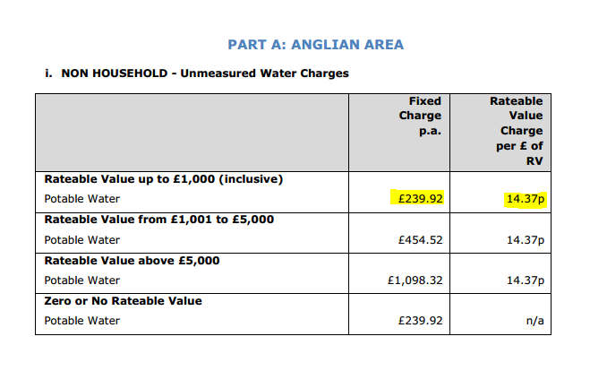
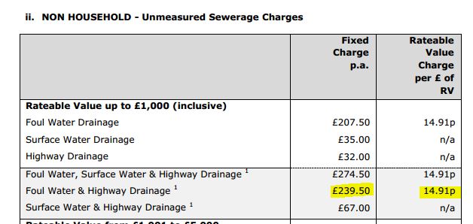

Fixed Charge £479.42
RV Multiplier £0.2928

