MUNICIPAL WASTE MANAGEMENT STRATEGY

NORTH EAST LINCOLNSHIRE COUNCIL

Final as approved by Cabinet 27th October 2008 and subject to supplementary policy added 3rd August 2009

Executive summary
All activities generate waste which needs to be collected, managed and disposed of. The amount of waste is increasing because the rate of growth is directly related to the UK’s economic performance, as measured by its Gross Domestic Product (GDP). The Government is seeking to improve resource efficiency and thereby break the link between increased economic performance and waste production.
North East Lincolnshire Council is responsible for the collection, recycling and disposal of municipal solid waste (MSW) in North East Lincolnshire. This consists mainly of waste generated by households. A 25 year contract was signed with Newlincs Development Ltd (Newlincs) in December 1999 and as part of this contract, Newlincs have constructed a combined heat and power (CHP) facility which is able to treat about 48,000 tonnes per year of MSW.
North East Lincolnshire Council published a waste strategy - “No Time To Waste” – in December 2004. This identified the need to increase the amount of waste which was recycled and many of the initiatives which were outlined in that strategy have now been implemented; these enabled North East Lincolnshire Council to exceed its Government target of recycling 21% of household waste in 2005/06 and achieve a household waste recycling rate of 26% in 2006/07. That strategy recognised that even with the use of the CHP facility, North East Lincolnshire Council will not be able to meet its future landfill targets if the amount of municipal waste continued to grow.
North East Lincolnshire Council has adopted a policy which will require its waste strategy to be reviewed every three years. This review coincided with the publication of the new national waste strategy for England in May 2007. This updated waste strategy for North East Lincolnshire takes account of the main aims of the new national strategy; waste minimisation, increasing recycling, recovering more energy from residual waste and only using landfill for waste where necessary
North East Lincolnshire Council’s preferred approach for meeting the aims of the new national waste strategy on waste minimisation and recycling is to meet or exceed the following targets:
- A reduction in the growth rate for MSW (currently 2% per year) to 1.5% per year by 2012 and to 1% per year by 2017. This is a challenging target as the number of households (which is one of the two factors which affects waste growth) is expected to grow by 0.7% per year over this period.
- A household recycling rate of 35% by 2010 (this is an increase of nine percentage points on the recycling rate achieved in 2006/07).
- A recycling rate target of 40% by 2015.
This will be initially achieved through:
A long-term publicity/education campaign which will aim to encourage households to reduce the amount of waste that they produce and to increase the amount of waste which is recycled
The expansion of the kerbside scheme for the collection of garden waste to all appropriate households.
These initiatives, together with other planned initiatives, should enable the 35% recycling target to be achieved by 2010.
North East Lincolnshire Council recognises that there is currently a strong level of public opposition to the introduction of alternate weekly collection of residual dustbin waste and has ruled this option out.
North East Lincolnshire Council is already recovering energy from residual waste using its CHP facility. To meet the aims of the national waste strategy on recovering energy from waste and only using landfill for residual waste where necessary, the following target has been set:
- Stop landfill of any biodegradable MSW by 2020 at the latest, with the aim of achieving this by 2015.
Achieving this target will require additional treatment capacity. North East Lincolnshire Council’s current preferred approach, is to use a second CHP facility located at the same site as that used for the current CHP facility. This is based on its assessment of current treatment technologies, their costs and the risks associated with them, North East Lincolnshire Council will continue to assess other options and will make a final decision on how to achieve this aim before the next review of the waste strategy in 2010.
North East Lincolnshire Council recognises the importance of regular consultation with stakeholders, particularly members of the public, to take into account a wide range of factors and views on the waste strategy. The public consultation for the strategy, as well as for the Strategic Environmental Assessment (SEA) will be completed in 2008.
North East Lincolnshire Council will publish a yearly progress report outlining the progress made in meeting the aims and targets identified in this waste strategy.
The next review of the strategy in 2010 will assess progress towards meeting the waste minimisation and recycling targets. It will identify any additional measures required to achieve the longer term aims for waste minimisation, the recycling rate of 40% by 2015 and 1% waste growth by 2017. It will also report on progress towards the aim of zero landfill of any biodegradable MSW.
There will be further consultation when the next review of the waste strategy is conducted in 2010.

Contents

Executive summary 2
Contents 3
1 Introduction 3
1.1 The purpose of this waste strategy 3
2 Legal Requirements and Guidance 3
2.1 European waste Policy and Legislation 3
2.2 UK waste POLICY and Legislation 3
2.3 Waste strategy for England 3
2.4 planning Policy guidance 3
3 Where are we today 3
3.1 Waste collection AND RECYCLING 3
3.1.1 Regular Collection of Household Waste, dry recyclables and green waste 3
3.1.2 Community Recycling Centres 3
3.1.3 Bring Recycling 3
3.1.4 Bulky Household Waste Collection 3
3.1.5 Clinical Waste 3
3.1.6 Commercial and Industrial Waste Collection 3
3.1.7 Street Cleansing 3
3.1.8 Abandoned Vehicles 3
3.1.9 Fly-tipped waste 3
3.2 Waste arisings 3
3.3 Waste composition 3
3.4 Amount recycled 3
3.5 Waste Disposal 3
3.6 Current cost 3
4 What do we need to do 3
4.1 The challenges we face 3
4.1.1 Waste Emissions Trading Legislation 3
4.1.2 Growth in waste arisings 3
4.1.3 Future management of residual waste 3
4.2 The options we considered 3
4.2.1 Waste minimisation and future waste growth rate 3
4.2.2 Increasing recycling 3
4.3 proposed approach to meeting these challenges 3
5 How we plan to implement actions 3
5.1 Roles and responsibilities 3
5.2 Possible PARTNERSHIPs with neighbouring authorities 3
5.3 Waste reduction/re-use 3
5.4 Improving recycling 3
5.5 Requirements for new capacity 3
5.6 IMPACT OF THE WASTE STRATEGY ON OUR CARBON FOOTPRINT 3
5.7 How we plan to keep this programme on track 3
6 Appendix 1 – Glossary of Terms 3
7 APPENDIX 2 – LEGAL REQUIREMENTS AND PLANNING GUIDANCE 3
8 Appendix 3 - Sources of further information 3
9 appendix 4: Current Policies 3
10 appendix 5: pOLICIES FOR RECCOMMENDATION AND CONSIDERATION 61

Introduction
North East Lincolnshire is an area of diversity and opportunity. It is situated on the east coast of England at the mouth of the Humber estuary and covers an area of 74 square miles (192 sq km). The Humber sub-region is considered to be a “Global Gateway” offering significant economic opportunities. It is an area that presents challenges as well as future potential. It includes the port towns of Grimsby and Immingham, the seaside of Cleethorpes, a range of villages of varying size and composition and the attractive landscape of the Lincolnshire Wolds.
The total population of the Borough is 158,900 - of which 1.4% is from minority ethnic communities. The population comprises approximately 71,000 households - less than 6% are in areas which could be described as rural. Over the next 20 years the population is predicted to increase by a little over 5,000 people. This is the first projected increase for many years. By 2009, older people are expected to outnumber children in North East Lincolnshire and by 2026 people of 50 years or older are expected to represent 44% of the total resident population.
Overall North East Lincolnshire is the 49th most deprived council area in England. However, this masks differences across the Borough. Some of the Borough’s wards are amongst the most disadvantaged 20%, highlighting pockets of deprivation in the urban area.
Chemicals, manufacturing, port activities and food processing have formed the main economic base of the Borough since the decline of the fishing industry. The twin ports of Immingham and Grimsby are of international trading significance, providing the economic gateway to the region as well as the rest of the world. Unemployment is higher than regional and national averages and gross earnings are lower than in the rest of the Yorkshire and Humber Region. Tourism accounts for a significant number of local jobs equating to 7% of the total.
All activities generate waste which needs to be collected and managed before final disposal. North East Lincolnshire Council is responsible for collecting, recycling and disposing of municipal solid waste (MSW), which mainly consists of waste produced by households. Other waste streams e,g, from commercial and industrial premises, demolition of old buildings and from agriculture ,are handled mainly by private sector waste management companies.
There are increasing concerns about sustainable development across the world: global warming (methane gas from landfill sites), natural resource depletion (the “throw away” society) and environmental pollution (emissions to land, water and air). The outcome is recognition at International, European and National levels that large-scale reliance on landfilling of waste is unsustainable. There is a need to reduce the burden of waste on the environment by producing less, making better use of the waste that is produced and becoming less reliant on landfill for management of the remaining waste. This has resulted in the introduction of legislation at European and national levels which gives a much higher priority to waste prevention, minimisation, recycling, composting and recovery and making disposal to landfill the least acceptable option.
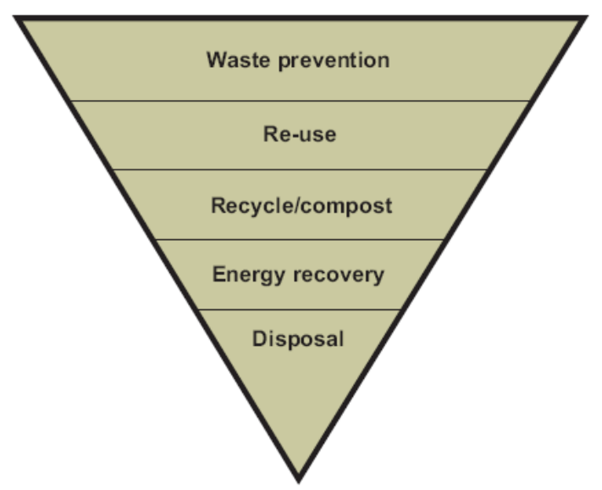

The purpose of this waste strategy
Following a local government reorganisation in 1996, North East Lincolnshire Council became responsible for the management of MSW operations across the borough. In December 1999, a 25 year Integrated Waste Management Contract and partnering agreement was agreed with Newlincs Development Ltd (Newlincs). The agreement between Newlincs and North East Lincolnshire Council provides for a forum where open discussion, the exchange of information and generation of ideas to solve problems strengthens the partnership.
As part of the process for procuring the contract, a Best Practicable Environmental Option (BPEO) assessment for managing future waste was conducted. This showed that the use of an Energy from Waste facility, which operated as a combined heat and power (CHP) plant, was the most environmentally beneficial option for managing municipal solid waste in North East Lincolnshire. NewLincs constructed a CHP facility at Immingham and this started operating in 2004.
North East Lincolnshire published a waste strategy - “No Time To Waste” – in December 2004. This identified the need to increase the amount of waste which was recycled. Many of the initiatives which were outlined in that strategy, such as expansion of the dry recyclables kerbside collection scheme to all properties, have now been implemented; these enabled North East Lincolnshire to exceed its Government target of recycling 21% of household waste in 2005/06 ( and achieve a household waste recycling rate of 26% in 2006/07). The strategy recognised that even with the use of the CHP facility, North East Lincolnshire would not be able to meet its future landfill targets if the amount of municipal waste continued to grow.
North East Lincolnshire Council has adopted a policy which will require its waste strategy to be reviewed every three years. The Government published its new waste strategy in May 2007 and North East Lincolnshire Council is assessing options for meeting the new requirements. Consequently, the objectives of North East Lincolnshire’s updated municipal waste strategy are:
- To develop a more sustainable system of waste management, promoting waste minimisation in the first instance, encouraging re-use and recycling and minimising the quantity of waste disposed of without recovering value from it
- To meet the challenging targets set by Government to recover value from waste and set in place arrangements to divert increasing amounts of biodegradable waste from landfill
- To ensure that “Best Value” principles are applied and to secure an economic, efficient and effective waste management service
- To meet the increasing expectations of residents.

This new draft waste strategy has been developed by officers and elected members of North East Lincolnshire Council in consultation with stakeholders. It:
- Outlines the current and future legal obligations that the Council will need to meet
- Describes the waste management services that are currently provided
- Identifies any changes that will need to be made to meet future legal obligations
- Describes how North East Lincolnshire Council plans to meet these by increasing the amount of waste which is recycled and minimising the amount of residual waste that is landfilled
- Explains how North East Lincolnshire Council plans to implement this programme.

There will be a public consultation on the draft waste strategy.
It is important to note that new legislation will require improvements in the management of all waste streams. However, as North East Lincolnshire Council is only responsible for MSW, the plans for any new recycling facilities and treatment facilities described in this strategy only cover this waste stream. North East Lincolnshire Council understands that MSW only accounts for 5% of the overall waste stream nationally, and will therefore, proactively seek partnerships with other sectors where economies of scale will provide increased economic and environmental benefits to the local community.

Legal Requirements and Guidance
This chapter outlines the main legal requirements regarding waste management that North East Lincolnshire Council either already has to meet or will need to meet as new legislation and requirements are introduced. It then considers the legislation regarding planning for any new recycling and waste management facilities which will be required to enable North East Lincolnshire in meeting future targets.

European waste Policy and Legislation
The European Commission has become the major source of environmental legislation and guidance in relation to the management of waste. A number of European Directives have been introduced which aim to increase levels of recycling, recovery and reduce the amount of waste which is landfilled:
- Framework Directive on Waste (75/442/EEC)
- Landfill Directive (1999/31/EC)
- Directive on Packaging and Packaging Waste (94/62/EEC)
- Waste Electrical and Electronic Equipment Directive (2002/96/EC)
- End of Life Vehicles Directive (2000/53/EC)
- Ozone Depleting Substances (Regulation 2037/2000)
- Directive on Batteries (2006/66/EC)
- Waste Incineration Directive (2000/76/EC)

The main area of European legislation that this waste strategy has to consider is the Landfill Directive. This aims to prevent, or minimise, the negative effects on the environment and human health caused by landfilling of wastes. It has and will continue to have a significant impact on landfill practices in the UK as it bans certain materials from being landfilled, requires waste to be pre-treated before it is landfilled and requires improvements to landfill management. The introduction of the Directive has resulted in a significant reduction in the number of landfill sites in the UK accepting hazardous wastes. The ban on landfilling of certain wastes, such as tyres, from 2006, has meant that new arrangements for their collection and management have been introduced.
Landfilled biodegradable waste is a major source of methane, a greenhouse gas over 20 times more potent than carbon dioxide in terms of climate change. The Landfill Directive will require the amount of biodegradable municipal solid waste sent to landfill in the UK to be reduced to:
- 75% of 1995 levels by 2010
- 50% of 1995 levels by 2013
- 35% of 1995 levels by 2020

The Government has implemented the requirements for landfilling of biodegradable waste through the Waste and Emissions Trading Act 2003. This sets Waste Disposal Authorities (such as North East Lincolnshire) annual allowances limiting how much biodegradable municipal waste (BMW) can be landfilled in any particular year with effect from April 2005. The Government will fine Authorities that do not achieve their annual targets. Authorities can buy and sell allowances from other Waste Disposal Authorities if they expect to landfill more, or less than their allocations.
This waste strategy outlines how North East Lincolnshire Council intends to meet or exceed these targets, in order to avoid the need to pay fines or purchase allowances.
Information on the other relevant EC legislation that North East Lincolnshire Council’s waste strategy has to consider can be found in Appendix 2.

UK waste POLICY and Legislation
Although most waste legislation in the UK has been introduced to meet the requirements set by European Directives, the UK Government has also introduced additional legislation, some of which is specifically aimed at encouraging recycling:
- The Financial Act 1996 and Landfill Tax Regulations 1996
- Waste Minimisation Act 1998
- Local Government Act 1999 – Best Value Regime
- Animal By-Products Order and Regulations 2003
- Household Waste Recycling Act 2004
- Clean Neighbourhoods and Environment Act 2005.

The main area of national legislation which this waste strategy has to consider is the Landfill Tax Regulations, a tax payable for each tonne of waste sent to landfill. It was introduced by the Government in 1996 as a way of encouraging more sustainable means of waste management through recognition of the hidden financial effects of the environmental impact of landfill. The landfill tax is currently £32/tonne. Before the budget in March 2007 the increase had been £3 per year. The budget announced that the increase would be £8 per year from April 2008 until at least 2010/11, resulting in a level of £48 per tonne in the 2010/11 financial year. This increase in landfill tax will cause a significant increase in waste disposal costs and will provide a further incentive to move to more sustainable means of waste treatment.
This waste strategy outlines how North East Lincolnshire Council intends to further reduce the amount of waste which is landfilled.
Information on the other relevant national legislation that North East Lincolnshire Council’s waste strategy has to consider can be found in Appendix 2.

Waste strategy for England
The Government first published a national waste strategy in 2000. The Prime Minister’s Strategy Unit reviewed the progress towards the targets set within Waste Strategy 2000 in 2002. The report suggested that “Waste Strategy 2000” may not be sufficient to move waste onto a more sustainable footing and the Government established the Waste Implementation Programme to address the recommendations made by the Strategy Unit.
An updated waste strategy for England was published (following consultation during 2006) in May 2007. The aim of this updated Waste Strategy, which sets the Government’s vision for sustainable waste management, is to reduce waste by making products with fewer natural resources, breaking the link between economic growth and waste growth. Products should be re-used, their materials recycled, energy from waste recovered and landfill of residual waste should occur only where necessary. More information on the national waste strategy for England can be found in Appendix 2.
This waste strategy outlines how North East Lincolnshire Council will meet the aims of the national strategy.

planning Policy guidance
North East Lincolnshire Council has a statutory duty to prepare a development plan for the Council’s policies. These include proposals for:
- land use
- transport
- the environment
- planning applications for development in accordance with the development plan.
Planning policy and waste management are inextricably linked to the development of future infrastructure for waste management in the UK. Planning decisions will influence whether or not the UK will be able to meet the landfill diversion targets set by the Landfill Directive.
Planning Policy Statements (PPS) set out the Government’s national policies on land use planning in England. The following documents will have an impact on planning for any future waste management facilities in North East Lincolnshire:
- PPS 10: Planning for Sustainable Waste Management
- Regional Spatial Strategy and the Yorkshire and Humber Plan
- Local Development Framework – Minerals and Waste Development Plan.
Information on the development of these can be found in Appendix 2. Any new waste management facilities which are required to implement this waste strategy will need to meet the planning requirements and policies set out in these documents.

Where are we today
There are a number of bodies that have responsibilities for waste management. These are:
- European Policy – Environment Directorate of the European Commission
- National Policy – National Government (DEFRA and the Department for Communities and Local Government)
- Regional Policy – Regional Assemblies
- Collection and Disposal - Waste Collection Authorities (WCAs) and Waste Disposal Authorities (WDAs)
- Regulators – The Environment Agency and The State Veterinary Service.
The Community sector has a role to play in waste management through their activities in minimisation, re-use and recycling schemes.
As North East Lincolnshire is a Unitary Local Authority, under the requirements of the Environmental Protection Act 1990, it acts as the Waste Collection Authority (WCA) and the Waste Disposal Authority (WDA) for MSW in North East Lincolnshire. The Council has to ensure that all the requirements set by legislation on waste have been implemented. They coordinate with the voluntary sector on their provision of re-use and recycling schemes and liaise with the Regulators to ensure that the waste management services it provides do not cause damage to either human health or the environment.

Waste collection AND RECYCLING
North East Lincolnshire Council provides the following services for waste collection and recycling.

Regular Collection of Household Waste, dry recyclables and green waste
Household waste - 69,279 households have been provided with a 240 litre wheeled bin and the remaining 1949 households have communal facilities, all receive a weekly refuse collection.
Dry recyclables – Households receiving the kerbside collection service for dry recyclables are provided with three recycling containers; blue for paper, green for glass and red for cans. These are collected fortnightly. The service covered 40,000 households in April 2006 and was expanded to cover all 71,228 households during 2007.
Garden waste – Households receiving the garden waste collection service are provided with a 240 litre wheeled bin for collection of garden waste and cardboard. The service covered 42,036 households in March 2007. There are plans to extend this service in 2008/9

Community Recycling Centres
There are currently two community recycling centres (CRC) in Grimsby and Immingham managed by NewLincs Development Ltd.
These provide facilities for collecting garden waste and a range of dry recyclable materials. Sites accept small quantities of construction and demolition waste and are also registered for the collection of Waste Electrical and Electronic Equipment.

Bring Recycling
North East Lincolnshire Council provides recycling banks at 46 locations (excluding those at the two community recycling centres) for residents who wish to deposit glass, textiles, cans, newspapers and magazines, plastic bottles and books (some sites do not have facilities to collect all of these materials).
A list of all recycling locations, including the two community recycling centres, is available at
http://www.nelincs.gov.uk/environment/recycling/North_East_Lincolnshire_Council_Recycling_Banks.htm

Bulky Household Waste Collection
North East Lincolnshire Council collects bulky items and excess household waste which may be unsuitable for collection as part of your normal weekly refuse collection service. A charge is made for this service. Details of charges and a list of items which are be collected by this service is available at:
http://www.nelincs.gov.uk/environment/rubbishcollection/bulkywaste/Additional+Waste+Collection.htm

Clinical Waste
Clinical waste is collected free of charge from domestic households. It is also collected from healthcare premises on a chargeable basis. This service is operated by North East Lincolnshire Council in partnership with the Primary Care Trust who arranges referrals.

Commercial and Industrial Waste Collection
North East Lincolnshire Council currently provides a ‘Trade Waste’ collection service. Approximately 617 premises are serviced by agreement and are charged for this service. The frequency of collection and the volume of material collected vary.

Street Cleansing
North East Lincolnshire Council provides a regular service throughout the area. Additional resources to the Mechanical and Manual sweeping teams (Beat Teams) inspect every street on a fortnightly basis and clean if required.

Abandoned Vehicles
Abandoned vehicles are removed in accordance with relevant legislation. This service is provided by North East Lincolnshire Council through an appointed vehicle recovery agent.

Fly-tipped waste
North East Lincolnshire Council collects fly-tipped waste. It investigates the waste source and takes enforcement action if it can be identified.

Waste arisings
The Waste Framework Directive identifies the following waste source arisings as controlled waste:
- MSW
- commercial premises;
- industrial premises
- construction and demolition (C&D)
- Certain agricultural wastes (this only covers a small percentage of total agricultural waste).

The overall arisings of waste in England are estimated to be about 330 million tonnes per year. Figure 1 shows the estimated proportion produced by each sector. This includes nearly 100 million tonnes of minerals waste from mining and quarrying not subject to control under the Waste Framework Directive and nearly 220 million tonnes of controlled wastes from households, commerce and industry (including C&D). Household wastes represent about 9% of the total.

Figure 1: Arisings of waste in England
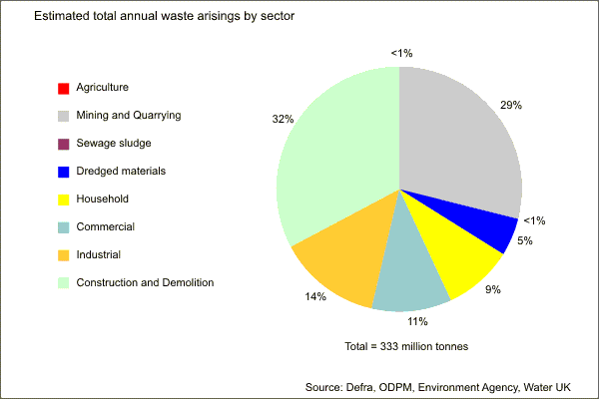

Waste from the agriculture sector represents less than 1% of total arisings. This waste, which excludes manure, slurries and straw, came under the same legislative controls as other controlled wastes in May 2006. Manure and slurry, which do not come under the new controls, were estimated as 45 million tonnes in 2002/03. If this waste is included in the total waste figure, the amount of waste produced in the UK in 2002/03 was 375 million tonnes.
Based on data provided by the Environment Agency, North East Lincolnshire generated an estimated 540,000 tonnes of controlled waste in 2006/07. This represented less than 0.3% of the total controlled waste in England. Municipal waste (94,000 tonnes) represented about 17% of total controlled waste arisings in North East Lincolnshire.
MSW in the UK includes all waste under the control of local authorities or agents acting on their behalf, which means all household waste, waste arisings from municipal parks, garden wastes and council office waste. It also includes any waste collected by local authorities from businesses. Although North East Lincolnshire Council has to manage all MSW, the Government sets targets for household waste, which includes waste collected from:
- household collection rounds, dry recyclables collected through banks or kerbside collections, bulky waste collections, hazardous household waste collection, garden waste collections,
- services such as street sweeping, litter and civic amenity sites.

The arisings of household waste in North East Lincolnshire in 2006/07 were 87,500 tonnes. This figure is lower than the MSW arising of 94,000 tonnes because it excludes waste streams such as trade waste collected by North East Lincolnshire Council and rubble collected at the Community Recycling Centres.
The main source (see Figure 2) of household waste in North East Lincolnshire is that collected from households (this includes material collected by the kerbside recycling schemes). This currently represents about 80% of total household arisings. Waste taken to the Community Recycling Centres (CRC) represents 15% of household waste and the other sources of household waste, such as litter, street sweepings and bulky household waste collections represents about 5%.

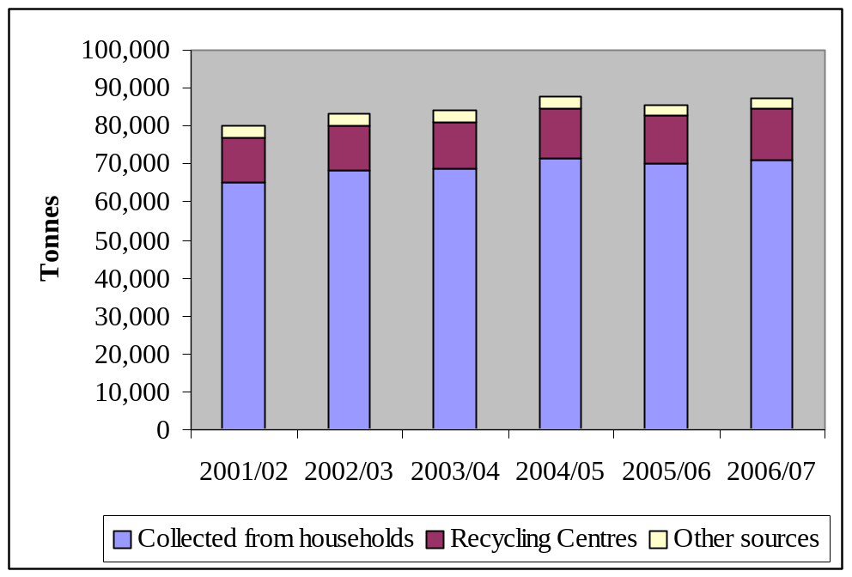
Figure 2: Sources of household waste arising in North East Lincolnshire

The graph shows that the total amount of household waste has increased from 79,900 tonnes in 2000/01 to 87,500 tonnes in 2006/07. This is an average increase of 2% per year over the last five years, and is over twice the average growth rate of less than 1% for year for household waste arisings in England.

Waste composition
shows the typical composition of household waste arisings. Not all material in the potentially recyclable categories can be recycled. For example, although dense plastic represents 4% by weight of household waste arisings, only half (2%) of this is plastic bottles that can be collected for recycling.

Figure 3: Composition (weight %) of household waste
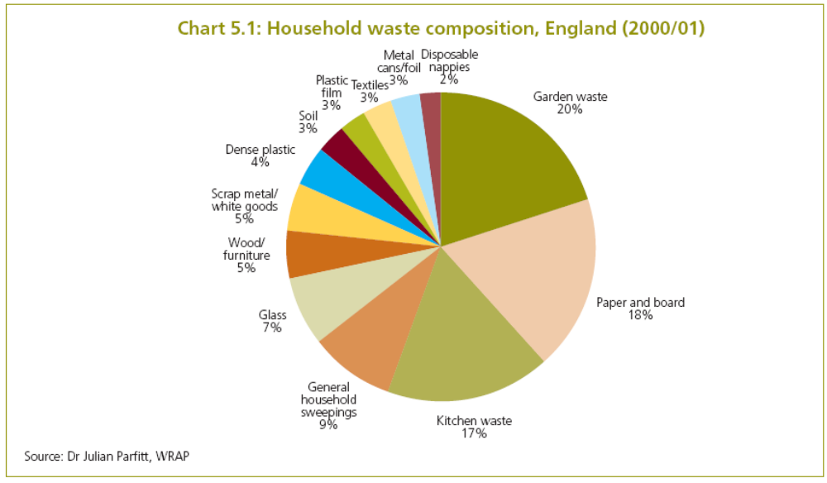

Although about two thirds of MSW could potentially be targeted for recycling, a number of factors, such as the availability of markets and the level of public participation in recycling services, mean that it will be a significant challenge to achieve long-term recycling targets of over 40%.
It is important to note that household waste has a high proportion of biodegradable wastes; i.e. waste that breaks down under biological action to produce greenhouse gases and is therefore the primary target of new waste legislation which is designed to reduce emissions of greenhouse gases.
The data on waste composition will inform implementation of the strategy through better targeting of recycling and composting programmes. However, North East Lincolnshire Council recognise that it may be necessary to conduct waste analyses later in the period of this strategy to assess progress towards meeting the targets set in the strategy.

Amount recycled
Figure 4 shows how the arisings of household waste in North East Lincolnshire have been managed since 2001. The proportion of household waste which is either recycled or composted has increased from 10% in 2001/02 to 26% in 2006/07. In 2006/07, 23,000 tonnes of household waste was either composted or recycled.

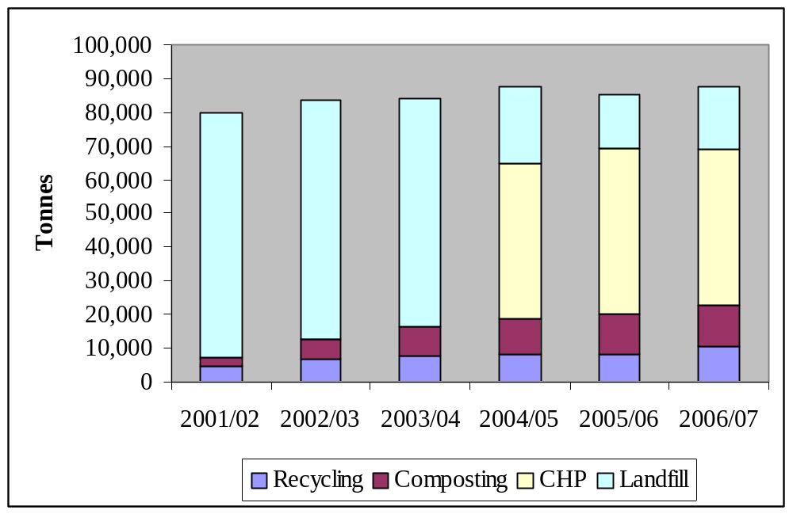
Figure 4: Management of household waste in North East Lincolnshire

The combined heat and power (CHP) facility started operating in April 2004 and treats approximately 48,000 tonnes per year of household waste. 17,000 tonnes of household waste was landfilled in 2006/07.
North East Lincolnshire Council was set Government targets for recycling household waste of 14% in 2003/04 and 21% in 2005/06. Both these targets were exceeded; the household waste recycling rate achieved was 19% in 2003/04 and 24% in 2005/06 (as compared to 27% for England in 2005/06).
The expansion of the fortnightly dry recyclable collection scheme to all 71,228 households during the second half of 2006/07 should enable North East Lincolnshire Council to achieve a household waste recycling rate of 30% in 2007/08. Options for further increases in the percentage of household waste which is recycled are discussed in the next chapter of this strategy.

Waste Disposal
Following the formation of the Council in 1996, North East Lincolnshire Council assumed control of waste management operations across the borough. At that time, the Authority disposed of its waste at the Immingham and Winterton landfill sites, operated by Wastewise, the Local Authority Waste Disposal Company (LAWDC). Wastewise was vested as a private limited company by the former Humberside County Council and was part owned by each of the unitary authorities formed as a result of local government reorganisation. North East Lincolnshire Council’s contract with Wastewise ceased in December 1999.
Subsequently, a new twenty-five year Integrated Waste Management Contract was agreed with Newlincs Development Ltd (Newlincs), which expires in December 2024 and includes a partnering agreement. Newlincs receives all waste that is collected by North East Lincolnshire Council, including household waste, waste from the community recycling centres and recyclables. Newlincs are responsible for:
- Identifying markets for the dry recyclables (such as newspapers & magazines)
- Sorting the garden waste to remove contaminants and then shredding it prior to delivery to the on-farm composting facility at Doncaster.
- Operation of the combined heat and power (CHP) facility at Immingham. This generates electricity and heat is used by a neighbouring factory. The bottom ash and metal from this plant are recycled.
- Landfill of the remaining waste. This is sent to the Immingham landfill, which has a remaining lifetime of approximately 20 years (an estimated 2 million cubic metres of capacity).

The partnering agreement formed between Newlincs and North East Lincolnshire Council provides for a forum where open discussion, the exchange of information and generation of ideas to solve problems strengthens the partnership.

Current cost
The budget for waste collection, recycling and disposal in 2006/07 was £9.4M. These costs translated into the following Best Value Performance Indicators for 2006/07:
- BVPI 86 (annual cost of waste collection) - £34.26 per household
- BVPI 87 (annual cost of waste disposal) - £73.89 per tonne of municipal waste
This is equivalent to an average Council Tax payment of about £133 per household for collection and disposal. The average household produces over one tonne of waste per year. This equates to £2.56 per week.

What do we need to do
Although North East Lincolnshire continues to increase the amount of waste which it recycles, it needs to set a way forward for managing future arisings of MSW. This chapter identifies the challenges that North East Lincolnshire Council faces and its proposed approach to meeting these challenges.

The challenges we face
North East Lincolnshire Council’s main challenge will be to meet longer-term requirements set by the Landfill Directive on reducing the amount of biodegradable waste that is landfilled. The European Commission will be able to fine Member States (including the UK) who do not meet their targets and the level of this fine is currently 500,000 Euros (about £350,000) per day. Meeting the longer-term challenge set by the landfill Directive will be made more difficult if the amount of waste that is produced continues to increase.
North East Lincolnshire Council will need to meet the requirements set by the Government’s new performance framework of 198 measures representing what the Government believes should be the national priorities for local government, working alone or in partnership, over the next three years. These replaced all other sets of indicators, including Best Value Performance Indicators and Performance Assessment Framework indicators, from April 2008.
The new measures on environmental sustainability included three which are discussed in this waste strategy:
- NI 191 Residual household waste (kg per person)
- NI 192 Household waste recycled and composted (Wt %)
- NI 193 Municipal waste landfilled (Wt %).

Other measures on environmental sustainability which are relevant to the waste strategy are:

- NI 185 Carbon dioxide reduction from Local Authority operations
- NI 195 Improved street and environmental cleanliness (levels of graffiti, litter, detritus and fly posting)
- NI 196 Improved street and environmental cleanliness – fly tipping.

North East Lincolnshire Council will assess options for increasing the current level of street cleaning and will continue to take enforcement action against fly tippers if the source of the waste can be identified. Reducing the amount of waste landfilled will reduce carbon dioxide emissions and the impact of this is considered later in the waste strategy.

Waste Emissions Trading Legislation
The UK Government has implemented the requirements of the Landfill Directive through the Waste Emissions Trading Act 2003. This spreads the responsibility for meeting the Landfill Directive target between all authorities and each authority has been set targets for the amount of waste that it can landfill each year to 2020. The targets for North East Lincolnshire Council are shown in Error: Reference source not found and if every authority meets its target, the UK will not have to pay any fines to the European Commission.
The targets (or allowances as they are referred to) set by the Government are based on MSW rather than household waste and assume that MSW contains 68% of biodegradable material by weight. The initial allowance for biodegradable municipal waste (BMW) disposal in North East Lincolnshire was set at 53,000 tonnes in 2005/06. This equates to an effective landfill limit of approximately 78,000 tonnes of MSW. This annual allowance diminishes each year until 2019/20 when the prescribed limit for North East Lincolnshire reaches 16,100 tonnes of BMW or 23,700 tonnes of MSW.

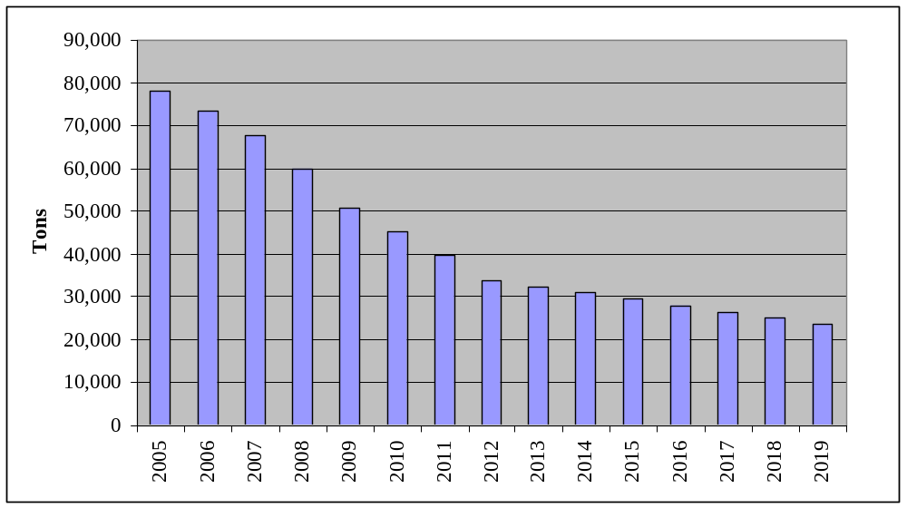
Figure 5: North East Lincolnshire’s landfill allowance targets

In 2006/07, North East Lincolnshire landfilled about 23,000 tonnes of MSW. This improved on the target of 73,500 tonnes for 2006/07 and is due to achieving a household waste recycling rate of 26% in 2006/07 and the treatment of residual waste in the CHP facility.
The Waste Emissions Trading legislation enables the UK Government to fine authorities that do not meet their yearly targets. The level of this fine is £150 for each tonne of biodegradable waste above the specified limit that is landfilled. The Government has recognised that some authorities, such as North East Lincolnshire, are already easily meeting their allowances because they have installed a suitable treatment plant. However, other authorities will not be able to meet their longer-term targets until they have installed a suitable treatment facility to treat the remaining waste. Consequently, the legislation enables allowances to be traded between authorities. The aim of the trading of allowances is to enable authorities to meet their obligations through purchasing allowances at a lower cost than the cost of paying a fine to the Government, but the cost of the allowances could approach the level of the fine if demand is high.
Although North East Lincolnshire Council comfortably met its landfill allowance target in 2006/07, the amount of waste that can be sent to landfill in future years will reduce and the amount of waste that is produced will increase. This will make it more difficult to meet the longer-term challenge set by the Landfill Directive and put North East Lincolnshire Council at risk of significant financial penalties.

Growth in waste arisings
Historically, waste arisings have been shown to grow in line with, or even above, the level of economic growth. Consequently, if this trend continues, a 3% p.a. growth in waste would result in doubling of waste in 20 years. The continuation of this trend is considered to be unsustainable. The European Commission’s Sixth Environment Action Programme set an objective to achieve a decoupling of resource use from economic growth through significantly improved resource efficiency, dematerialisation of the economy and waste prevention.
The growth in household waste (and hence MSW) is due to two key factors:
- An increase in the number of households and
- Growth in waste produced per household due to increased consumption.

Waste minimisation and re-use initiatives aim to tackle the growth in waste produced by a household. Even if these initiatives were to reduce the growth in waste per household to zero, arisings of household waste would still increase as a result of an increase in the number of households.
A number of models for predicting future waste arisings are available. These predict average growth rates between 1% and 2% per year from 2005 to 2020. The Waste Strategy has developed four growth scenarios for MSW to assess a range of possible future outcomes to 2020:
- 2.25% per annum reflecting recent trends in growth in consumer spending;
- 1.5% per annum in line with waste growth in the five years to 2004/05;
- 0.75% per annum, in line with current projections of household growth and reflecting more closely waste growth in the five years to 2005/06; and
- 0% growth, representing the possibility that waste growth will be decoupled from household and economic growth.

It is unlikely that scenario 4 (0% growth) will occur due to Government policy regarding future housebuild. Even if a waste minimisation programme reduces the level of growth of waste in a household to 0%, the arisings of MSW will increase because of the increase in the number of houses. It is also unlikely that scenario 1 (2.25% growth) will occur due to the emphasis on future waste minimisation in the national waste strategy.
MSW in North East Lincolnshire in 2006/07 was 94,000 tonnes. Figure 6 shows that an average growth rate of 1% per year would result in waste arisings of about 115,000 tonnes in 2025. An average growth rate of 3% per year would result in 165,000 tonnes of waste in 2025.
The average growth rate in household waste in North East Lincolnshire over the past five years has been 2% per year. Household waste represents over 90% of overall MSW. To make projections regarding future waste management capacity, North East Lincolnshire Council has assumed that the average growth rate of MSW between 2007 and 2025 in the authority will continue to be 2% per year. This means that the amount of MSW that will need to be managed in 2025 is 137,000 tonnes.

Figure 6: Effects of waste growth in North East Lincolnshire

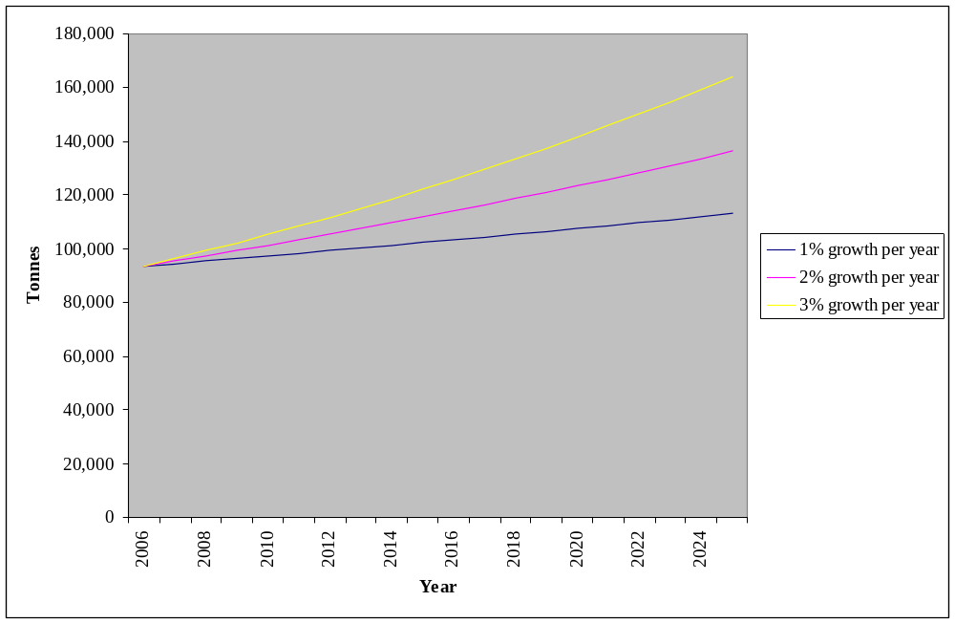

Future management of residual waste
The improvements made to the kerbside recycling schemes during 2006/07 were intended to enable North East Lincolnshire Council to achieve a household recycling rate of 30% in 2007/08. Assuming this recycling rate is maintained, waste continues to grow at 2% per year and the CHP facility continues to process 48,000 tons per year of residual waste, then Figure 7 shows that North East Lincolnshire Council will not be able to meet its landfill allowance targets after 2014/15 and will exceed its 2019/20 target by 14,000 tonnes. This figure also shows that if North East Lincolnshire Council was not sending waste to a treatment facility (which is the current situation for the majority of Councils in England), then it would not be able to meet its 2008/09 landfill allowance target.

Figure 7: Amount of waste to be managed (assuming 2% growth)
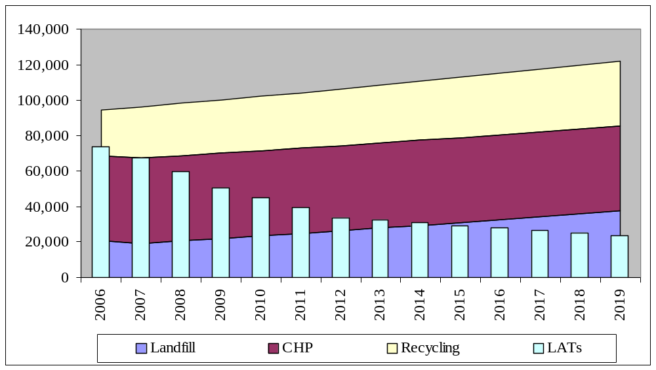
The following Table shows that if a 30% recycling rate was maintained, 48,000 tonnes per year was treated in the CHP facility waste and waste only grew at an average of 1% per year, then North East Lincolnshire Council would be able to meet its landfill targets until 2017 and would only exceed its 2019/20 target by 4,000 tonnes. An average growth rate of 3% per year would mean that North East Lincolnshire Council would exceed its 2019/20 target by 25,000 tonnes.

Table 1: Impact of waste growth rate on meeting future landfill targets
Growth Rate Wt/year | Year that North East Lincolnshire Council will not be able to meet its landfill allowance target | Tonnage by which 2019/20 target is exceeded
1 | 2018 | 4,000
2 | 2015 | 14,000
3 | 2013 | 25,000

Figure 7a below also shows the impact of a 3 % waste growth scenario.

Figure 7a: Amount of waste to be managed (assuming 3% growth)
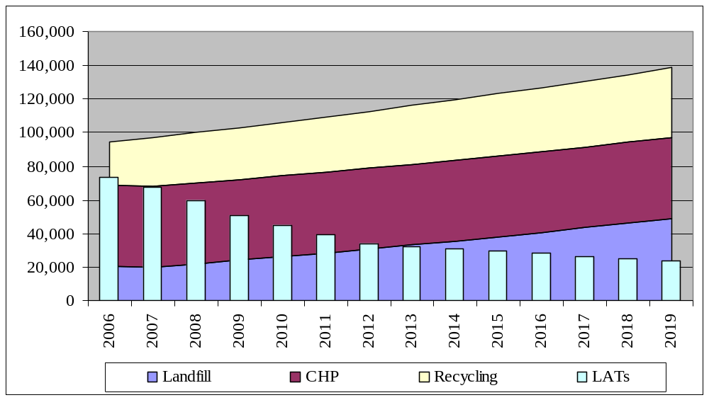

North East Lincolnshire Council considers that not reducing the amount of waste which is landfilled would not be acceptable because:
- North East Lincolnshire would not be making any further contribution to meeting the targets for the UK on landfilling of biodegradable waste set by the Landfill Directive
- Responses received at the public consultation on the waste strategy produced in 2004 indicated that recycling should be increased
- Providing additional recycling and/or treatment facilities will result in a lower increase in Council taxes than those which would occur if North East Lincolnshire Council continued to landfill all the remaining waste.

North East Lincolnshire Council needs to identify the most suitable way forward which will enable it to meet the landfill allowance targets to 2020 and beyond. In order to assist in this process, it has:
- Developed, following consultation with Council officers, elected Members and other stakeholders, a number of approaches for meeting future targets,
- Assessed the issues for each of these approaches.

These are discussed in the next section.

The options we considered
North East Lincolnshire Council recognises that its future strategy for waste management will need to meet the challenges that have been identified and meet the main aims of the 2007 national waste strategy. These are:
- Reducing the amount of waste which is produced
- Increasing the amount of waste which is recycled
- Increasing the amount of energy produced from waste that can't be reused or recycled
- Only landfilling waste where necessary

The current waste management contract with NewLincs expires in December 2024. It is necessary to consider what would be required to meet North East Lincolnshire Council’s requirements to 2024 assuming that the 2019/20 landfill Directive target for landfilling biodegradable waste continues to 2024/25.

Waste minimisation and future waste growth rate
The main impact of waste minimisation initiatives will be a reduction in the growth rate for waste arisings (these initiatives may well also impact on waste composition by reducing the weight of packaging materials). A lower average growth rate between 2007 and 2025 than the initial projection of 2% per year will have an impact on either the level of recycling or the amount of additional treatment capacity required to meet the targets for 2024/25 for diversion of biodegradable MSW from landfill.
Table 2 shows the impact of three waste growth rates (1.0% per year, 1.5% per year and 2.0% per year) on two approaches to managing the residual MSW; increasing the recycling rate or providing additional treatment capacity (assuming that the CHP facility continues to treat 48,000 tons per year of residual MSW). If the average growth rate between 2007 and 2024 could be reduced to 1% per year, then it would only be necessary to achieve a recycling rate of 37% in 2024/25 to meet the 2024/25 target for diversion of biodegradable MSW from landfill (this could be met without the introduction of alternate week collection of residual waste, but would still result in the landfilling of North East Lincolnshire Council’s current allowance of 16,000 tonnes per year). If the average growth rate between 2007 and 2024 was 2% per year, then a recycling rate of 47% would need to be achieved in 2024/25 to meet the target for diversion of biodegradable MSW from landfill. 16,000 tonnes of waste would be landfilled in 2024/25.

Table 2: Impact of waste growth rate on future waste management
Average growth rate  Wt% per year | Recycling rate (Wt %) required to meet landfill diversion target |  | Waste landfilled (tonnes) in 2024/25 if 30% recycling rate is maintained
Average growth rate  Wt% per year | 2019/20 | 2024/25
1.0 | 34 | 37 | 31,000
1.5 | 38 | 42 | 38,000
2.0 | 42 | 47 | 46,000

Household waste arisings in North East Lincolnshire have grown at an average rate of 2% per year for the past five years. It is quite unlikely that a target of an average growth of 1% per year can be achieved for the period 2007 to 2020, particularly if the number of new households is set to increase by at least 0.7% per year over this period. However, it is possible to achieve an average growth rate of 1.5% per year if the measures on waste minimisation outlined in the 2007 national waste strategy can be successfully implemented.

Increasing recycling
To meet landfill targets without treating any additional waste, North East Lincolnshire will need to achieve a recycling rate of 42% in 2019/20 and 47% in 2024/25, if the amount of MSW continues to grow at a rate of 2% per year.
The expansion of the kerbside scheme during 2006/07 was expected to enable North East Lincolnshire to achieve a recycling rate of 30% in 2007/08. The two approaches to further increasing the recycling rate are - either collecting additional materials, or increasing the number of households that recycle.
This section considers the amount of material that could be collected through these options and the resulting impact on the overall recycling rate achieved. North East Lincolnshire Council also has to consider the costs for implementing any of these options for increasing the recycling rate and these are assessed in section 4.3 of this waste strategy.

Collecting more materials
North East Lincolnshire Council considered the following options for collection of additional materials:
- Expansion of the kerbside green waste collection scheme
- Introduction of a kerbside plastics collection scheme
- Collection of food waste

The kerbside green waste collection scheme collected over 10,000 tonnes of material in 2006/07, almost 12% of the overall household waste arisings. The scheme currently covers 42036 of the 71,228 properties. Although some properties, such as flats or those with very small gardens, will not produce much garden waste, expansion of the green waste kerbside collection scheme could result in the collection of up to an additional 2,400 tonnes per year of material. Collection of this additional material could enable North East Lincolnshire Council to increase its recycling rate by between 2% and 3%.
The arisings of dense plastic, that includes plastic bottles, are estimated to represent 4% by weight of this waste stream (see on the composition of household waste). However, this total dense plastic content includes many items such as yoghurt pots and plastic toys, that cannot be collected for recycling as there is no market/use for this material in the manufacture of new items. The arisings of plastic bottles (such as soft drink bottles) are about 1,800 tonnes per year. Findings from schemes which collect plastic bottles from the kerbside indicate that a maximum of 50% of these are collected. This is a weight of 900 tonnes representing about 1% of overall household waste, indicating that the collection of plastic bottles would only enable North East Lincolnshire Council to increase its recycling rate by between 0.5% and 1%.
The 2007 national waste strategy encourages collection of food waste and this could increase the recycling rate achieved in North East Lincolnshire by up to 5%. The Animal By-Products Regulations (ABPR) requires food waste, which contains meat or dairy products, to be either composted in an ABPR compliant facility (an in-vessel composting system) or an anaerobic digestion facility. If North East Lincolnshire introduced a scheme that collected food waste together with green/garden waste, then all of the collected material would need to be treated in an ABPR compliant facility. Thus, although there would be only a minimal increase in collection costs, the costs for treating all of the garden waste in the ABPR compliant facility would result in an increase in treatment costs. There are also concerns about markets for the compost product which is produced from mixed food and garden waste and this could result in all of the compost product having to be landfilled.
The alternative would be to collect food waste separately. This would require a separate collection vehicle. It is also likely that the food waste would have to be collected weekly, which would result in a significant increase in collection costs. The food waste would need to be treated in an ABPR compliant facility
Currently, any material that is home composted cannot be included in the calculation of household waste recycling rate. The Government is considering whether the amount of material (or at least a proportion of this) diverted for home composting, can be included in the calculation of the recycling rate. A final decision is expected during 2008. Even if this waste is included in the calculation of recycling rate, it will not increase the amount of material diverted from landfill. Consequently, it has been excluded from the assessment of options for increasing the amount of material diverted from landfill through collection for recycling.
One factor that will need to be considered for the introduction of any new recycling scheme is the impact of the collection of additional recyclable materials on the calorific value (heat content) of the residual waste sent to the CHP facility. The CHP facility has been designed to produce a specific amount of heat. If the calorific value of the waste that is burnt to provide this heat increases, then less waste can be burnt. Modelling of the impact of changes in the calorific value of the waste sent to the CHP due to changes in the types of material collected for recycling showed that:
- Collection of additional paper, glass and metal has little impact on the calorific value. Paper has a high calorific value, but glass and metal have low calorific value.
- Collection of plastic will reduce the calorific value as it has a much higher calorific value than any of the other materials in MSW. Removing it from MSW will reduce the calorific value of the residual waste stream.
- Collection of food waste will increase the calorific value as it has a much lower calorific value than any of the combustible materials in MSW. Removing food waste from MSW will increase the calorific value of the residual waste stream.
If food waste collection was provided to all houses in North East Lincolnshire, the amount of such material collected for recycling could be about 6,000 tonnes per year. The subsequent increase in the calorific value of the residual waste sent to the CHP facility would result in a decreased capacity of the facility by about 4,000 tonnes per year. Thus, the overall impact of the introduction of the food waste collection would be to only reduce the amount of material landfilled by about 2,000 tonnes per year.

Increasing the number of households which recycle
North East Lincolnshire Council considered the following options for increasing the number of households that recycle:
- Encourage more households to recycle by raising their awareness of waste issues through the use of a suitable publicity and education campaign
- Make it more convenient for households to recycle by introducing a weekly collection for recyclable materials
- Introduce fortnightly collection of residual waste.
Monitoring of the kerbside collection schemes for dry recyclables and garden waste has shown that a significant proportion of households do not use these schemes. Some houses that use the schemes put out materials that are not collected. It results in a low rate of collection of materials and the need to separate out the unwanted items before the materials are sent for recycling or composting, which adds to costs. Experiences in other authorities show that a suitable education campaign could be used to:
- Increase the number of households that recycle
- Increase the amount of materials separated for recycling in households that recycle
- Reduce the level of contamination in the collected materials.

This type of campaign could also be used to educate households about the need to reduce the amount of waste that they produce, which would support any plans for meeting waste minimisation targets. Experience gained from other campaigns indicates that these need to be long-term (minimum of five years) to have a noticeable impact. North East Lincolnshire Council recognises the need to assess the cost-effectiveness of any potential education campaign.
Currently, the dry recyclables collection scheme collects material from each household fortnightly. Though the introduction of a weekly collection scheme for dry recyclables will marginally increase the cost of collection, it will make recycling more convenient for households and may also encourage more households to recycle. Data from such studies show that this would increase North East Lincolnshire Council’s recycling rate by between 2% and 3%.
Councils achieving recycling rates of over 40%, such as those in Cambridgeshire and Suffolk, have been awarded Beacon status for recycling. They all collect residual waste fortnightly. The Government recognises that it does not have the right to prescribe how waste is collected and it is a matter for local authorities to decide. Experiences from authorities in the UK and abroad suggests that well designed and implemented alternate week collection schemes can contribute to significantly higher recycling rates. However, North East Lincolnshire Council recognises that there is currently a strong level of local public opposition to the introduction of alternate weekly collection of residual waste and has ruled this option out.

Provision of additional treatment capacity
In the 2007 national waste strategy, the Government indicated that subject to further analysis and consultation, it may introduce legislation that will ban biodegradable and recyclable waste from landfill sites. Some European countries already have similar legislation.
If the recycling rate of 30% is maintained, MSW continues to grow at an average of 2% per year and the existing CHP plant continues to process 48,000 tonnes per year, the amount of waste that will need to be landfilled in 2024/25 is estimated to be about 46,000 tonnes. The two approaches to treating this waste are
- either provide additional treatment capacity - a plant able to treat about 50,000 tonnes per year within North East Lincolnshire,
- or send the waste to a suitable facility in a neighbouring authority.
The two main factors that North East Lincolnshire Council would need to consider regarding an additional treatment plant (either in North East Lincolnshire or in a neighbouring authority) are
- status of the technology - is it fully commercially proven?
- markets for the products that the treatment plant produces. The availability of long-term markets for the products is a very important factor as otherwise, they will have to be landfilled.
The existing CHP facility is a proven technology that is meeting all of its specified requirements and has a well established market for the main product (electricity). If an additional CHP facility is identified as the preferred approach for meeting these targets, there will be little risk to North East Lincolnshire Council meeting future landfill targets.
Although there is some public opposition to this type of technology due to concerns about potential health impacts, the introduction of the EU Waste Incineration Directive and strict enforcement of emissions standards means that new facilities operate to very high standards. The Review of the Environmental and Health Effects of Waste Management commissioned by Government concluded that the effects on health from emissions from CHP facilities, largely to air, are likely to be small in relation to other known risks to health.
The alternative to CHP technology is Mechanical/Biological Treatment (MBT). This encompasses a wide range of technologies aiming to process solid waste by a mixture of mechanical and biological separation to produce a fuel and/or compost. They enable metals and other dry recyclables to be recovered. Some MBT technologies are reasonably well developed and are operating in other European countries, but others still require further development. Current Government policies support the development of MBT technologies through financial subsidies for generation of electricity (as part of the renewable energy target). However, the main concern for all MBT processes is the availability of suitable long-term markets for the fuel product. An increasing number of proposed MBT plants are now considering gasifying the fuel and then burning the gas to produce electricity, but the technology for gasifying the fuel is not yet commercially proven.
There is a limited third-party market for the fuel and other options for using it are not yet commercially proven. If a MBT plant was identified as the preferred approach for meeting future landfill targets and no market/use for the fuel product was identified, it would have to be landfilled. This could result in a significant risk to North East Lincolnshire Council for meeting future landfill targets.
The main advantage of sending waste to a suitable facility in a neighbouring authority is that no new treatment facility would need to be built in North East Lincolnshire. However, there may be limited capacity for the Council to send residual MSW to these facilities if the planning conditions for them stipulate that they can only treat waste generated in that authority. North East Lincolnshire Council recognises that there are likely to be similar concerns regarding planning approval if a new facility built in its area treated waste generated in a neighbouring authority.

proposed approach to meeting these challenges
The 2007 national Waste Strategy sets the Government’s vision for sustainable waste management. Its aim is to reduce waste by making products with fewer natural resources and break the link between economic growth and waste growth. Products should be re-used, their materials recycled, energy from waste recovered and landfilling of residual waste should be done only where necessary.
After assessing a number of options for meeting the aims of the national waste strategy and the resulting costs to Council Tax payers, North East Lincolnshire Council’s proposed the following targets to meet these challenges:
- Waste minimisation targets – Waste growth reduced to 1.5% per year by 2012 and to 1% per year by 2017
- Recycling rate target - 35% recycling rate by 2010 (and a target of 40% by 2015)
- Energy recovery target - Maximising the recovery of energy from the residual waste by treating all of it in an additional CHP facility
- Landfill target - Not sending any biodegradable waste to landfill.

North East Lincolnshire Council recognises that there is currently a strong level of public opposition to the introduction of alternate weekly collection of residual dustbin waste, and has ruled out this option.
Meeting the average growth rate target of 1% per year by 2017 will be a challenging target, particularly as the number of households (one of the two factors that affects waste growth) is expected to grow by 0.7% per year over this period.
The timescale proposed for achieving the first waste growth target (1.5% by 2010) is longer than that proposed for meeting the recycling target. This is because waste minimisation initiatives can take up to five years to have any noticeable effect. Also, though the Government is proposing initiatives in areas such as reducing junk mail, these may well not be fully introduced for at least two to three years.
The 35% recycling rate target for 2010 has been set on the basis that it should be possible to achieve this through expanding the green waste collection scheme and increasing the number of households which recycle through the long-term waste minimisation and recycling campaign. This is the most cost-effective approach to achieving this target. North East Lincolnshire Council recognise that additional recycling initiatives are likely to be required in order to meet the 40% target. It will conduct a further assessment of these when the waste strategy is reviewed in 2010.
Figure 8 shows that if the 35% recycling rate and the waste minimisation targets (1.5% by 2012 and 1% by 2017) are achieved, then North East Lincolnshire Council will meet its landfill allowance targets to 2018/19 and will only just fail to meet its 2019/20 target. If a 40% recycling rate is achieved, then North East Lincolnshire Council would meet its landfill targets until 2024 (assuming that the amount of waste which can be landfilled in 2024/25 is the same as that in 2019/20).

Figure 8: Position if 35% recycling rate and waste growth targets are achieved
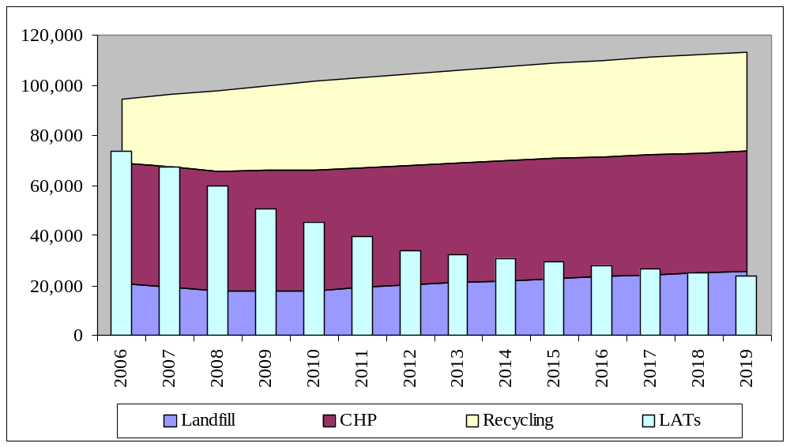
Although achieving a 40% recycling rate would mean that North East Lincolnshire Council meets its landfill targets to 2024/25, the amount of waste landfilled in 2024/25 would be 23,000 tonnes. Landfilling this waste will mean not achieving the national waste strategy aims of recovering energy from residual waste and minimising the amount of waste landfilled. Consequently, North East Lincolnshire Council has set a target to send all of this residual waste to a suitable treatment facility by 2020 at the latest, with the aim of achieving this target by 2015.
To achieve this target, the Council will require additional treatment capacity. Although the Government is not generally expressing a preference for one type of technology over another for recovering energy from waste, it does believe that any given technology (where applicable), is more beneficial if both heat and electricity can be recovered. Based on its assessment of treatment technologies, their costs and the risks associated, North East Lincolnshire Council’s preferred approach is to use a second CHP facility located at the same site as the current one. Another CHP facility would also enable North East Lincolnshire Council to meet its target of not landfilling any biodegradable MSW whereas a MBT plant would produce a reject fraction which would need to be landfilled. North East Lincolnshire Council will continue to assess other options and will make a final decision before the next review of the waste strategy.
The main risks to achieving these targets are:
- The waste minimisation campaign is not effective in reducing the rate of waste growth
- The recycling education campaign does not encourage sufficient number of new households to start recycling
- The recycling education campaign does not encourage households (that are already recycling) to separate more material for recycling
- Markets for the additional materials that are collected cannot be identified and they have to be landfilled.

The long-term nature of a waste minimisation campaign means that it will be more difficult to monitor progress towards meeting this target, but data on yearly tonnage arisings will be used to assess this.
The effectiveness of the recycling education campaign will be monitored through regular set-out/participation surveys and this will identify the priority areas to be targeted for the door-stepping campaigns.
Markets for all of the dry materials (paper, glass, plastics and metal) which are collected are well established and stable. There are well established markets for the compost produced from the collected garden waste. The recycling education campaign will also aim to reduce the level of contamination of the collected materials; this will reduce any costs for sorting these materials to remove contaminants before they are sent for recycling or composting and will also increase market acceptability for these products.

How we plan to implement actions
This chapter describes how we plan to implement our proposed waste strategy. It:
- Identifies key responsibilities
- Discusses possible partnerships with neighbouring authorities
- Outlines North East Lincolnshire Council’s activities for developing waste minimisation and recycling initiatives
- Outlines North East Lincolnshire Council’s activities for reviewing options for treatment of additional waste.
It also presents our proposed timetable for implementing the strategy, assesses the impact of the strategy on our carbon footprint, discusses how we plan to keep this programme on track and identifies how further consultation will be conducted as the strategy is implemented.

Roles and responsibilities
There are a number of groups that will have a role to play in implementing North East Lincolnshire’s waste strategy:
- National Government – Provide publicity/education programmes through Waste and Resources Action Programme (WRAP), which aim to encourage a reduction in the amount of waste and increase the amount of recycling.
- Regulators – Ensure that facilities for processing dry recyclables, composting organic material and treating residual waste, meet all environmental requirements on emissions to air, water and land.
- North East Lincolnshire Council – Arrange for the provision of facilities for recycling and composting, and ensuring that any new treatment facilities are sited in accordance with the policies in the waste development plan. Appropriate Council assets will be employed to assist with delivery.
- Newlincs (Waste management company) – Operate recycling and composting services, the CHP facility which treats North East Lincolnshire’s residual waste and provide capacity for any landfilled waste.
- Voluntary groups – Provide facilities which enable items such as washing machines to be re-used, and provide and/or support additional recycling services.
- Commerce and Industry – Reduce waste arisings by, for example, reducing the amount of packaging required for products and increasing the amount of recycled material.
- The public – Participate in waste reduction and recycling activities.

The public will also have an important role in the continuing consultation as the strategy is implemented.

Possible PARTNERSHIPs with neighbouring authorities
Joint working on waste by local authorities is a key feature of the National Waste Strategy. The Government has indicated that it may develop incentives for joint working. Regional Spatial Strategies acknowledge the strategic significance of waste management and the need for an effective regional waste treatment and disposal infrastructure.
North East Lincolnshire Council, along with the three neighbouring unitary authorities of North Lincolnshire Council, East Riding of Yorkshire Council and Kingston upon Hull City Council, were created following the abolition of the former Humberside County Council in 1996. Immediately following the reorganisation of local government, the two authorities on the north bank of the Humber joined together and contracted to a single private sector organisation for the management of their municipal solid waste until 2024. Though planning permission for an Energy from Waste (EfW) facility to treat their residual MSW has been granted recently, it is unlikely that this will provide suitable capacity for processing any of North East Lincolnshire’s wastes.
North Lincolnshire Council’s waste disposal contract expires in 2011. They are developing their waste strategy and assessing options for treatment of their residual waste.
To the south, Lincolnshire County Council is the waste disposal authority for the constituent District Councils that collect waste on behalf of their respective residents. Lincolnshire County Council are considering treatment options for the residual waste stream and the location(s) of the facility(s) required, but it is unlikely that these will provide suitable capacity for processing any of North East Lincolnshire’s wastes.
Informal discussions have been held from time to time with each of these authorities about possible opportunities for collaborative working on waste. A joint strategy on procurement has been agreed recently with North Lincolnshire Council.
Informal discussions have been held with the Yorkshire & Humberside Regional Assembly about possible opportunities for collaborative working on waste. North East Lincolnshire Council officers will continue to have informal discussions with neighbouring authorities about possible partnership options on future waste management. If a potential partnership opportunity is identified, the officers will seek approval from elected members.

Waste reduction/re-use
Waste reduction is at the top of the waste hierarchy and is pivotal to the development of sustainable waste management practices.
Waste reduction refers to the minimisation of waste at source, which means not producing waste in the first place. In some countries, householders are charged to dispose of the actual amount of waste produced and this has been shown to have an effect on the amount of waste produced and material recycled. However, the so-called ‘pay-as-you-throw’ schemes can be difficult to implement and are likely to be unpopular with a large proportion of the public.
North East Lincolnshire Council has set a target to reduce the rate of waste growth to 1.5% per year by 2012 and to 1% per year by 2017. To achieve this target, it will be necessary for households to reduce the amount of waste that they produce.
North East Lincolnshire Council is promoting a number of initiatives for reducing waste. These cover the new initiatives outlined in the national waste strategy and include:
- Promoting home composting
- Promoting the use of real nappies
- Reducing unwanted junk mail
- Reducing unaddressed mail

Further information on these, together with other initiatives on waste reduction can be found at http://www.nelincs.gov.uk/environment/recycling/101.htm
North East Lincolnshire Council will actively promote all of these activities through the recycling/education campaign and will support national and regional campaigns on waste reduction and re-use.
Appendix 4 contains a number of policies which will be used by North East Lincolnshire Council to support the achievement of these targets:
North East Lincolnshire Council will monitor progress towards achieving the waste minimisation targets.

Improving recycling
“Recycle Now” is the national publicity/education campaign aimed at increasing the number of people who participate in recycling schemes. This was launched in September 2004 by Waste and Resources Action Programme (WRAP) to replace the ‘Rethink Rubbish’ campaign. The ‘Recycle Now’ campaign has a distinctive logo. Besides providing information for the public, its website also provides resources that local authorities can use and adapt to compliment their existing waste promotion campaigns.
North East Lincolnshire Council has set a target to recycle 35% of household waste by 2010, an increase of 9% on the household waste recycling rate achieved in 2006/07. Some of this increase will be achieved by the expansion of the dry recyclables kerbside collection scheme (for paper, glass and metal) to all households during 2006/07. In the short-term, North East Lincolnshire Council will increase recycling collections during 2008 through expanding:
- the kerbside collection scheme for garden waste to all households
- capacity at bring sites for plastics collections.

Collection of these materials will have little impact on the calorific value of the residual waste sent to the CHP facility and it should be able to continue processing waste at 48,000 tonnes per year.
North East Lincolnshire Council will assess options for increasing the number of recycling facilities at the Community Recycling Centres.
The Council launched a door-stepping campaign on increasing recycling in 2008. It will also support all national and regional campaigns aimed at increasing recycling.
Appendix 4 contains a number of policies which will be used by North East Lincolnshire Council to support the achievement of these targets:
The next review of the strategy will assess options for further increasing the recycling rate to meet the target of a 40% recycling rate by 2015.

Requirements for new capacity

To implement the waste strategy, three areas where additional waste handling/treatment capacity could be required are:
- additional recyclables
- treating residual municipal waste
- managing similar, non-municipal, waste streams arising locally.

Landfill capacity will also be required.

Recycling
Collected dry recyclables and green waste are delivered to the Newlincs site at Immingham, where the dry recyclables are bulked for transport to recycling facilities and the green waste is sorted to remove contaminants before being sent to a composting facility. The capacity is sufficient to handle the dry recyclables and green waste predicted to be collected.
North East Lincolnshire Council will explore options for partnering with neighbouring authorities to provide facilities for treating food waste and mixed food/garden waste. This information will be used in the assessment of the possible introduction of a kerbside recycling scheme for food waste.

Waste treatment
In this waste strategy, the preferred approach for managing residual waste is to maximise the recovery of energy from the residual waste by treating all of it. This will require additional treatment capacity.
The existing CHP plant treats 48,000 tonnes per year. As its capacity cannot be increased, an additional treatment plant will be required. For any treatment plant, the gate fee cost for processing a tonne of waste reduces as the size of the plant increases (see Table 3). However, it would not be economic for a plant of this type to treat an additional 20,000 to 25,000 tonnes of residual waste (that would need to be processed) to meet the target of not landfilling any biodegradable waste. There is an economic incentive for treating this waste in a plant which also treats other similar wastes.
North East Lincolnshire Council will explore options for either partnering with neighbouring authorities to provide the required treatment capacity, or partnering with waste management companies to provide a facility which would treat the authority’s residual MSW and suitable commercial/industrial waste. This information will be used in the assessment of options for increasing the amount of residual MSW treated and a final decision will be made by 2010 at the latest.
Table 3: Costs of Treatment Options
Technology | Plant Scale (kt/y) | Capital Cost (£m) | Gate fee (£/t) 2003/04 | Gate fee (£/t) 2009/10
IVC/AD | 20 | 6 | 68.7 | 76.9
IVC/AD | 50 | 6.8 | 53.6 | 60
IVC/AD | 150 | 24 | 48 | 53.8
MBT biodrying (RDF to EfW) | 50 | 29.9 | 73.3 | 113.8
MBT biodrying (RDF to EfW) | 100 | 52.6 | 60.2 | 88.2
MBT biodrying (RDF to EfW) | 200 | 86.8 | 49.9 | 67.5
MBT producing CLO and RDF | 50 | 53 | 106.6 | 181.5
MBT producing CLO and RDF | 100 | 62.5 | 67.1 | 105.2
MBT producing CLO and RDF | 200 | 79.5 | 52.2 | 66.2
MBT producing CLO to landfill | 50 | 15.3 | 66.8 | 74.8
MBT producing CLO to landfill | 100 | 23.2 | 55.6 | 62.3
MBT producing CLO to landfill | 200 | 35.2 | 46.6 | 52.2
EfW | 100 | 54.6 | 52.5 | 86.4
EfW | 200 | 88.2 | 45.7 | 64.9
EfW | 400 | 125.7 | 35.8 | 43.5
ATT | 30 | 21.1 | 127.9 | 127.9
ATT | 100 | 38.9 | 81.5 | 81.5
ATT | 150 | 54.6 | 70 | 70
CLO - Compost like Output
ATT - Advanced Thermal Technology, e.g. pyrolysis, gasification

Landfill capacity
North East Lincolnshire Council has set a target of not sending any biodegradable waste to landfill. However, even if this target is achieved, landfill capacity would still be required for any inert wastes that could not be recycled. NewLincs Development Ltd is contracted to source additional landfill capacity if required.
There is sufficient capacity at the Immingham landfill site to take all of North East Lincolnshire’s residual municipal waste until 2027. The full lifespan of this site is 20 years and will, amongst other things, be dependant upon input rates. The site receives waste from a number of private sector waste collection companies. The operator of the landfill site may have to review the commercial viability of the site if North East Lincolnshire Council achieves the target of not sending any biodegradable waste to landfill.
With few exceptions, landfill sites that take municipal solid waste also take other types of waste such as from commercial and industrial premises. The Landfill Directive requires all waste to be treated before it is landfilled. However, recent guidance issued on this by the Environment Agency indicates that this requirement can be met by, for example, the continued operation of the existing recycling schemes (such as separate collection of office paper) that most companies operate. Unless changes to Government policy (such as a ban on landfilling biodegradable wastes) require all suitable commercial and industrial waste to be treated in a similar manner to MSW, there is unlikely to be any noticeable reduction in the amount of these wastes which are landfilled. Subsequently, there is likely to be no noticeable increase in the expected lifetimes of the existing landfill sites in North East Lincolnshire.

IMPACT OF THE WASTE STRATEGY ON OUR CARBON FOOTPRINT
The Government has indicated that, in the longer term, it will develop an indicator measuring the climate change impact of a local authority’s waste management operations.
Methane emissions from biodegradable waste in landfills account for 40% of all UK methane emissions and 3% of all UK greenhouse gas emissions. Methane is 25 times as damaging a greenhouse gas as carbon dioxide. Any measure (such as recycling) that reduces the amount of waste landfilled will reduce the carbon dioxide emissions associated with waste management.
Recycling of materials saves energy and emissions that would otherwise be required to extract raw materials. UK recycling of paper, glass, plastics, aluminium and steel is estimated to save more than 18 million tonnes of carbon dioxide a year through avoided primary material production - this is equivalent to an annual use of 5 million cars or 14% of UK transport sector emissions. Table 3 shows the carbon benefits of diverting waste from landfill in term of the kg carbon dioxide saved per tonne of material recycled.

Table 3: Savings in carbon dioxide emissions due to recycling
Material | kg carbon dioxide saved per tonne recycled
Paper | 1,400 | (50% saved because not landfilled, 50% saved due to recycling
Kitchen waste | 350 | 80% saved because not landfilling, 20% saved by composting
Garden waste | 100 | Saved because not landfilled
Plastic | 1,000 | Saved by recycling
Ferrous metal | 1,300 | Saved by recycling
Aluminium | 11,000 | Saved by recycling
Glass | 600 | Saved by recycling

Paper and food/garden waste are biodegradable and would produce methane if they were landfilled. The savings in carbon dioxide emissions due to recycling these wastes are from avoiding the need to landfill the waste and the savings achieved through recycling. Plastic, metal and glass are not biodegradable and would not produce any methane if they were landfilled - all the savings in carbon dioxide emissions occur due to recycling.
The amount of waste landfilled can also be reduced by treating waste that has not been separated for recycling to reduce its biodegradable content. Treating waste to recover energy reduces greenhouse emissions through reducing methane emissions from the landfill site and the carbon dioxide impacts offset through avoiding alternative generation of electricity or heat. An EfW facility will reduce the kg of carbon dioxide saved per tonne treated by 232 kg and this figure will be higher for a CHP facility because of additional heat recovery. ??
Waste management activities generate carbon dioxide emissions due to the transport activities required to collect and deliver waste and recyclables to suitable facilities. However, these impacts will have a minimal impact on carbon dioxide emissions when compared with the reduction in waste landfilled.
The overall impact of the England Waste Strategy 2007 is expected to be an annual net reduction in global greenhouse gas emissions from waste management of at least 9.3 million tonnes of carbon dioxide equivalent per year compared to 2006 - equivalent to annual use of around 3 million cars. The additional greenhouse gas emissions reductions result from an increase in diversion of waste from landfill. These benefits will be boosted by significant extra greenhouse gas benefits from the waste prevention measures in the strategy.
North East Lincolnshire has reduced the carbon footprint for its waste management activities by introducing recycling schemes and treating residual waste in the CHP facility. The use of this facility reduced the carbon footprint for emissions of carbon dioxide by 12,000 tonnes per year. Additional recycling measures contained in this waste strategy will reduce our carbon dioxide emissions by 8,500 tonnes per year, which is about 0.1% of the total future reduction anticipated for England.
MSW in North East Lincolnshire represents about 0.3% of the total MSW in England. North East Lincolnshire’s contribution to the overall reduction in carbon dioxide emissions arising from the waste management activities that are proposed in this strategy will be smaller than the amount of waste that we produce. This is mainly because the estimate of the reduction for England includes the provision of residual waste treatment capacity by many authorities that have not yet started using this. If the reduction due to the use of the CHP facility is included, then the overall reduction in carbon dioxide emissions due to improved waste management in North East Lincolnshire will be about 0.3% of the target of 9.3 million tonnes, which is comparable to the percentage of total MSW that is produced in the authority.
Further consultation
North East Lincolnshire Council recognises the importance of regular consultation with all stakeholders, particularly members of the public, to take into account the wide range of views on the waste strategy. There will be a public consultation on this waste strategy and the findings will be assessed before the final version of the waste strategy is produced.
There will also be a consultation with all stakeholders during the strategic environmental assessment (SEA) of the waste strategy.
The provision of any new waste treatment facilities will require additional consultation with all stakeholders as part of the process for obtaining planning permission for such facilities.

How we plan to keep this programme on track
The proposed timetable to enable North East Lincolnshire to meet its future landfill allowance targets is as follows:

Year | Activity
2008 | Launch long-term waste minimisation and recycling education campaign  Expand kerbside collection scheme for green waste  Expand capacity at bring sites for plastics collections  Assess treatment options
2009 | Review progress towards meeting 35% recycling target  Begin procurement of additional waste treatment capacity
2010 | Review progress towards meeting 35% recycling target and waste growth target  Review the waste strategy, taking account of possible changes in Government legislation and identify any new requirements
2011 to 2015 | Review progress towards meeting waste growth target  Review progress towards meeting 40% recycling target  Implement changes required to meet any new Government targets
2016 to 2020 | Review the waste strategy  Implement changes required to meet any new Government targets
2020 to 2024 | Review the waste strategy  Implement changes required to meet any new Government targets  Procure new waste management contract to run from December 2024

For the strategy to be implemented, there is a clear need for all activities to be co-ordinated and monitored. Through its performance management system and service planning linked to the Cabinet and Scrutiny Committees, North East Lincolnshire Council will, monitor waste activities and ensure that the strategy is delivered.
There will also be a partnership framework with Officer, Political and other stakeholder Group structures, which will cover:
- Continuous monitoring of recycling rate, service performance and compliance
- Establishing critical review points for progress towards recycling tonnage targets, waste growth targets and applying project management principles to ensure delivery
- Effects of possible changes in legislation on the future waste strategy
- Ensuring that “Best Value” is maintained
- Introducing a system of management accountability.

North East Lincolnshire Council will publish a yearly progress report of the aims and targets identified in this waste strategy.
North East Lincolnshire Council has adopted a policy which will require its waste strategy to be reviewed every three years. The next review of the strategy in 2010 will assess progress towards meeting the waste minimisation and 35% recycling targets. It will identify any additional measures required to achieve the longer term aims for waste minimisation, 40% recycling rate by 2015 and 1% waste growth by 2017. It will also report on progress made towards reaching the aim of not landfilling any biodegradable MSW.

Appendix 1 – Glossary of Terms
Glossary
Best Value | The duty for Local Authorities to deliver quality, cost effective services in an efficient way.
Best Value Performance Indicators | Criteria by which the government assess the performance of local authorities against their duty of Best Value.
Biodegradable Municipal Waste (BMW) | The organic components of municipal waste (such as paper, food and garden waste) which break down to release harmful green house gases.
Commercial Waste | Waste from individual traders, wholesalers, catering establishments, shops and offices, etc which is not collected by a local authority.
Community Recycling Centres (CRC) | Facilities provided by the Council, for residents to bring items for disposal, including bulky items, green waste, recyclables and general refuse. Sometimes called Civic Amenity Sites, or simply the “Tip”.
Composting | Processing of organic materials to allow their nutrients to be put back onto the land as a soil improver. This process can prevent the problems associated with the generation of methane from biodegradable waste in landfill sites.
DEFRA | The Department for the Environment, Food and Rural Affairs, who have responsibility for national waste policy.
Energy from Waste (EfW) facility | The combustion of waste under controlled conditions in which the heat released is recovered to provide steam, which is usually used for electricity generation.
Gasification | Heating waste in a low-oxygen atmosphere at high temperatures to give off a fuel gas. This technology was used to produce gas from coal, however it is a relatively new application to treat waste.
Green Waste | Garden waste which is suitable for composting.
Greenhouse gas | Those gas compounds in the atmosphere that reflect heat back to earth rather then letting it escape freely into space. A number of gases are involved, including carbon dioxide, nitrous oxide, ozone, water vapour and some of the chlorofluorocarbons.
Household Waste | All waste from household collection rounds, including bulky waste collections and separated materials for recycling and composting, waste from street sweeping, schools waste, waste from litter and dog fouling bins, waste brought to recycling points and waste deposited at civic amenity sites.
Industrial Waste | Waste arising from factories and industrial plants.
In-vessel Composting | The composting of biodegradable material in an enclosed vessel. In-vessel systems have greater process control than windrow systems and speed up the initial phases of composting.
Landfill | Burying waste, usually in disused quarries.
Landfill Directive | A Directive on waste management from the European Commission which aims to prevent, or reduce as far as possible, the negative effects on the environment and human health caused by landfilling of wastes.
Landfill Allowance | The weight of biodegradable municipal waste (BMW) that can be landfilled.
Landfill Allowance Trading Scheme (LATS) | A scheme which allows Unitary Authorities and Waste Disposal Authorities to trade landfill allowances to meet their landfill allowances.
Landfill Tax | A tax payable for each tonne of waste sent to landfill, introduced to encourage more sustainable means of waste management through recognising the hidden financial effects of the environmental impact of landfill.
Mechanical Biological Treatment (MBT) | A term for mechanical sorting/separation techniques, which is, used in conjunction with biological treatment processes, such as composting or anaerobic digestion.
Municipal Solid Waste (MSW) | All household wastes plus hazardous household waste; parks and garden wastes and the waste from institutions and commercial premises collected by the local authority.
Open Windrows | Windrow composting consists of forming the mixture of raw materials (green waste) into long narrow piles, which are turned and re-mixed on a regular basis.
Pre-Treatment | The prior sorting, chemical or biological processing of waste to reduce volume or make the waste material safer.
Refuse Derived Fuel (RDF) | A solid, liquid or gaseous fuel derived from waste, which can be used as a fuel product either in an on-site combustion facility or by a third-party user such as cement kilns or power stations.
Recovery | Recovery of energy from waste, through incineration, anaerobic digestion or other end treatment technologies to allow some of the energy value to be retrieved from the material through the generation of heat and power.
Recycling | Creating new products from waste materials. It has three elements, the collection and processing of the materials, making the materials into a new product and the purchase of products with recycled material contents.
Reduction | Not creating waste in the first place.
Reuse | Using materials again, or many times, particularly in the location they were generated.
Strategic Environmental Assessment (SEA) | Directive 2001/42/EU implemented in England Wales in July 2004. It provides a process of evaluating the environmental impacts of a policy, plan, strategy or programme. The Directive requires public consultation to be included as part of the SEA process.
Stakeholder | Anyone who has an interest or involvement in waste management.
Sustainability | Meeting the needs of the present without damaging the ability of future generations to meet their needs.
Unitary Authority | A Local Authority which is responsible for collecting and disposing of municipal solid waste.
Waste Collection Authority | A District or Borough Council which has responsibilty for collecting municipal solid waste.
Waste Disposal Authority (WDA) | A Local Authority (usually a County Council) which is responsible for disposing of municipal solid waste.

Abbreviations

BMW | Biodegradable Municipal Waste
BVPI | Best Value Performance Indicator
C&D | Construction and Demolition
CHP | Combined Heat and Power
CPA | Corporate Performance Assessment
DEFRA | Department of the Environment, Food and Rural Affairs
EfW | Energy for Waste
ELV | End of Life Vehicles
EOA | Environmental Options Assessment
IPPC | Integrated Pollution Prevention Control
LATS | Landfill Allowance Trading Scheme
MBT | Mechanical Biological Treatment
MSW | Municipal Solid Waste
ODS | Ozone Depleting Substances
PFI | Private Finance Initiative
PPC | Pollution Prevention Control
PPG | Planning Policy Guidance
PPS | Planning Policy Statements
RDF | Refuse Derived Fuel
SEA | Strategic Environmental Assessment
WCA | Waste Collection Authority
WDA | Waste Disposal Authority
WEEE | Waste Electrical and Electronic Equipment
WLP | Waste Local Plan
WRAP | Waste Resources Action Programme
UDP | Unitary Development Plan

APPENDIX 2 – LEGAL REQUIREMENTS AND PLANNING GUIDANCE
This appendix outlines the main legal requirements regarding waste management that North East Lincolnshire Council either already has to meet or will need to meet as new legislation and requirements are introduced. It then considers the legislation regarding planning for any new recycling and waste management facilities which will be required to enable North East Lincolnshire Council to meet its future targets.
European waste Policy and Legislation
The European Union has become the major source of environmental legislation and guidance in relation to the management of waste. A number of European Directives which aim to increase levels of recycling and recovery and reduce the amount of waste which is landfilled have been introduced:
- Framework Directive on Waste (75/442/EEC)
- Landfill Directive (1999/31/EC)
- Directive on Packaging and Packaging Waste (94/62/EEC)
- Waste Electrical and Electronic Equipment Directive (2002/96/EC)
- End of Life Vehicles Directive (2000/53/EC)
- Ozone Depleting Substances (Regulation 2037/2000)
- Directive on Batteries (2006/66/EC)
- Waste Incineration Directive (2000/76/EC)

Framework Directive on Waste (75/442/EEC)
This Directive established the fundamental principles for waste management in Europe, which must be reflected in National, Regional and Local Strategies. The key principles are:
- The Waste Hierarchy – this provides a framework of how sustainability in waste management can be increased progressively. The aim is to move up the waste hierarchy by significantly reducing reliance on landfill to increased recycling, reuse, composting, recovery and ultimately waste reduction. However, the waste hierarchy should be used as a guide rather than being applied rigidly and a certain amount of flexibility is needed to arrive at the most balanced environmental, social and economic solution, which will inevitably result in a mixed solution.
- Regional Self-Sufficiency and The Proximity Principle - This requires that waste should generally be managed as close as possible to where it is produced to limit the environmental impact of transportation and create a more responsible approach to waste generation. Each region is expected to provide sufficient facilities and services to manage the amount of waste it is expected to produce. However, as not all regions have specialist recovery, recycling or treatment facilities, it is recognised that the best solution for some waste may be to transport it to another region where it can be dealt with more effectively.

Figure 9: The Waste Hierarchy

The requirements of the Framework Directive on Waste were implemented in the UK through the Environmental Protection Act 1990. This legislation defines the different categories of waste and how waste should be managed and controlled. It also defines the duties of Waste Collection and Waste Disposal Authorities and sets out the Duty of Care applicable to all those handling and disposing of waste including householders.
The European Commission is developing a Directive on Waste which will succeed the Waste Framework Directive. This new Waste Directive is being discussed in the European Parliament and is expected to:
- Introduce targets to halt the growth in waste generation in Europe at 2008 levels from 2012, with Member States required to draw up national waste prevention programmes.
- Set targets for re-use and recycling, including re-using or recycling 50% of municipal waste by 2020.
- Define when recycled materials or products are no longer deemed to be waste also gained support. This would see materials or products that have been fully recycled (perhaps according to a standard) no longer falling under waste legislation.
- Develop efficiency criteria which would enable incinerators to qualify as recovery plants if they meet these criteria.

The European Parliament has also requested the European Commission to develop a Directive on Biowaste (kitchen and garden waste) by June 2008.
The European Commission is also developing a Thematic Strategy on waste prevention and recycling. This will lead to a further reduction in the amount of waste landfilled through further recycling and composting and an increase in the amount of energy which is recovered from residual waste.
The Commission plans to review the amounts of waste going to landfill in the EU in 2010 and if the move away from landfill is not progressing quickly enough, further landfill bans will be considered.
North East Lincolnshire Council’s waste collection and management procedures meet the requirements of the Framework Directive on Waste and the Environmental Protection Act 1990.

Landfill Directive (1999/31/EC)
The main aim of the Landfill Directive is to prevent, or minimise the negative effects on the environment and human health caused by landfilling of wastes. It has and will continue to have a significant impact on landfill practices in the UK as it bans certain materials from being landfilled, requires waste to be pre-treated before it is landfilled and requires improvements to landfill management. The introduction of the Directive has resulted in a significant reduction in the number of landfill sites in the UK accepting hazardous wastes. The ban on landfilling of certain wastes, such as tyres from 2006 has meant that new arrangements have been introduced for their collection and management.
Landfilled biodegradable waste is a major source of methane - a greenhouse gas over 20 times more potent than carbon dioxide in terms of global warming. The Landfill Directive will require the amount of biodegradable municipal solid waste sent to landfill in the UK to be reduced:
- to 75% of 1995 levels by 2010,
- to 50% of 1995 levels by 2013 and
- to 35% of 1995 levels by 2020.
The Government has implemented the requirements for landfilling of biodegradable waste through the Waste and Emissions Trading Act 2003. This sets Waste Disposal Authorities (such as North East Lincolnshire) annual allowances limiting how much biodegradable municipal waste (BMW) can be landfilled in any particular year with effect from April 2005. The Government will fine Authorities that do not achieve their annual targets, but will allow them to buy allowances from other Waste Disposal Authorities if they expect to landfill more than their allocations and sell their surplus if they expect to landfill less than their allowance.
North East Lincolnshire Council’s waste strategy outlines how we intend to meet or exceed these targets avoiding the need to either pay fines or purchase allowances.

Directive on Packaging and Packaging Waste (94/62/EEC)
The aim of the Directive is to reduce the amount of packaging waste sent for final disposal by introducing recovery and recycling targets for packaging waste. The UK has implemented this Directive through the Producer Responsibility (Packaging Waste) Regulations 1997. The European Commission regularly increases the amounts of packaging which need to be recycled. The target is to recover 60% of all packaging waste by December 31, 2008 and meet recycling targets for specific materials, which include a 60% recycling target for glass and paper/board.
The packaging being collected for recycling in North East Lincolnshire will contribute towards meeting the UK’s target.

Waste Electrical and Electronic Equipment Directive (2002/96/EC)
The aims of this Directive require hazardous components to be removed from waste electrical and electronic equipment (WEEE) and also reduce the amount sent to landfill by introducing recovery and recycling targets. Some WEEE items, such as washing machines, are already being recycled, but additional systems for recycling items like televisions and computers need to be provided. The UK has implemented this Directive through the Waste Electrical and Electronic Equipment Regulations 2006 and this requires manufacturers to meet the treatment and recycling costs for WEEE items from July 2007.
The European Commission plans to review the existing targets set out by the WEEE Directive in 2008.
North East Lincolnshire Council provides facilities for collecting these items at its Community Recycling Centres. Collected items are sent to suitable recycling facilities.

End of Life Vehicles Directive (2000/53/EC)
The aims of this Directive require hazardous fluids (such as brake fluid) to be removed from end-of-life vehicles (ELVs) and set recovery and recycling targets. Although ELVs are already being recycled, the Directive requires all ELVs to be treated in authorised treatment facilities (ATFs) and for manufacturers to meet the treatment and recycling costs from 2007.
The Department of Trade and Industry introduced the first set of UK ELV regulations in November 2003. These introduced design standards for vehicle manufacturers and environmental standards for the dismantling, recycling and disposal of ELVs by authorised treatment facilities (ATFs). The second set of UK ELV regulations came into force in February 2005. These address the setting up of networks of ATFs by manufacturers for processing vehicles at no cost to last owners from 2007.
The reuse and recycling targets are 80% by 2006 and 85% by 2015. The Commission plans to review the existing targets during 2007.
North East Lincolnshire Council collects abandoned vehicles and sends them to a suitable facility for recycling.

Ozone Depleting Substances (Regulation 2037/2000)
European Council Regulation No. 2037/2000 on substances that deplete the ozone layer came into effect at the end of 2001. The Regulation requires the removal of all ozone depleting substances (ODS) (including CFCs and HCFCs) from refrigeration equipment before such appliances are recycled. Ozone depleting substances are present in the refrigerant liquid and the insulating foam in fridges and freezers. Until this Regulation was introduced, the only requirement was to remove the refrigerant liquid before the appliance was recycled.
North East Lincolnshire Council provides facilities for collecting refrigerators and freezers at the community recycling centres. These are sent to a suitable facility which separates out the ozone depleting substances; the remaining materials are then sent for recycling.

Directive on Batteries (2006/66/EC)
A new Directive on batteries was published in September 2006 and Member States, which includes the UK, will have to implement it by September 2008.
The original batteries Directive (91/157/EEC) only covered consumer batteries containing mercury, lead and cadmium above a certain threshold level. The new Directive will require collection schemes (financed by battery manufacturers) to be set up. The target is to collect 25% of household batteries by September 2012 and 45% by September 2016. The UK currently recovers less than 1% of household batteries.
Facilities for collecting lead/acid (car) batteries are provided at the Community Recycling Centres. North East Lincolnshire Council will assess options for collecting small household batteries.

Waste Incineration Directive (2000/76/EC)
This Directive ensures that energy from waste (EfW) incinerators continue to be tightly regulated in terms of their emissions and sets minimum technical requirements for waste incineration and co-incineration. The Directive applies to all incinerators from the beginning of 2006 and has been implemented in the UK through the Pollution Prevention and Control (PPC) regime.
The combined heat and power (CHP) facility used to treat residual municipal waste arising in North East Lincolnshire meets or exceeds all of the emission requirements set by this Directive.

UK Waste Policies
Although most waste legislation in the UK has been introduced to meet the requirements set by European Directives, the UK Government has also introduced additional legislation. Some of these are specifically aimed at encouraging recycling:
- The e-Financial Act 1996 and Landfill Tax Regulations 1996
- Waste Minimisation Act 1998
- Animal By-Products Order and Regulations 2003
- Household Waste Recycling Act 2004
- Local Government Act 1999 – Best Value Regime
- Clean Neighbourhoods and Environment Act 2005

The Financial Act 1996 and Landfill Tax Regulations 1996
Landfill Tax is a tax payable for each tonne of waste sent to landfill and was introduced by the Government in 1996 as a way of encouraging more sustainable means of waste management through recognising the hidden financial effects of the environmental impacts of landfill. The landfill tax, currently £32/tonne, had been increasing at a rate of £3 each year till 2007. The Budget in March 2007 announced an increase to £8 per year from April 2008 until at least 2010/11. This would result in a level of £48 per tonne in the 2010/11 financial year.
This increase in landfill tax will cause a significant increase in waste disposal costs and will provide a further incentive to move to more sustainable means of waste treatment in the near future.
North East Lincolnshire Council’s waste strategy outlines how it intends to further reduce the amount of waste which is landfilled, thereby reducing landfill tax costs.
Waste Minimisation Act 1998
The Waste Minimisation Act enables local authorities to implement schemes to minimise the amount of household waste generated. However, the Act does not place an obligation on authorities to carry out such initiatives, nor does it allow councils to impose any requirements on businesses or households in their area.
North East Lincolnshire Council already has a waste minimisation programme, for example, provision of home composting units to households. The national waste strategy outlines a number of new waste minimisation initiatives and North East Lincolnshire Council will work with other stakeholders to implement these measures.

Animal By-Products Order and Regulations 2003
As a result of the foot and mouth crisis in the UK, the Government introduced legislation which states that composting is not a permitted disposal route for any material that has possibly been contaminated by meat products. The Regulations also place restrictions on the use of compost produced from materials which may have contained meat products on land where animals (including wild birds) may have access.
Presently, North East Lincolnshire Council collects garden waste and sends it for composting at an “open windrow” facility. This legislation means that food waste cannot be composted using this type of facility. If North East Lincolnshire Council was to increase its recycling rate by collecting food waste, then new composting facilities would need to be constructed that met the requirements of this legislation. The cost for using these would be higher than those associated with the “open windrow” facility.

Household Waste Recycling Act 2004
The aim of the Act is to increase recycling of household waste by requiring that waste collection authorities (WCAs) collect at least two types of recyclable material separately from the rest of the waste. The deadline for implementation is 2010.
The expansion of the kerbside collection service to all households in North East Lincolnshire during 2006/07 means that North East Lincolnshire Council has met this requirement.

Local Government Act 1999 – Best Value Regime
Under the Local Government Act 1999, all authorities are required to provide “Best Value” services and secure continuous improvement by regularly reviewing the economics, efficiency and effectiveness of their functions. Authorities have ‘Best Value Performance Indicators’ (BVPI) for all of their services on which they are required to report annually. The BVPIs include a broad range of waste related measurements, for example, the percentage of total household waste recycled.
North East Lincolnshire Council’s aim is to ensure that its performance against each of the BVPIs for waste management is better than the average for all authorities in England. The use of the energy from waste facility means that we landfill a smaller percentage of our waste than most authorities. This strategy outlines our proposals for increasing our recycling rate to ensure that it matches or exceeds the national average recycling rate in future years.

Clean Neighbourhoods and Environment Act 2005
The Clean Neighbourhoods and Environment Act deals with the problems affecting the quality of our local environment. This is part of a continuum with anti-social behaviour, vandalism, disorder and levels of crime.
The Act provides local authorities, parish and community councils and the Environment Agency with more effective powers and tools to tackle poor environmental quality and anti-social behaviour. In particular, the Act includes sections on nuisance and abandoned vehicles, litter, graffiti, waste, noise and dogs. The section on waste covers flytipping and enables local authorities to issue fixed penalty notices if waste is left out on the street.
North East Lincolnshire Council will enforce this legislation.

National Waste Strategy 2007
The Government first published its waste strategy in 2000. The Prime Minister’s Strategy Unit reviewed the progress towards the targets set within this Strategy in 2002. The report suggested that the Strategy may not be sufficient to move waste onto a more sustainable footing and the Government established the Waste Implementation Programme to address the recommendations made by the Strategy Unit.
An updated waste strategy was published in May 2007. The aim of this updated Waste Strategy, which sets the Government’s vision for sustainable waste management, is to reduce waste by making products with fewer natural resources and breaking the link between economic growth and waste growth. Products should be re-used, their materials recycled, energy from waste recovered and landfilling of residual waste should occur only where necessary. The key objectives are to:
- decouple waste growth (in all sectors) from economic growth and put more emphasis on waste prevention and re-use
- meet and exceed the Landfill Directive diversion targets for biodegradable municipal waste in 2010, 2013 and 2020
- increase diversion from landfill of non-municipal waste and secure better integration of treatment for municipal and non-municipal waste
- secure the investment in infrastructure needed to divert waste from landfill and for the management of hazardous waste
- maximise the environmental benefit from that investment through increased recycling of resources and recovery of energy from residual waste using a mix of technologies.

The main points of the waste strategy are:
- A strong emphasis on waste prevention with householders reducing their waste (for example, through home composting and reducing food waste) and business helping consumers, for example, with less packaging. There will also be a new national target to help measure this.
- More effective incentives for individuals and businesses to recycle waste, leading to at least 40% of household waste recycled or composted by 2010, rising to 45% by 2015 and 50% by 2020. This is a significant increase on the targets (30% by 2010 and 33% by 2015) in the previous waste strategy published in 2000.
- Plastics and aluminium - proposals (subject to further analysis) for higher packaging recycling requirements beyond the 2008 European targets to increase recycling because of savings in carbon dioxide emissions.
- Increasing the amount of energy produced by a variety of Energy-from-Waste schemes, using waste that can't be reused or recycled. It is expected that from 2020, a quarter of municipal waste, that is, waste collected mainly from households by local authorities, will produce energy, compared to 10% currently.

Other measures include:
- Removing the ban on local authorities introducing household financial incentives for waste prevention and recycling through early legislative change. Local authorities would have the option to introduce revenue-neutral schemes potentially reducing annual residual waste landfilled by up to 15% – equivalent to 1.5 million tonnes or 130 kg per household.
- Government will work with the Direct Marketing Association to develop a service so that people will be able to opt-out of receiving unaddressed as well as addressed direct mail. The Government is also considering moving towards an approach where people would only get direct mail if they opted in by placing their name on the direct mail register.
- Government will work with retailers to reduce the use of free single use bags. This could involve retailers only selling long-life bags or charging for disposable bags and using the proceeds to sell long-life bags at a discount.
- Recycling extended from the home and office to public areas by providing recycling facilities in shopping malls, train stations and cinema multiplexes, so that recycling becomes a natural part of everyday life.
- Banning biodegradable and recyclable waste from being put into landfill sites, subject to further analysis and consultation.

This waste strategy outlines how North East Lincolnshire Council will meet the aims of the national waste strategy.

Waste Planning and Policy guidance
North East Lincolnshire Council has a statutory duty to prepare a development plan that sets out the Council’s policies and proposals for land use, transport and the environment and to determine planning applications for development in accordance with the development plan. Thus, planning policy and waste management are inextricably linked to the development of future infrastructure for waste management in the UK. Planning decisions made now and in the near future will influence whether or not the UK will be able to meet the landfill diversion targets set by the Landfill Directive.
Planning Policy Statements (PPS) set out the Government’s national policies on different aspects of land use planning in England. The following planning policy documents will have an impact on planning for any future waste management facilities in North East Lincolnshire.

Planning Policy Statement 10: Planning for Sustainable Waste Management (PPS10)
This was published in July 2005. It identifies a pivotal role for the planning system, underpinned by the following principles:
- Delivering sustainable development by driving waste up the waste hierarchy;
- Using waste as a resource;
- Disposal to be considered the last option but one which must be adequately catered for;
- Communities to take more responsibility for their own waste;
- Sufficient and timely provision of waste management facilities;
- Helping to implement the national waste strategy;
- Secure the recovery and disposal of waste without endangering human health or harming the environment;
- Reflecting the interests and concerns of communities;
- Protecting green belt but recognising that certain waste facilities have particular locational needs;
- Design and layout of new development should support sustainable waste management.

It also requires the Regional Spatial Strategy to identify tonnages of waste requiring management for the commercial, industrial and municipal waste sectors. These tonnages are to be apportioned to individual waste planning areas or subregions where there is a commitment to work jointly.

Regional Spatial Strategy and Yorkshire and Humber Plan
The Yorkshire and Humber Assembly, the regional planning body, submitted the draft Yorkshire and Humber Plan, the new Regional Spatial Strategy (RSS) in December 2005. Public consultation on the draft Plan and an Examination in Public to test the Plan was held in 2006. A report from the Examination in Public Panel was submitted to the Secretary of State in March 2007. This report will be used to inform the preparation of proposed changes to the draft plan, which will be subject to public consultation. The Secretary of State will then consider any representations made during the consultation period and publish the approved RSS, expected to occur in March 2008.
The RSS sets out a long-term strategy for the spatial development of the region for the period up to 2026. When adopted, this strategy will have statutory status and all local development documents will have to be in general conformity with it.
In relation to waste policy, the Yorkshire and Humber Plan seeks to:
- Decouple the link between economic growth and growth in waste arisings;
- Provide the circumstances for the implementation of a sustainable regional waste strategy;
- Promote a fundamental change in the way waste is dealt with;
- Promote the development of new markets for recycled products;
- Ensure that the region is served by an integrated waste management infrastructure.

RSS waste policy extends beyond mere management of waste arisings, taking a more comprehensive approach to dealing with waste from encouraging minimisation to the re-use of materials, for example, by encouraging sustainable building techniques. It includes providing conditions for the development of a wide range of facilities to recover value from materials that are currently landfilled.
The RSS acknowledges that there is an urgent need for a significant number of new facilities in the region. It also recognises that during the RSS plan period, which runs to 2026, new techniques and processes for the management and treatment of waste will emerge. Therefore, it is not appropriate for it to be prescriptive on the number and type of facilities needed to manage waste.. However, it does require local authorities to allocate sites for new waste management facilities and to include policies that identify specific criteria for the location of new waste management facilities.
It is difficult to gauge the likely patterns of future hazardous waste arisings. Hazardous waste includes several types of waste, many of which require specialist treatment. Therefore, it is not appropriate for waste planning authorities to identify specific sites for their management and treatment in the same way as sites are identified for more generic waste management facilities.

Local Development Framework
As part of the development of the LDF, North East Lincolnshire Council is reviewing saved policies set out in the North East Lincolnshire Local Plan adopted in May 2003. - ???
The Local Plan informs interested parties of waste management issues and sets out policies and proposals for waste management activities. An important element of the Local Plan is to identify policies for managing waste within the area that draw the right balance between the protection of the environment and the provision and maintenance of sufficient capacity to deal with the waste produced.
In accordance with the Planning & Compulsory Purchase Act 2004 and alongside the development of the Yorkshire and Humber Plan RSS, a Local Development Framework (LDF) is being prepared to set out the new statutory development plan for North East Lincolnshire. The LDF will gradually replace the Local Plan. It will consist of a portfolio of Local Development Documents (LDDs) - Development Plan Documents (DPDs) and Supplementary Planning Documents (SPDs). The aim of the LDF is to provide a clear framework to guide future development and sets out a vision for North East Lincolnshire which recognises and builds on the area’s characteristics, its aspirations and needs.
The Local Development Scheme sets out the LDDs that will be prepared for the LDF and the opportunities for consultation. Reflecting the dynamic process of LDF development, it is anticipated that this will be kept under review on an annual basis.
Over the next few years, the Council will progressively replace Local Plan policies with the Development Plan Documents (DPDs) and Supplementary Planning Documents (SPDs). The priority in the first few years will be the preparation of a Local Development Framework to address the more strategic issues through the Core Strategy and Housing and Employment Allocations DPD. North East Lincolnshire intend to progress with the following documents over the first 5 years:
- The Core Strategy DPD (incorporating waste issues);
- Housing and Employment Allocations DPD; and
- Proposals Map.
The Core Strategy will set out a 15 year vision for the future of North East Lincolnshire and will include strategic policies covering aspects of waste. It will set the broad context for the location of new development and delivery of the vision for the authority.

Sustainability Appraisal
Under the new regulations implementing the provisions of the Planning and Compulsory Purchase Act 2004, a Sustainability Appraisal (SA) is required for all LDDs. The purpose of SA is to promote sustainable development through better integration of sustainability considerations in the preparation and adoption of plans. The regulations stipulate that SA of LDDs should meet the requirements of the Strategic Environmental Assessment (SEA) Directive.
The requirements to carry out SA and SEA are distinct, but Government’s guidance of November 2005 states that it is possible to satisfy this through a single appraisal process and provides a methodology for doing so. This methodology goes further than the SEA methodology (primarily focused on environmental effects) requiring the examination of all the sustainability-related effects, whether they are social, economic or environmental. However, those undertaking the SA should ensure that in doing so, they meet the requirements of the SEA Directive.
As part of the LDF production process, North East Lincolnshire Council is undertaking the associated SA and SEA to inform and influence the preparation of the Core Strategy.

Appendix 3 - Sources of further information

This Appendix lists a number of Internet sites that provide further information.

Policy makers
EU Environment Directorate – European environment policy http://europa.eu.int/comm/environment/index_en.htm

Department for Environment, Food and Rural Affairs (DEFRA) – UK environment policy http://www.defra.gov.uk/environment/waste/index.htm
DEFRA - Local authority support
http://lasupport.defra.gov.uk/
Department for Local Government and Communities (formerly, the Office of the Deputy Prime Minister) – Responsibilities for planning http://www.communities.gov.uk
Regulators
Environment Agency http://www.environment-agency.gov.uk
State Veterinary Service - Responsibilities regarding composting of food waste http://www.svs.gov.uk
Waste minimisation and awareness
National Resource and Waste Forum - Promotes sustainable resource and waste management http://www.nrwf.org.uk
Recycle Now Campaign http://www.recyclenow.com
Mailing preference service - Reducing the amount of direct/junk mail received http://www.mpsonline.org.uk
Women’s Environmental Network http://www.wen.org.uk
Real Nappy Campaign http://www.realnappycampaign.com/index.html
Wastewatch http://www.wastewatch.org.uk
Re-use
Community Recycling Network - the national umbrella organisation for community-based, not-for-profit and co-operative waste management groups which work in reduction, re-use and recycling. http://www.crn.org.uk
Remploy – Refurbishment of white goods. http://www.remploy.co.uk
CREATE UK – Refurbishment of white goods http://www.createuk.com
Recycling
Waste and Resources Action Programme (WRAP) http://www.wrap.org.uk
Paper – Confederation of Paper Industries http://www.paper.org.uk
Glass - British Glass http://www.britglass.org.uk/index.html
Plastic – British Plastics Federation http://www.bpf.co.uk
Steel – Steel Can Recycling Information Bureau (SCRIB) http://www.scrib.org
Aluminium – Aluminium Packaging Recycling Association (Alupro) http://www.alupro.org.uk
Textiles - Salvation Army http://www.satradingco.org
Packaging – Industry Council for Packaging and the Environment (INCPEN) http://www.incpen.org
Composting
Composting Association http://www.compost.org
Community Composting Network http://www.communitycompost.org
Treatment of residual waste
DEFRA – Waste implementation programme http://www.defra.gov.uk/environment/waste/wip/index.htm
Waste Technology Data Centre http://www.environment-agency.gov.uk/wtd
Rreport - Mechanical biological treatment: a guide for decision makers http://www.juniper.co.uk
Other sources of information
4Ps – Provide procurement Support to Local Authorities http://www.4ps.co.uk
Lets Recycle – Articles on recycling http://www.letsrecycle.com
Local Authority Recycling Advisory Committee (LARAC) http://www.larac.org.uk
Green Alliance - an independent charity promoting policies for a better environment http://www.green-alliance.org.uk
appendix 4: Current Policies

Current Policies (to be retained)

Reduce amount of Waste
Policy Statement 1
Encouraging home composting activities to targeting large households with gardens and properties with little or no gardens. In all activities involving home composting, householders can be encouraged to include kitchen waste within the waste available for composting.
Policy Statement 2
The Council will continue each year to actively promote home composting as a method of minimising organic waste at source. Subsidised home composting units will be available to householders.
Policy Statement 3
The Council will identify and implement measures that restrict the use of the Community Recycling Centres to only those households living within North East Lincolnshire Administrative Boundary.
Policy Statement 4
The Council will seek greater enforcement measures against generators of fly-tipping waste.
Policy Statement 5
The Council will, within the principles of enforcement concordat and its enforcement policy, investigate abuses of waste such as fly-tipping, littering and abuse of the refuse collection service. Action will include liaising with the Environment Agency, in accordance with the “Working Better Together Protocol” on fly-tipping, when dealing with “trade” waste. Where the abuse involves non-trade waste enforcement action will be taken, this will include the issue of fixed penalty notices and prosecuting offenders where it is reasonable to expect a conviction.
Policy Statement 6
The Council will seek to work in conjunction with community and voluntary sector +
organisations in encouraging and promoting community based composting where this creates new jobs and does not conflict with contractual arrangement for waste recycling or collection.

Policy Statement 7
The Council will seek to impose restrictions on the collection of side waste as part of the household waste collection service.
In the first instance, no side waste will be collected where residents have access to a full range of recycling options, i.e. garden waste and triple boxes.
In the second instance, one sack of side waste where there is a segregated garden waste collection.
In the third instance, not more than two sacks where there are no kerbside recycling collections available.
Policy Statement 8
The Council will continue to adopt a joint approach to the growing problem of abandoned vehicles in collaboration with the Environment Agency and Police and review arrangements for abandoned vehicles in light of End of Vehicle Life Directive.

Recycling Facilities
Policy Statement 9
The Council will research the means by which it could recover recyclable materials from litter bins and street cleansing operations.
Policy Statement 10
The council will support markets for goods manufactured or derived from recycled materials by encouraging their use with the Authority and their local communities.
Policy Statement 11
The Council will continue to work with health authorities and other interested parties to ensure all clinical waste is collected and disposed of correctly and in a safe manner. The Council will regularly review their arrangements for clinical waste and the potential for partnerships.
Policy Statement 12
The Council will provide and promote the use of facilities, e.g. CRC sites for collecting waste oil for collection.
Policy Statement 13
The Council will consider paying discretionary recycling credits to local third party organisations as requested.

Education / Awareness
Policy Statement 14
The Council will provide an education programme aimed at raising awareness of waste initiatives.

Policy Statement 15
The Council will positively promote waste minimisation and recycling amongst their populations through regional and national initiatives and through their own environmental education programme.
Policy Statement 16
The Council will promote and assist recycling, waste minimisation and environmental/education initiatives from the community, parish councils, charities and voluntary sector organisations, where this creates new jobs and does not conflict with contractual arrangement for recycling collection.
Policy Statement 17
The Council will work with the local manufacturing sector to consider the manner in which packaging waste could be reduced and exploring ways in which this could be applied on a nationwide basis. Furthermore, the Council will work with local business to encourage the development of products to facilitate reuse and recycling.
Policy Statement 18
The Council will act to comply with relevant legislation concerning Waste Electrical and Electronic Equipment (WEEE) and will seek to engage with the manufacturing and retail industry in its implementation.

Avoid Waste being Sent to Landfill
Policy Statement 19
The Council will collaborate towards finding solutions to the disposal of difficult and hazardous waste, including tyres.
Except where there are strong economic, practical or environmental reasons to the contrary, the Council will dispose of tyres in such a way as to ensure that the value is recovered from them either by re-use, recycling or incineration with energy recovery or by other means.
Policy Statement 20
The Council will continue to ensure fridges and freezers containing ozone depleting substances are managed in accordance with Ozone Depleting Substances (ODS) Regulations 2002 and any subsequent legislative changes.
Policy Statement 21
The Council will ensure household waste that is designated as hazardous waste in accordance with the EC Dangerous Substances List is managed in accordance with the guidance issued by the Environment Agency and to comply with relevant legislation.
Policy Statement 22
The Council will ensure that income received from the Packaging Recovery Note Scheme will be ring fenced to support schemes to reduce the volume of waste sent to landfill.
Policy Statement 23
The Council will ensure that 50% of income received from the sale of Landfill Permits be ring fenced to support schemes to reduce the volume of waste sent to landfill.

Targets
Policy Statement 24
The Council will work to achieve the targets set by the Waste and Emissions Regulations and shall work to reduce the amount of waste sent to landfill.
Policy Statement 25
The Council will work actively to achieve the Government recycling performance requirements.
Policy Statement 26
Unless there are strong practical and environmental reasons to the contrary the Council will employ waste by road as BPEO for the transportation of municipal waste. The method employed will be subject to regular reviews.
Policy Statement 27
The Council will regularly review potential sources of funding and will apply for and utilise sources for the operation of waste management functions to help fund implementation of the options, policies and measures defined in the MWMS and RWMP. Where practicable the Council will work in partnership with the Community and Voluntary sector.
Policy Statement 28
The Council will undertake a sustainable development appraisal of the MWMS within twelve months of its adoption.
Policy Statement 29
Under the direction of the Scrutiny, the Waste Work Group will scrutinise the delivery of the strategy and keep scrutiny informed of progress achieved.

New Policies adopted

Reduce amount of Waste
Policy A
Tackle Waste Growth: Continue to discount provision of home composting equipment and promote and encourage its use.
Policy B
Carrier Bags: Work with local retailers to explore actions to reduce the use of plastic carrier bags.
Policy C
Council Waste: Minimise the production of and maximise the recycling of Council waste as part of the Council’s Environmental Action Plan.
Policy D
Bulky Waste: Establish partnership arrangements to maximise re-use of bulky waste and minimise the amount of waste sent to landfill sites.

Recycling Facilities
Policy E
Recycling: Pilot weekly kerbside collection of dry recyclables.
Policy F
Food Waste: Assess the viability of implementing a kerbside collection of kitchen waste, identifying if it makes a cost effective contribution towards targets.
Policy G
Plastics Recycling: Expand capacity for plastics collections at existing bring-to sites.
Policy H
Garden Waste: Expand existing kerbside garden waste collection service to all appropriate households.
Policy I
Garden Waste: Allow all households with garden waste service to purchase biodegradable sacks to present side waste.
Policy J
Bring to Sites: Install additional bring sites across the borough in strategic locations.
Policy K
Bring to Sites: Work towards bring to sites predominantly for collecting recyclates which are not subject to a kerbside collection.
Policy L
Community Recycling Centres: Increase recycling rates at CRC Sites and expand provision for the collection of Waste Electrical and Electronic Equipment.

Education / Awareness
Policy M
That the Council write to all households clearly setting out how, where and when waste & recyclable materials shall be presented for collection, and that this includes the Council’s policy on side waste.
Policy N
Communications: Continually review, adapt and deliver improvements to the communications plan to increase its effectiveness. Aim to encourage waste minimisation and greater participation in recycling.

Policy O
Communications: Continually review, adapt and deliver an ongoing targeted doorstep campaign to monitor and encourage waste minimisation and participation in recycling – aimed at poor performing households.
Policy P
Recycling Incentives: Assess the viability of developing and implementing an incentive scheme to encourage greater participation in recycling.
Policy Q
Schools: Assess the viability of all schools being provided bring-to sites which must include at least 3 commodities. Provide free recycling collection service to all schools for bring-to sites.
Policy R
Recycling: Subsidise the provision of can and bottle crushers to encourage greater participation in recycling.

Avoid Waste being Sent to Landfill
Policy S
Local Area Agreement: Contribute to the delivery of the Local Area Agreement and in tackling Climate Change.

Targets
Policy T
Alternative Technology: Procure additional waste treatment capacity through the existing strategic waste management contract to be in place by 2013 (suggest by 2020 at the latest with target of 2015)
Policy U
Alternative Technology: Explore partnership arrangements with neighbouring authorities to develop joint solution.
Policy V
Funding: The Council will investigate and apply for external funding where opportunities are identified.
Policy W
Reporting The Waste Strategy Team will produce regular reports on waste performance to be presented to the WWG.
That the following policy added as per the decision made 3rd August 2009 by Cabinet
ref: DN 45

Policy X

“The Council will provide smaller 180 litre Wheeled Bins to all new build properties and to those households who request smaller bins. This shall be on a non-compulsory basis and the Council will explore how this can be incentivised”.

Information published by DEFRA - http://www.defra.gov.uk/environment/statistics/waste/kf/wrkf02.htm
Yorkshire and Humberside Strategic Waste Management Information 2003
The New Performance Framework for Local Authorities & Local Authority Partnerships: Single Set of National Indicators. Department for Communities and Local Government, October 2007.
Source – England Waste Strategy 2007
Source – England Waste Strategy 2007

