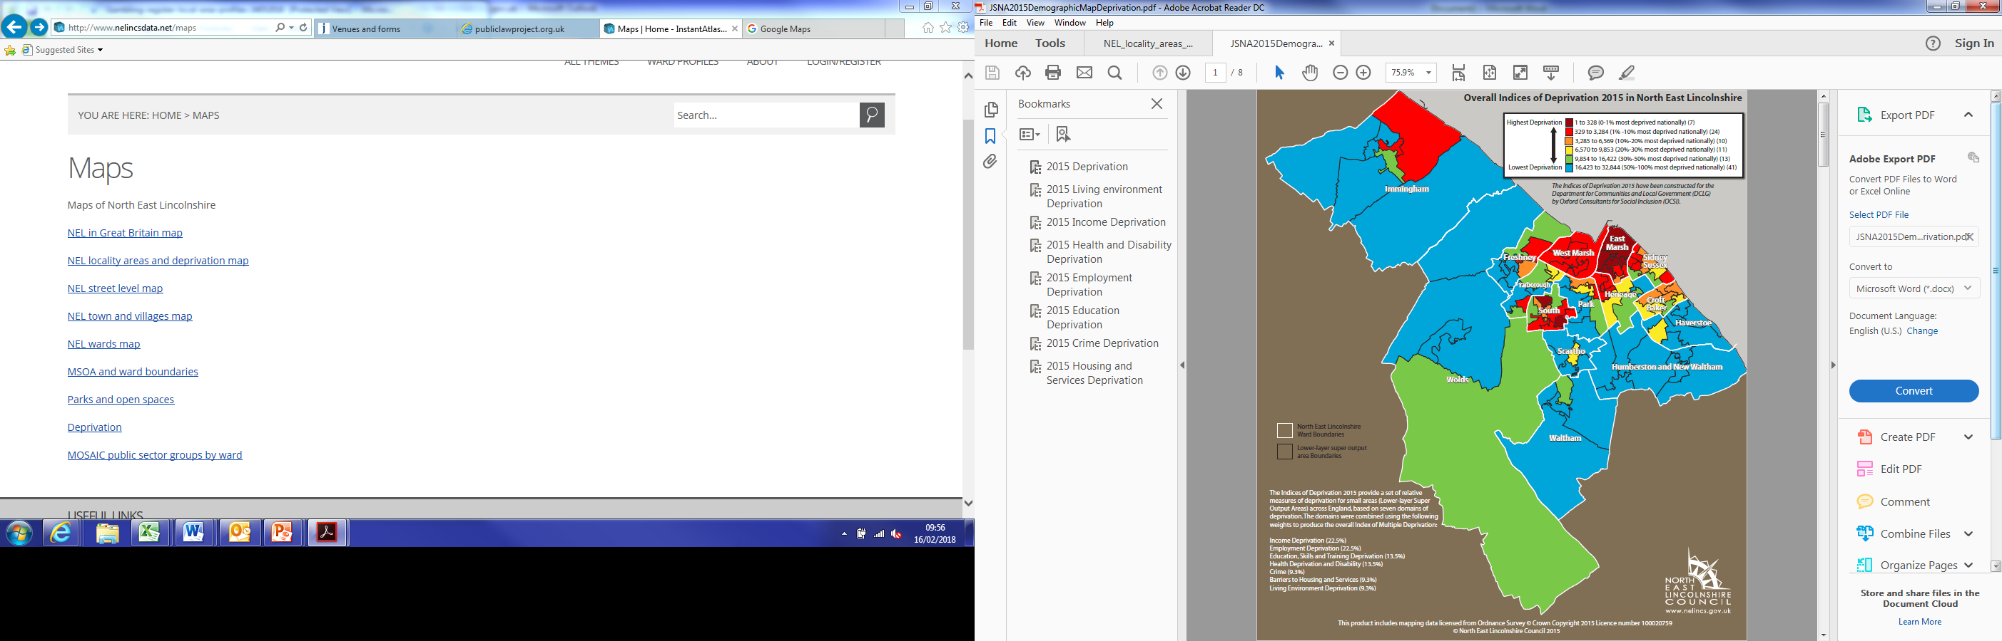

More details maps and information can be found here: <http://www.nelincsdata.net/>