Grimsby Town Centre Consultation Results

The consultation was open from 17th July 2018 to 14th August 2018 (4 weeks). In total there were 1210 responses; 1085 of those were online responses with 125 paper copies completed.

Respondents could take part by completing the survey online at [www.nelincs.gov.uk/have-your-say](http://www.nelincs.gov.uk/have-your-say) or by completing a paper survey at Lincs Inspire libraries or the Customer Access Point. North East Lincolnshire Council officers also conducted a number of face to face interviews. The consultation was promoted twice on NELC’s Facebook page whilst shared by Families First, Live Well NEL, I Can NEL and 82 people. It reached 15,194 people with 809 clicking the survey link. On Twitter it was promoted twice alongside 19 retweets and 15 likes by people.

This was a project between Safer NEL, Humberside Police, Freshney Place and Stagecoach. We asked for views about Grimsby town centre including why you visit, how you travel, your shopping habits, what you like, what would encourage you to visit more, how safe you feel, if anything puts you off the town and your view on anti-social behaviour. Here is the specific area of Grimsby Town Centre we asked to be considered when answering the survey:



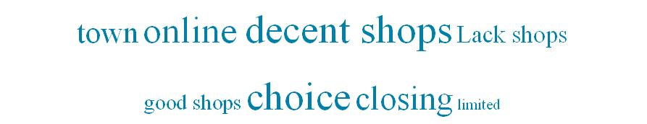Those that answered ‘no’ were then asked why. Below is a word cloud of the most common responses. 954 reasons were given.

* Shops – 498 (46%) - This included lack of shops, shops closing and no decent shops
* Online - 64 (7%)
* Nothing
* Convenience – This included comments that it's easy for them to visit as it may be fairly nearby or have everything they need in one place
* Shops
* Restaurants/pubs
* Outdoor spaces – People liked the architecture, heritage, green spaces and buildings
* Compact – This summarised that all shops and amenities are fairly close together and easy to get to
* Parking – Respondents feel the price is fair as well as spaces being available
* More choices - People would like more shops and activities available
* High-end shops
* ASB – People stating drinking, violence, swearing, smoking, rowdiness and other forms of anti-social behaviour should be reduced
* Restaurants
* Cheaper/free parking
* Reduced homelessness – This also includes people begging
* Police – This also includes security and a greater police presence in town

Those that answered ‘not very safe’ or ‘not at all safe’ were then asked why. Below is a word cloud of the most common responses. 897 reasons were given.

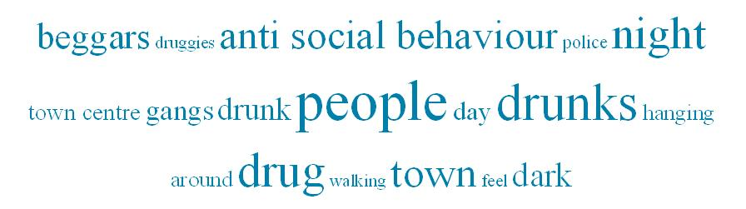

* Drugs – 230 (26%)
* Drunks – 168 (23%)
* Night – 94 (10%) – This described people felt unsafe at night
* Beggars – 46 (5%)

Those that answered ‘yes’ were then asked why. Below is a word cloud of the most common responses. 983 reasons were given.

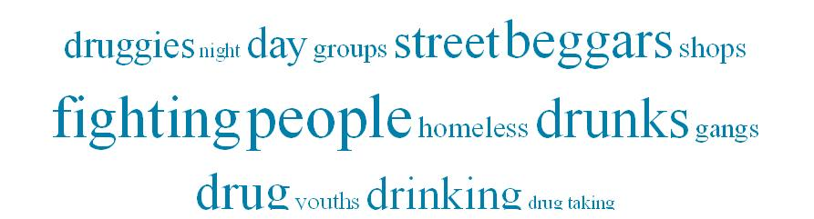

People – 320 (36%) - This includes youths

Drinking – 205 (23%)

Fighting – 132 (13%)

Beggars – 79 (8%)

Those that answered ‘yes’ were then asked why. Below is a word cloud of the most common responses. 433 reasons were given.

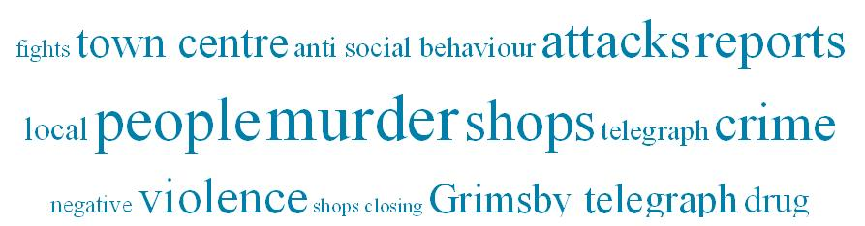

* Violent crime – 100 (24%) – This includes murder, attacks and violence
* Crime – 32 (7%)

Question 9 – What do you consider to be anti-social behaviour?

1174 respondents, 36 skipped. Open answer themed.

Below is a word cloud of the most the common responses.

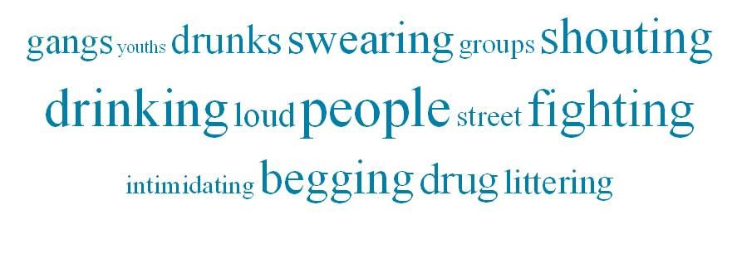

Drinking – 291 (25%)

Fighting – 165 (14%)

Shouting – 151 (13%)

Beggars – 116 (10%)

Drugs – 94 (8%)

Question 10 – What is your postcode?

This has not been analysed at this time.

**Next Steps and Actions:**

To be updated by the working group and fed back publicly following the ‘You said, we did’ format.