**Little Coates Road/ Cambridge Road Junction Improvement Scheme**

The Little Coates Road Junction Improvement Scheme will see the removal of the mini roundabout at the junction of Little Coates and Cambridge Road. In its place, there will be a new fit-for-purpose roundabout, which aims to improve traffic flow and provide access to a potential new housing site.

The highway improvement works are expected to take approximately 28 weeks to be delivered, works are due to start January 2020 and will be ending in July 2020, with some return visit working during September for application of anti-skid surfacing once the surfacing has bedded in. The disruption to road users will be kept to a minimum at all times but especially at the beginning and end of the scheme. The majority of the works will take place on the former Western site and therefore not affect road users.

Once completed, the existing routes of Cambridge Road and Little Coates Road will have been realigned to meet the new roundabout. We will keep residents and businesses up to speed, with reminders and letters sent out regularly.

As part of the works, a number of trees will be removed and replaced elsewhere to allow the roundabout to be constructed. There are a few protected trees in the area, all which will remain where they are.

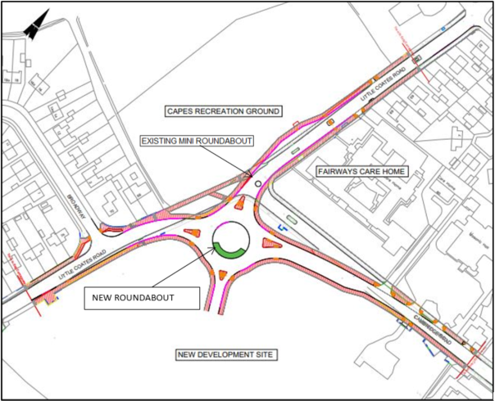

*Figure 1: General Layout*

**FAQ’s**

1. Is the Central Island/ crossing on Cambridge Road staying?

Crossing points will be re-provided, and the zebra crossing will remain in place. Further information on temporary arrangements is included in the Traffic Management section in Point 12.

1. What provisions will there be on the new roundabout for cyclists?

A shared cycle/footway will be in place for pedestrians and cyclists going from Little Coates Road south to Little Coates Road north. This will follow the footway alignment which is currently in place, and will be retained when the new roundabout is introduced. This is highlighted in the Figure 1.

1. Will any land from Capes Recreation Ground be used?

A very small section of Capes Recreation Ground will be used to facilitate a new bus layby. This is a further upgrade, as buses stopping to pick up passenger will no longer block traffic.

1. Will driveway access still be available?

Accesses to private dwellings will be retained as much as reasonably practicable. The contractor will have an on-site Public Liaison Officer who will liaise directly with residents and businesses whose access may be affected by works.

1. Will the drainage be sorted out on Little Coates Road?

Previously improvements have been made to the drainage at the adjacent Grimsby Golf Club. As part of the works to the junction, improvements will be made to surface water drainage along Little Coates Road.

1. Where can I find copies of the plans?

https://www.nelincs.gov.uk/roads-parking-transport/

1. Is the camber of the road safe?

The camber on Little Coates Road is higher than we would like in places, but is not in the scope of this project.

1. Please can the children’s play equipment on Capes Recreation Ground and fencing be reviewed?

This query has been forwarded to grounds maintenance for inspection, but is not work directly associated with the highways project.

1. Please can the condition of the signage near the new crossing be checked?

Yes – signage will be reviewed as part of the scheme, with new signage put in place where necessary.

1. Will the road ever close? If so when and how long for?

Road closures will be kept to a minimum, but information on how traffic will be managed during works is presented in more detail below.

1. Can the width of the new crossing on Little Coates Road be reviewed?

The central island was designed to avoid drivers overtaking/ squeezing past cyclists without pulling around them. The lane width on both side of the island is 3.0m and therefore considered to be consistent with design guidance. The central island is on a straight section of Little Coates Road. Refuse vehicles are typically 2.4m wide, as seen in figure 3, so should not have a problem passing the island.

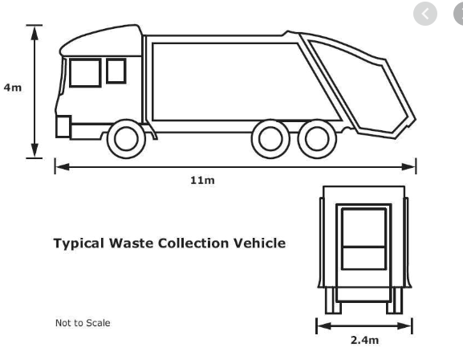

*Figure 2: Waste Collection Vehicle*

1. What are the traffic management plans?

There are a number of phases of this work. In outline, these are:

Early Feb 2020: site set up

**Phase 1**: Feb to early March – works off the main road to move utilities and services. Access to footpaths will be diverted.

**Phase 2**: late Feb to end April – roundabout construction on the former Western site.

**Phase 3**: May – resurfacing work. Likely to involve some night-time closures

**Phase 4**: June to early July – landscaping. Likely to involve narrowing the traffic lanes for safe working.

**Phase 5**: mid July – final resurfacing work, likely to involve some night-time closures, and project completion.

Please note, all of the above are subject to change, depending on the progress of the project. Further details about each phase are listed below.

Image of the timeline

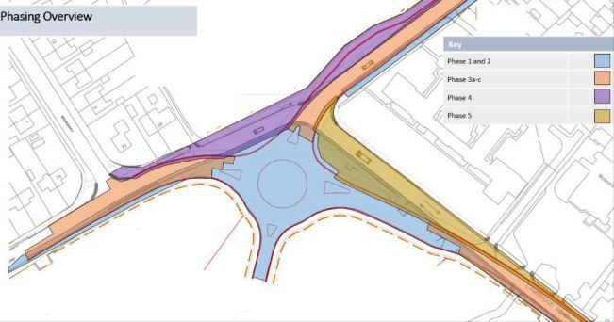

*Figure 3: Phasing Plan*

During **Phase 1** of the works, which runs to early March, Virgin Media, Northern Power and BT will be moving their underground infrastructure into the new footway, so that when they need to do maintenance in the future they won’t need to close the road. They will need to close the footway in order to achieve this. A diversion route for pedestrians will be in place; pedestrians will be able to use the footway on the west side of the Little Coates Road, crossing over where necessary via temporary signalised crossing points, which will be provided. This will help to keep full, safe access to Cambridge Road during this phase of works. The existing zebra crossing on Cambridge Road will not be affected by the works in this phase.

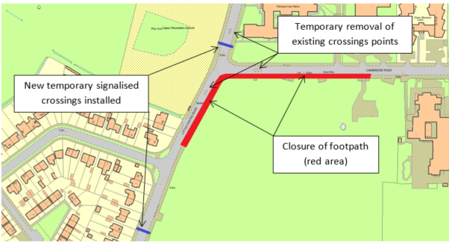

*Figure 4: Temporary Footway Arrangements*

At the start of **Phase 2**, which slightly overlaps Phase 1 and runs from late February to late April, there will be an installation of off-peak 3 way signal control at the roundabout to enable the removal of the existing pedestrian refuge islands. This will last for around 1 week. Once reinstated with surfacing materials a narrow lane traffic management system will be implemented, this will provide a minimum of 3.25m wide traffic lanes. Introducing narrow lanes will ensure best and safest use of the available working room while maintaining traffic flows at all times. An example of what this may look like is presented in Figure 5.

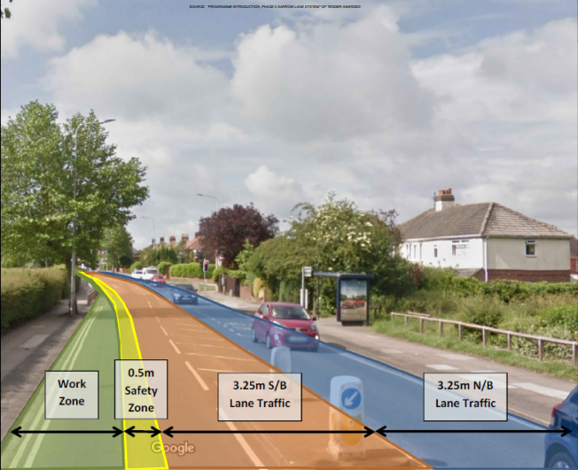

*Figure 5: Narrow Lanes*

Works are planned to take place overnight between Monday – Thursday to minimise disruption.

**Phase 3** will take around 4 weeks to complete during May. Phase 3 has been broken down into three sub-phases.

**Phase 3a** will see a single overnight closure of Little Coates Road (South), Little Coates Road (North) while Cambridge Road will be maintained. During this time traffic will be diverted via Laceby Road.

**Phase 3b** will also see a single overnight closure of Cambridge Road whilst maintaining Little Coates Road.

**Phase 3c** will require 3 overnight closures. The traffic will be diverted via the new roundabout during this phase, access will be maintained via Little Coates Road (South) and Cambridge Road. Any traffic to Little Coates Road North will be diverted.

The pedestrian routes and crossing will be maintained the same as they were in Phase 2 on Little Coates Road Northbound and Eastbound on Cambridge Road.

At the end of **Phase 3**, traffic will be permanently switched to the new alignment roundabout.

**Phase 4** runs from early June to mid-July. To mitigate disruption to the road users during this period narrow lanes will be reinstalled, this time to the west side of Little Coates Road to ensure a safe working zone while kerbing is installed northbound. Pedestrians will be diverted to the new roundabout alignment with temporary crossings maintained to the scheme extents on Little Coates Road. During this phase a Toucan crossing has been commissioned to enhance pedestrian access and enable the temporary crossing to be removed.

Pedestrians will be diverted to the completed shared areas and will utilise the permanent Toucan crossing and pedestrian refuge island.

The project team and contractor will be liaising with residents and businesses on an ongoing basis.

**Phase 5** is to lay the final surface and road markings during July. This will require overnight closures for around 4 nights. During September, a return visit works for the application of anti-skid treatments shall take place once the surfacing works have settled-in. This shall again be undertaken under overnight closures for an approximate duration of 4 nights.

If you have any questions, please email [littlecoatesroadjunction@nelincs.gov.uk](mailto:littlecoatesroadjunction@nelincs.gov.uk)