Internal reference: | NELC ESAGGuide
Review date: | September
Version | V1

Event Safety Advisory Group (ESAG) general guidance

Contents
Introduction
What is ESAG
Timeline for ESAG application
Event planning
Event management
Traffic management
Noise management
Litter management
Medical plan (first aid)
Sanitation
Health and safety advice
Provision of food and drinking water
Temporary event notice (TEN)
Finally

Introduction

There are many different types of public events that take place in North East Lincolnshire every year. These can range from sporting events to musical concerts; some taking place indoors; some outdoors; some are large and some small. It is important to remember that when large groups of people gather together a wide range of dangerous situations can occur. There are also many different factors that can influence crowds.
As an event organiser you are responsible for and have a legal duty to ensure the health, safety and welfare of the people attending your event, as well as that of the employees, volunteers, contractors and sub-contractors working there.
This guide will help you to plan a safe and successful event by using simple safety measures to reduce risks. It also includes the timescales for submitting event plans.
This guidance applies to public and private events, for example:
- Street parties, fetes and fairs
- Agricultural shows, car shows and caravan shows
- Sporting events
- Charity events
- Religious events
- Marches and carnivals
- Fireworks displays
- Open air concerts (This is not an exclusive list)

What is the Event Safety Advisory Group?
The Event Safety Advisory Group (ESAG) helps to monitor and discuss event health and safety. It acts as the single point of contact for event organisers.
ESAG's objectives are:
- To promote high levels of safety and welfare at events by giving advice and guidance
- To encourage good practice in safety and welfare planning for events
- To ensure events have minimal negative impact on communities
- Encourage cooperation and coordination between all relevant agencies so that events are safe and successful
- Advise landowners on the safety of events
You can complete an online ESAG request and member of the group will be in contact with you if there are issues to discuss. If the group is satisfied with your plans you may not hear back from them. ESAG is purely an advisory group which is concerned with protecting all involved in an event.

Timeline for ESAG application

Required 120 days before the event
Check list | Event organiser to provide documentation which will be circulated to and considered by
Application for a Premises Licence, including draft site plans (including campsites and car parks) | All Responsible Authorities for purpose of Licensing Act 2003

Required 90 days before the event
Check list | Event organiser to provide documentation which will be circulated to and considered by
Draft Event Management Plan - this needs to include sufficient information to demonstrate that plans are in place to deal with all issues outlined in our event management template – you do not have to use our template but we will expect all areas within | All Responsible Authorities
Draft Traffic Management Plan – required for any event where you expect more than 2000 people to be involved or where your event includes use of the public highway whether or not you have a formal road closure in place | NELC Highways, Humberside Police & Ambulance
Draft Noise Management Plan | NELCC Environmental Protection Team (Noise)
Draft Litter & Waste Management Plan – required for all events | NELC Environment - Health & Safety

Required 60 days before the event
Check list | Event organiser to provide documentation which will be circulated to and considered by
Medical Plan | East Midlands Ambulance Service (EMAS) & NLAG Hospital Trust
Drinking Water & Sanitation Plan | NELC Environment - Health & Safety

Required 28 days before the event
Check list | Event organiser to provide documentation which will be circulated to and considered by
Final Event Management Plan this should be in a format where if the event manager was unable to run the event it could be passed on to an alternative event manager who would be able to safely manage the event | All Responsible Authorities & Agencies
Detailed Site Layout Plans, with scale | All Responsible Authorities & Agencies
Final Traffic Management Plan | NELC Highways, Humberside Police & East Midlands Ambulance Service
Signage & Coning Information | NELC Highways & Humberside Police
Final Noise Management Plan | NELC Environmental Protection Team (Noise)
Final Litter & Waste Management Plan | NELC Environment - Health & Safety
Final Drinking Water & Sanitation Plan | NELC Environment - Health & Safety
Final Medical Plan | East Midlands Ambulance ) & NLAG
Structural Information on stages, marquees & temporary structures | NELC Environment - Health & Safety & NELC Building Control

Event Planning
Considering these ideas at an early stage will make event planning easier and more focused.
What would you like your event to focus on?
Consider the activities that will take place at the event and any specific risks involved with these. You may wish to decide on the size of the event.
Who will attend your event?
Choose your target audience, such as teenagers, or the elderly. How many people could attend your event? Is this number safe? How will you control access to your event? Will you have tickets?
Where will you hold your event?
Is your chosen venue suitable for the activities within your event? Is your venue accessible for those with disabilities? How will people get to your event? Is there suitable car parking? Will you need to close a road? How will emergency services gain access to your event? Is your venue close to residential areas, where your event may disturb members of the community?
When will you hold your event?
Will you be able to submit your ESAG notification form in time? Will you need to take into account seasonal risks, such as extreme summer heat or bad winter weather? Could event clash with another already taking place in the area?
During your planning process you may contact North East Lincolnshire Council for advice and guidance. It is vital to inform the ESAG if there are major changes to your event plan.

Event Management
To effectively and efficiently manage an event you will need an event management plan. This may include the following and must include sufficient information against the headings in your event management plan so that anyone not involved in the event would be able to pick up the plan and safely manage the event:
Managing your event
Key responsibilities for each person in the event management team should be identified and one person should not have multiple responsibilities at the event. This ensures that each person knows their role and that these roles and responsibilities match the person’s skills and experience. One person should be designated as the manager, and will be the sole contact for the ESAG. An event plan showing the roles and responsibilities of the team should be prepared. This should also include how issues will be mitigated and managed.
You also should plan and allocate time to set up your event, but to also clean up the site after you have used it.
Risk assessments
A detailed risk assessment will make it easy to identify risks and safety hazards, and work out how these can be eliminated or reduced. The event organiser should complete the risk assessments, ESAG will not consider the event to be safe without a suitable risk assessment.
Risk assessments should:

Identify hazards
- A hazard is ‘a potential source of harm or adverse health effect on a person or persons’
- A hazard could include:
- Slip, trip, or fall hazardElectrical hazards from electrical equipment
- Fire hazards such as combustible material or bottled gas
- Traffic hazard for example danger to pedestrians through moving vehicles
- Machinery hazards
- Temporary structures such as scaffolds Decide who could be affected
- Members of the public
- Participants / spectators
- Employees
- Volunteers Asses the risk
- The risk is the likelihood that injury or an accident could occur from a hazard
- The severity of this risk should be identified and classified as either high, medium or low
- You should consider what you have already put in place to minimise these hazards and risks
View an example of a risk assessment.

Site plan
You should formulate a site plan to show the locations of key facilities and activities that take place at your event.
Key facilities would include:
- Entry and exit points for visitors and employees. Separate entry and exit points should be considered for pedestrians and vehicles
- Emergency exits and exit routes
- Emergency services entry and exit points, and their routes around your site
- Emergency service rendezvous point
- Toilets, including accessible and baby change facilities
- First aid points
- Lost child points
- Information points
- Food and drink locations
- Ticketing points
Your site plan should be a scale drawing, with the top of the illustration marked towards magnetic North. It is acceptable to use a digital map (such as ‘Google Maps’) with drawings placed on top as long as a scale is included.
For smaller, community events a basic, non-scale plan will be sufficient.

Crowd management
You need to be aware of the number of people your venue can safely hold, and throughout your event the numbers of people present should be monitored. This may include counting people as they enter your site and restricting access when the maximum number of people is reached. It is important to consider how you would communicate to and evacuate a large number of people should an emergency arise.

Entry to and exit from the venue
If you have people arriving by car and on foot, it may be beneficial to place barriers to separate vehicles from pedestrians. You should consider if stewards are needed to direct people to the appropriate entrance, or if signs need to be put in place. If road closures are required signs must be placed on the highway prior to the event to inform residents. An application for road closure must be made to Highways.

Emergencies
You should have a plan in place for emergency situations. This may include identifying members of the management team to take action in the event of an emergency. Plans should also be made for emergency vehicle access, and how to keep the access routes clear.

Animals at events
The event organiser is responsible for the welfare of any animals which are to be featured at an event. This includes the transport, housing and feeding of any animals. The organiser should abide by the Animal Welfare Act of 2006.

Lost children
- Identify arrangements for the ‘safe’ care of children until such time that they can be reunited with their parent/s or guardian
- There should be a clearly advertised point for information on lost children
- Lost children should never be left in the care of a sole adult, always ensure that there are at least two adults that have the appropriate DBS (Disclosure and Barring Service) checks in place.
- If a lost child is found and reported to one of the event staff a message should be communicated to all event staff as per the communication plan (radio, phone, in person to event control point).
- Remain in-situ with the child for an allotted time
- If after an allotted time there has been no reunion then the child should be taken to the designated lost children’s point by two members of staff. If possible this point should be adjacent to your event control point or the first aid/medical area.
- All incidents need be logged, ensuring all details are recorded.
- The DBS checked staff should try to ascertain a description of the child’s guardian, their name, mobile number if known and a description.
- The child and the parent/s guardian should not be reunited until a match has been established. To this if a parent comes to the lost children’s point claiming they have a lost child they must provide a signature and identification along with a description of their child, this could include age, clothing, hair colour, height etc.
- If there is any reluctance from the child to go with the adult then you should inform the police
- Once a lost child incident has been resolved you must inform all staff that the ‘code’ has been resolved. Complete the report and log.

After the event
Consider holding a de-brief after your event has finished to review successes and areas for improvement. Make sure that your site is properly cleaned after you have used it. Please share your de-brief with ESAG so that any lessons learnt can be shared with event organisers of similar events or using the same site

If your event is of a small scale or low impact (for example a beach clean or charity stall) we will not need your debrief to be shared.

Traffic management
Consider how easy it will be for people to travel to and from your venue by car, and if there is enough parking for the number of people who could attend your event. If the event is in a residential area, you may need to erect signs that tell people not to park on verges, or block residents’ drives.

Noise management
If your event is near residential areas you should ensure that you consider the timings of your noise. It may be useful to position the main source of noise so that it is pointing away from residential areas. You need to have consideration for existing policies to limit noise disturbance.

Litter and Waste management
Your event should have an adequate provision of bins and personnel to pick up litter. No waste should be left on your site as it could pose a contamination and pollution hazard.

Medical plan (first aid)
To administer first aid you may need arrangements with local hospitals and first aid providers. You may wish to have a designated first aid point on your site. There should be no fewer than two first aiders at any size of event, and first aid should be their only role.

Sanitation
This is the advised provision of toilets for an event:
Events with a gate opening time of | Female | Male
Less than 6 hours | 1 toilet per 120 females | 1 toilet per 600 males and 1 urinal per 175 males
6 hours or more | 1 toilet per 100 females | 1 toiler per 500 males and 1 urinal per 150 males
6 hours or more with food and alcohol being served | 1 toilet per 75 females | 1 toilet per 400 males and 1 urinal per 125 males

Health and safety advice
An event organiser has a duty to plan, manage and monitor the event to make sure that workers and the visiting public are not exposed to health and safety risks.
You should carry out and provide a written risk assessment as the first step in planning your event. This will ensure that adequate health and safety measures are put in place, more information is available from the HSE website.
Event organisers must hold public liability insurance to a minimum value of £5 million. You must also ensure that any contractors that you are engaging also hold public liability insurance to the same level and any other appropriate insurance, i.e. product liability, employee insurance. It is the responsibility of the Event organiser to ensure that all appropriate insurances are in place.

Provision of food and Drinking Water
You must ensure that food preparation is undertaken in hygienic conditions and complies with relevant legislation.
Where food is provided, ensure that each provider is registered as a food business. It is strongly recommended that only businesses with a Food Hygiene rating of 4 or 5 are permitted to trade. You can check if a business is registered, and their hygiene rating by visiting the GOV.UK website. Some charitable and ‘one off’ provision does not require registration, but this is an exception rather than a regular occurrence so if you suspect that this might be the case please contact Environmental Health for advice.
If the organiser is providing water to the catering outlets then they should satisfy themselves that it meets the EU Drinking Water Standard. For all events, and especially sporting events, it is essential that there is a drinking water supply available to people who attend your event. Any drinking water supply should meet the EU Drinking Water Standard.
When you have this information an outline of the type of catering and facilities should be sent to Environmental Health.
View the detailed guide for outdoor and mobile catering.

Do I need a Temporary Event Notice (TEN)?
Businesses, organisations and individuals who want to sell/supply alcohol, serve hot food after 11pm or provide types of entertainment may require a licence from the licensing authority.

Licensable activity includes:
- Selling alcohol
- Serving alcohol to members of a private club
- Providing entertainment, such as music, dancing, plays, indoor sporting events, boxing, wrestling and film screenings
- Serving hot food or drink between 11pm and 5am

You will require a TEN if a licensable activity is not included in the terms of an existing Premises Licence.

Restrictions
Your event must:
- Have fewer than 499 people at all times – including staff running the event
- Last no more than 168 hours (7 days)
You must be at least 18 to apply for a temporary event notice (TEN).

Number of notices you can apply for
You need a TEN for each event you hold on the same premises. A single premise can have up to 15 TENs applied for in one year, as long as the total length of the events is not more than 21 days.
You can have up to 5 TENs a year. If you already have a personal licence to sell alcohol, you can be given up to 50 TENs a year.

If you’re organising separate but consecutive events, there must be at least a 24 hour gap between them.

How to apply
You must apply at least 10 clear working days before your event. (Clear working days do not include the day your council receives your application or the day of the event).
Temporary event notices are charged at £21 per application. You can apply online at the North East Lincolnshire Council’s website.

Additional Information
Should you have any additional questions regarding an event, please do not hesitate to contact the Licensing Team using the details below:
Licensing Section
Doughty Road Depot Doughty Road Grimsby
DN32 0LL
Telephone:01472 326299
Email: Licensing@nelincs.gov.uk

This flow chart should help you decide if you need to apply for a TEN:
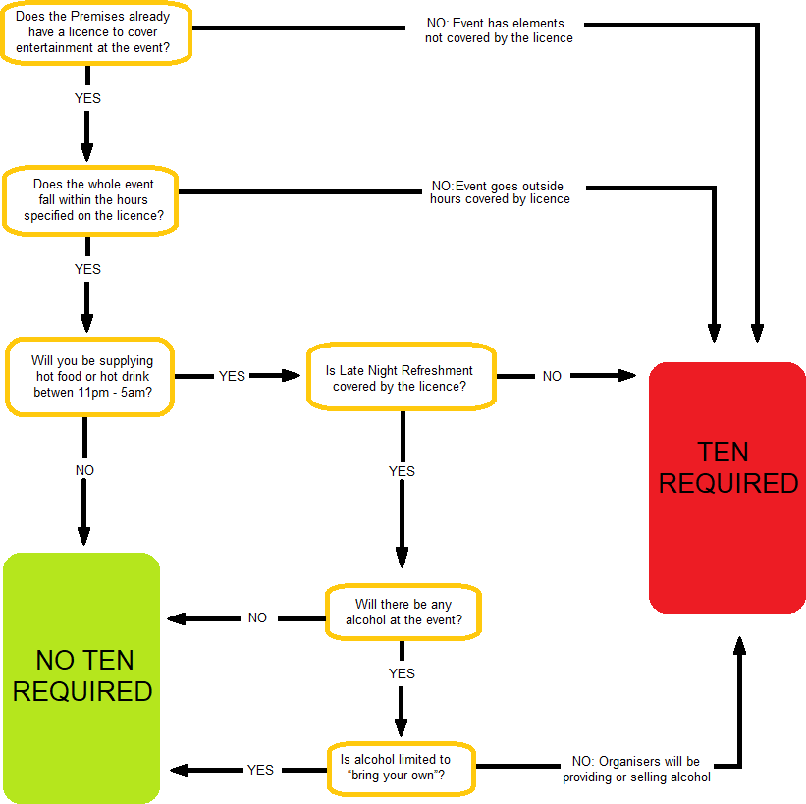

Finally
This guide is intended to help you fulfil your responsibilities as an event organiser. However, you should supplement the information provided by other reading including the Events Safety Guide.
The Events Safety Group will not be held responsible for any deaths, loss or damage to property arising as a consequence of your event. It is your responsibility to ensure that you take the necessary steps to protect yourself from liability.
We hope you find this guide to be a useful tool and wish you a successful event.

