Do I need to register/create an account to fill in the form? I have more than one property, how do I submit multiple forms?

Here are some step by step instructions:



How do I know what my account number is?

Look on your rates bill, all account numbers start with ‘44’

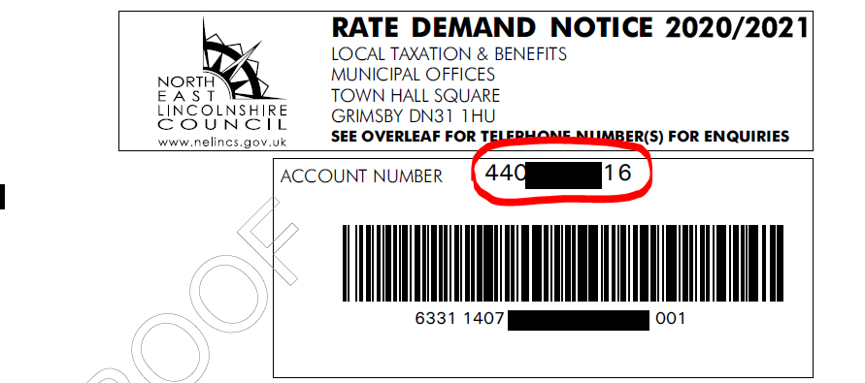

Some people are reporting that when they submit their form, It says that their “Online Status is Closed”. What does this mean?

When the customer has register/created an account and they look in “My Requests” in the self-service portal; that Case Status says Closed. This is because, as far as the system is concerned, there are no further actions. It is a form that has been completed.

The form does not recognise the customer’s postcode/can’t find their address?

The customer can search by street alone and pick from the list; make sure the customer has scrolled fully down on the list to find their address. Alternatively tick “Can’t Find Your Address” to enter this manually.

I do not have the information for some of the questions, what can I do?

If you do not have the relevant information, you can put “not known” or “waiting for information” The mandatory fields need something in them but are not locked down to a specific format, as long as the field has a green tick next to it, the form can be submitted. This applies to all mandatory fields where information is not known.

How can I find out the rateable value of my premises?

You can check on the government website here: <https://www.gov.uk/correct-your-business-rates>

However please note that the website only gives the property reference for the business/unit but not the business rates reference number.

**I think my business is eligible to receive the grant and have completed my local council’s online form. When will we receive the grant into our bank account?**

We are waiting for the funding to be made available from central government before processing grant payments, which is currently expected by Wednesday 01 April. We are working hard to process and make grant payments into eligible business’s bank accounts as soon as possible. However, as there are thousands of eligible businesses, it may take a number of days for the payment to be made, so they are asking all businesses to be patient – they are trying to move on this as quickly as possible!

**I’ve read that my local council are writing to businesses at their business address to inform them whether they’re eligible for a grant. I’ve closed my business and locked-up the premises and the letter won’t be able to be delivered, what do I do?**

Don’t worry. For this very reason we are not writing to you, instead we have set up online forms for businesses to fill-in that think they are eligible for the grants.

**I run a Retail, Leisure or Hospitality business, and also qualify for Small Business Rate Relief. Will I get two grants – the small business grant and the retail, leisure and hospitality grant?**

No. Businesses will only receive the specific grant they are eligible for, not both. However, businesses may receive one grant per eligible commercial premises.

**Do the grants have to be paid back, and are they taxable?**

No to both of those points. However, grants will need to be repaid if any business is caught falsifying their records to gain additional grant money. Businesses will also face prosecution if they are found to have falsified their records and fraudulently claimed the grant.

**I run a retail business but I don’t know if my property’s rateable value is less than the £50,999.99 cut off to get the retail, leisure and hospitality grant. How can I find out?**

You can check your commercial premises’ rateable value using the Valuation Office Agency’s here. Enter the postcode or address of your business premises and the current rateable value will be shown for your premises.

**I own a small accountancy firm that trades on the high street. Are we eligible for a grant?**

Possibly – it depends on the rateable value of your business premises. If your business currently receives small business rate relief (SBRR) or rural rate relief, then you will likely receive the £10,000 small business grant. However, current government guidance for the Retail, Leisure and Hospitality grant fund advises that businesses in the “professional services” industry – which includes accountancy firms – are not eligible for that grant.

**I run a hairdressing salon and I rent the back room out to a massage therapist. Who will receive the grant – will we both get one?**

It will depend. Only the person who according to the billing authority’s records was the ratepayer in respect of the commercial premises on the scheme eligibility date (11 March 2020) will get the grant. If your premises only receives one business rates bill, then only one of you will get the grant, and that will be the person and business that is named as the rate payer on local council records as of Wednesday 11 March 2020.

**I rent commercial premises that I think is eligible for small business rate relief but I and my business are not the ratepayer. Can I still get the grant?**

Possibly. Government guidance states that:

‘The person who according to the billing authority’s records was the ratepayer in respect of the commercial premises on the scheme eligibility date (11 March 2020)’.

So if you and your business were not the ratepayer for the premises on 11 March 2020 then you are unlikely to be awarded the grant.

It is therefore advisable to speak to your landlord in the first instance to clarify who the ratepayer was on 11 March 2020 and you should question whether this was accurate. Indeed, government guidance also states that:

‘Landlord and management agents are being urged to support local government in quickly identifying the correct ratepayer’

**I signed the lease on my business premises on Thursday 12 March 2020. Can I still get the grant?**

No. Only businesses that operated from commercial premises that appear on the business rates register on Wednesday 11 March 2020 are eligible for this grant.

**I run my business from my home. Am I eligible for a grant?**

Almost certainly not. Only businesses that operated from commercial premises that appear on the business rates register on Wednesday 11 March 2020 are eligible for this grant.

**I own a wholesale business that supplier food and drink to the catering and hospitality industry, our premises rateable value is above the £15,000 small business rate relief threshold so we can’t get the £10,000 small business grant. Are we eligible for the £25,000 retail, leisure and hospitality grant instead?**

No. Government guidance does not currently list wholesalers and suppliers to the retail, leisure and hospitality industry as eligible to receive the £25,000 grant. Please see the table below for a full list of premises that are currently eligible to receive this grant. However, there is possible scope for the government to alter the eligibility criteria for this grant scheme in the future, but for the moment nothing has been announced.

**I’ve been approached by someone offering to get me a grant in return for 15% commission on the grant. Should I do this?**

No, it is not recommended. You do not need to ‘apply’ for the grant; you merely need provide your council with some specific and straightforward information via an online form – this will not be complex or complicated to do – and the grant will be paid to you if you are eligible. Moreover, the grant will be paid direct to the bank account of eligible businesses anyway, and so it is difficult to see what value such a ‘broker’ would have by trying to help you get the grant. If in any doubt about this grant process, speak to us.