Do I need Planning Permission for householder development?

Applicant details
Name
Address

Postcode
Telephone number
Email

Site address
Address

Postcode

Brief description of proposed works

Is your property:
☐Detached
☐Semi-detached
☐Terraced
☐Flat
☐End terrace

Is the site in a conversation area or is it a listed building?
☐Yes
☐No

Extensions, improvements or alterations to a dwelling (including porches)
Where will the extension/alterations be?
☐Front
☐Side
☐Rear
If an extensions, will it be:
☐Single storey
☐Two storey
☐Or both
How far does the proposal project off of the original wall?
Please provide height of the proposal in metres below:
Height to the eaves:
Height to the highest point:
If the proposal is for a porch, would the porch be within 2m of a highway?
☐Yes
☐No
Will the materials match the existing house?
☐Yes
☐No
If no, what will they be?
External walls:
Roof:
Will the proposal, when combined with existing structures cover more than 50% of the curtilage/plot (for example the total area of the whole property excluding the ground area of the original dwelling house)?
☐Yes
☐No
Will the proposal be higher than the highest part of the roof of the existing dwelling?
☐Yes
☐No
Will the eaves of the proposal be higher than the eaves of the existing dwelling?
☐Yes
☐No
Will the proposal be within 2m of any boundary?
☐Yes
☐No

Are there any new windows proposed to the upper floor of any side wall or roof slope?
☐Yes
☐No
If yes please specify how high this would be above the floor of the room in which it is to be installed:
Would it be obscurely glazed?
☐Yes
☐No
Would any part of the proposal include a veranda, balcony or raised platform?
☐Yes
☐No
If you are proposing a side extension, please confirm the width of the original dwelling:
If the extension is more than 1 storey, would it be within 7m of any rear boundary?
☐Yes
☐No

Installation or replacement of a chimney, flue or soil and vent pipe:
Would the proposal exceed the highest part of the existing dwelling roof by more than 1m?
☐Yes
☐No

If the site is within a conservation area, would the proposal be inserted onto a wall or roof slope which fronts a highway and forms either the principle (main) elevation or side elevation of the existing dwelling?
☐Yes
☐No

Alteration or enlargement of a dwelling roof:
Will the proposal be higher than the highest part of the existing roof?
☐Yes
☐No
Will the proposal extend beyond an existing roof slope which forms the principal elevation of the dwelling or fronts a highway?
☐Yes
☐No
What would the cubic volume of the extension/alteration be (height x width x depth)?
What would the proposed external materials be?
Would any part of the proposal include a veranda, balcony or raised platform?
☐Yes
☐No
If yes, please specify how high this would be above the floor of the room in which it is to be installed:
And would it be obscurely glazed?
☐Yes
☐No
If the proposal is for rooflights or solar panels, how far would it/they project beyond the plane of the roof slope?

Outbuildings within the curtilage of the dwelling:
Please provide the external measurements of the proposal below:
Length:
Width:
Height to the eaves:
Height to the highest roof point:
Would any part of the proposal be within 2m of any boundary?
☐Yes
☐No
Would the building be:
☐Single storey
☐Two storey
Where will the buildings be positioned?
☐Front
☐Side
☐Rear
Would any part of the proposal include a veranda, balcony or raised platform?
☐Yes
☐No
What is the intended use of the proposal? For example domestic use or business use?

Will the proposal, when combined with existing structures (excluding the ground area of the original dwelling house), exceed 50% of the curtilage of the dwelling?
☐Yes
☐No

Fences, walls or other means of enclosure:
What would the total height be from ground level?
If this is a repair, would the proposal exceed its former height?
☐Yes
☐No
Is it adjacent to a highway used by vehicular traffic or to the front of the property?
☐Yes
☐No

Hard surfacing:
What is the size of the area to be hard surfaced or replaced?
Please identify where in the curtilage (plot) this will be? (A plan showing this area would be useful)
What materials are to be used?
How will surface water run-off be disposed of?

Where will surface water run off drain to?

Domestic Solar Energy:
Where would solar panels be on the dwelling?
Would it result in the highest part being higher than the highest part of the existing dwelling roof (excluding the chimney)?
☐Yes
☐No
How far would it/they project beyond the wall or plane of the roof slope?
If the solar panel is to be stand alone in the curtilage of the dwelling, how high would it/they be?
Would it/they be within 5m of any boundary?
☐Yes
☐No
How many would there be?
Would the surface area of the panels forming part of a stand alone solar exceed nine square metres or any dimensions of its array exceed 3 square metres?
☐Yes
☐No
Does the proposal include the installation, alteration or replacement of a ground source, water source or air source heat pump?
☐Yes
☐No
If yes, which?
Does the proposal include the installation, alteration or replacement of a flue, forming part of a biomass heating system?
☐Yes
☐No
If yes would this exceed the highest part of the roof of the dwelling?
Is yes, by how much?

Is the proposal to erect a wind turbine?
☐Yes
☐No
Is yes, where would it be located?
If yes, how high would it be?
Would it be attached to the dwelling?
☐Yes
☐No
You must provide either a sketch, photographs or a drawing in the space provided on the following page.
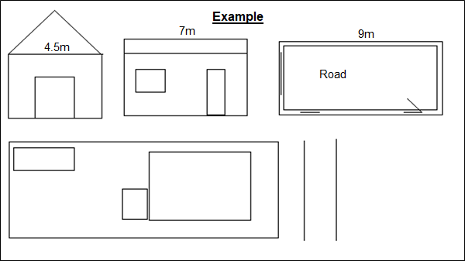

Sketch:

Signed:

Date:
Please send completed form with supporting documentation and the correct fee of £42 (including VAT) to:
North East Lincolnshire Planning
New Oxford House
2 George Street
Grimsby
North East Lincolnshire
DN31 1HB
Payment can be made by cheque, payable to ENGIE Services Ltd, or by debit card by contacting 01472 326289 – Option 1. If paying by card please quote the development address or enquiry number if you have this.
Please note: We aim to respond to enquires within 10 working days. It is possible that more information will be needed before a response is issued. Make sure all measurements are provided in metres. If possible please provide site photographs and rough sketches.
You may also need building regulation approval, you can call the team to enquire on 01472 325959.
The formal way to determine if a proposal is authorised or not is to apply for a Certificate of Lawful use. More information on this can be found on the planning portal.

